LTC Rapid Orientation/Onboarding Framework for Deployed Health Care Staff

March 29, 2021
Contents
Rapid Onboarding Orientation Framework 3
Purpose of Framework 3
Expectation of Use 3
Orientation Information 3
Additional Resources to Support On-Boarding/Orientation 5
Appendix A 5
Appendix A: Nova Scotia Health 6

Rapid Onboarding Orientation Framework

Purpose of Framework
The following framework is designed to help long term care facilities determine the necessary information needed to rapidly orient health care staff deployed to an unfamiliar facility experiencing a COVID-19 outbreak. This information is intended for staff who will be working on a temporary basis within the facility, and it can be further customized for licensed and general worker staff. It is not intended to be a substitute for a full orientation program for staff hired on a permanent basis
The objective of this framework is to provide a list of the types of necessary information required for deployed staff to work safely and provide appropriate resident care.

Expectation of Use
The expectation is that each individual facility will customize this framework and provide deployed staff with the specific and detailed information for each area listed below. The listed areas are not all encompassing, and each facility should add any additional information as they see fit.

Orientation Information
- Overview of long-term care
  - Overall approach to care (e.g. Philosophy of care – Eden etc.)
  - Demography of residents, families and caregivers.
  - What to expect/see on the floor (e.g. “A day in the life”)
  - Sample Checklist – Appendix A

- Getting to know the facility - Key Topics:
  - Tour of facility
    - Maps, parking, personal storage/locker assignment
    - Facility Entrance – Protocol
      - Signing in, mask supply, where to report, facility signage
    - Washrooms, offices, smoking areas
- Staff break rooms (breaks, lunch policies and mask protocol)
- Personal cell phone use/internet/access/WIFI
- Facility positions and roles
      - Scope of Practice of nursing care positions
- Norms, expectations, organizational values, any “unwritten rules” (e.g. everyone plays a part despite your role)
  - Safety related facility information
    - Emergency procedures (fire, evacuation, huddle in place etc.)
    - Location of MSDS, eye wash stations, AED, first aid
    - Smoking procedures
    - Introduction to team and assign a Point of Contact - your supervisor
    - Security and Communications: Telephone, call bell, and paging system
      - Position identification and role (Who’s who and what they are responsible for)
      - Wander guard system and exit codes
  - Tour of resident care areas
    - Utility rooms – clean/soiled
    - Location of supplies and procedures
    - Safe Lifts and Transfers-equipment and procedures
    - Dining room mealtimes/operations
    - Maintenance and housekeeping expectations/requirements
- Resident care plan orientation
  - Infection prevention and control information information/procedures (for all infectious agents, not just COVID-19)
  - Charting procedures (e.g. Point Click care)
  - Protection of persons in Care Act
  - Critical incident reporting
  - NSH Attendant Care Plan sample –Appendix B
- Policy and Procedure Review
  - Acceptable use of computers
  - PHIA Confidentiality
  - Code of Ethics
  - Dress Code
  - Mistreatment/Harassment (e.g. Respectful Workplace)

- Occupational Health & Safety: (AWARE- NS customized Online Learning)
  - Why the need for safety?
    - AWARE-NS Participatory Health and Safety video
    - AWARE-NS Quick Response Orientation
      - Rights and Responsibilities
      - Joint OHS Committee
      - Hazards and Reporting
      - Incidents and Reporting
      - Common Risks and Injuries
        - Sprains and Strains
          - PACE (5 Videos)
        - Slips, Trips and Falls
        - Infectious Diseases
          - PPE – Don and Doff/Storage
          - Hand Hygiene ( video)
6. Emergencies
a. Fire Safety and Evacuation
    - Emergency showers and eye wash stations
  - Workplace Violence Prevention
    - Code White, Code Silver
  - WHMIS
    - MSDS sheets and Eye wash stations

Additional Resources to Support On-Boarding/Orientation

  - Facility Based Safety Orientation – www.awarens.ca Front Line Resources – Aware NS
  - Quick response Orientation Online Learning module –www.awarens.ca/courses/
  - Resident Care – organization to select and insert youtube videos
    - Wound care
    - Choking
    - Feeding with Sensitivity
    - Protection of Person’s in Care Act/Policy

  - Equipment – organization to select equipment demonstration videos
    - Arjo Alenti
    - Arjo Rhapsody
    - Using the Typhoon
    - *Organization to add other equipment

Appendix A

      - NS Health: Attendant Care Plan tool and Tip Sheet
      - Orientation Checklist Samples:
        - Gem Healthcare CCA
        - Rose Crest Communities

Appendix A: Nova Scotia Health
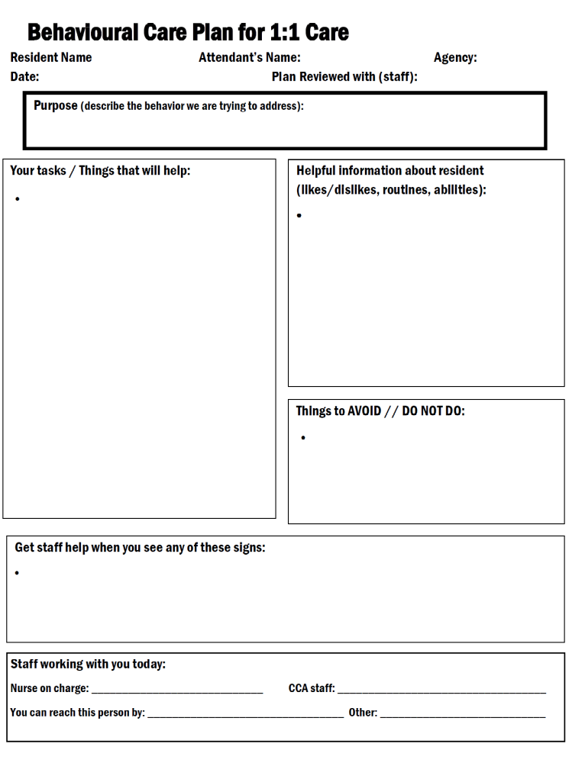

- Completed Care Plan Example
Behavioural Care Plan for 1:1 Care
Date: March 14 2019 Resident Name: Jim F.
Plan Reviewed with (staff):
Purpose (describe the behavior we are trying to address):
To keep Jim away from room 215 as much as possible.

Your tasks / Things that will help:
- Jim has a ‘work bench’ set up in the lounge and 2 bins of items for him to fix (at his workbench and outside room 215).
- You can ask for his help to fix something, then walk with him to his workbench and get an item from the bin.
- If he seems bored suggest ‘Break time!” and get a snack/drink. You can ask a staff member, or help yourself in the servery.
*********************************
If Jim leaves his workbench or is wandering the hall: walk past Jim and sit at the chair outside room 215. Greet him with a big smile and show him an item from the bin. You can say “found it!” or “can you help with this one?” etc. then guide him away from the room (for example, ‘let’s go to the bench’ and point down the hall).
*************************************
If Jim gets into room 215: gently ask him to come with you. If he has picked up something from the room, offer him an item from the bin instead. If that doesn’t work, leave and tell staff right away that he is in room 215.

Staff working with you today:
- Nurse on charge _________________________ - CCA staff: _________________________________
You can reach this person by: _____________________________ - Other:
Helpful information about resident (likes/dislikes, routines, abilities):
- Jim is a retired mechanic. He has memory problems and often thinks that he is at work. We help him to feel like he is still at work. This makes him feel good.
- He likes to walk, and often ends up in room 215 (this is where the hallway ends). He may be “looking for parts”. This bothers these residents and has caused lots of difficulty in the past.
- Jim has lost his ability to speak, but he can still understand you if you use simple words.
- Jim also likes to watch sports on the TV sometimes.

Things to AVOID // DO NOT DO:
- Do not tell Jim he “is in a nursing home now.”
- Do not grab any items out of Jim’s hands. Offer him to hold something new instead (from one of his bins).
- If Jim will not leave the room voluntarily, do not pull him out. Call for staff.
Get staff help when you see any of these signs:
•

Get staff help when you see any of these signs:
- If Jim discards the items, you offer to him (throws on the floor)
- If you hear Jim swear or say a curse word.
- If Jim has gone into room 215 and he wants to stay.



