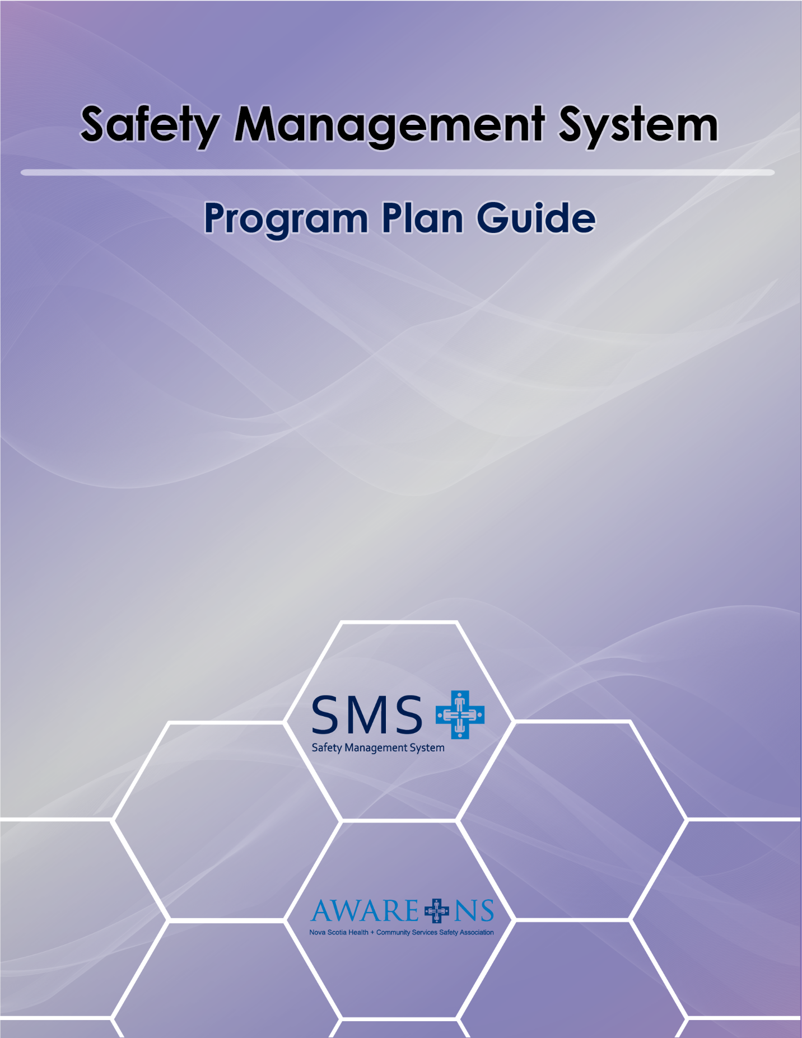

TABLE OF CONTENTS

Introduction 3
What is a Safety Management System? 4
The SMS Development and Implementation Process 9
Element 1: Commitment, Leadership and Participation 12
Element 2: Hazard Management 14
Element 3: Workplace Inspections 19
Element 4: Incident Management 22
Element 5: Emergency Prepardness 25
Element 6: Training 27
Element 7: Safe Work Procedures and Practices 30
Element 8: Joint Occupational Health and Safety Committee 33
Element 9: Contractor Safety 36
Element 10: Stay-At-Work/Return-To-Work 38
Element 11: Communication 40
Element 12: Documentation 43
Element 13: Monitoring 44
References 45
Appendix A: Safety Management System Checklist 46

Introduction

Each day health and community services employees are exposed to a variety of ever-changing workplace hazards. These hazards continually place these workers in risk of workplace injuries that can have long-lasting physical and mental effects.

Increased complexity of regulations, shrinking budget resources and workforce shortages are all factors that make it difficult for employers to develop effective safety programs.

For this reason, AWARE-NS has developed a Safety Management System Template that will assist health and community service based organizations in developing their occupational health and safety programs.

This Guide should provide a good starting point for developing a safety management system. Each section contains information that will help to prepare a safety management system and provides a base from which more information from other sources can be utilized. Other sources of information may include industry experts, formal training and government publications.

Organizations may utilize as much or as little of the template and guide as they wish depending on if they are just beginning to develop their program or if they are revising and updating.

Organizations should visit the AWARE-NS website (awarens.ca) for additional resources that are available for developing their program.

What is a Safety Management System?

Safety management systems are more than just a collection of documents located in a binder. Many times safety management systems are designed with the focus of making sure that organizations are meeting their legislative requirements. Even though it is a significant business requirement, a safety management system’s purpose should always be developed with the focus of creating a system that keeps everyone safe at the workplace.

A Safety Management System (SMS) is therefore a proactive management based process that helps effectively manage all safety aspects of an organization. It incorporates all safety components of an organization into one system rather than a number of individual sections.

It provides for the continual identifying, eliminating and controlling of hazards in an effort to protect the organizations employees and its assets from injury and illness. It accomplishes this by initiating organizational structures that include policies, procedures, accountability, monitoring and evaluating systems, employee participation and emergency preparedness.

Elements of the Safety Management System (SMS)

The AWARE-NS SMS template is divided into 13 sections:

- Commitment, Leadership and Participation
- Hazard Management
- Workplace and Equipment Inspection
- Incident Management
- Emergency Preparedness
- Training
- Safe Work Practices
- Joint Occupational Health and Safety Committee
- Contractor Safety
- Stay at Work/Return to Work
- Communication
- Documentation
- Monitoring

Benefits of a Safety Management System

In addition to effectively creating a safe working environment for everyone at the workplace, the SMS also creates other benefits to the organization. These include the following:

- A system meeting risk needs - A SMS can prioritize the planning, organizing, control, monitoring and review of measures to protect people from work risks. It’ll help you allocate the correct resources, achieving effectiveness and efficiency.

- Legal compliance is easier to attain and prove - Organizations can have difficulty keeping up to date with the requirements relevant to their sectors. A SMS helps identify relevant statutory provisions and creates a framework of procedures to make sure that the organization consistently complies with the law

- Visible commitment of ‘top managers’ - SMS, like other management systems, formally require ‘top management’ to be involved in and committed to the system. This is carefully documented through setting policies and objectives and through regular reviews to check the results achieved. Once the objectives are set, senior managers must visibly demonstrate their commitment to achieving them. It’s consistently argued that such commitment is essential for ‘world-class’ OHS results.

- Reassuring the enforcement authorities - Enforcement authorities require organizations to comply with applicable health and safety legislation. The formality and systematic approach to compliance required by an SMS encourages confidence in the organization’s internal approach.

Effective safety management systems do not just happen. They require a great deal of positive influence and commitment from all individuals of the organization. This commitment can best be seen by the degree of its safety culture. The following will explore this idea of safety culture and how it relates to a Safety Management System.

Safety Culture

Safety culture can be defined as:

The attitude, beliefs, perceptions, and values that employees and employers share about safety in the workplace. It is a commitment from individuals and the group that safety is integral to the workplace and is everyone’s responsibility”. 1

All organizations have some degree of safety culture. Safety cultures that tend to be more positive normally will see reduced safety incidents, higher employee morale and retention rates, and generally have an overall healthier productivity rate and financial stability. Safety cultures that are more negative will normally see an increase in incident rates, a low employee morale and retention rates and may experience issues with productivity.

A positive safety culture is therefore more than the expectation of meeting legislative requirements – it is good business. It is a shared belief by all members of the organization that safety at the workplace is everyone’s responsibility.

The Internal Responsibility System (IRS)

The Internal Responsibility System is the underlying philosophy of the occupational health and safety legislation in all Canadian jurisdictions. Like a positive safety culture, the Internal Responsibility System’s foundation is that everyone in the workplace, both employees and employers, are responsible for his or her own safety and for the safety of co-workers.

Leadership Commitment

A positive safety culture does not develop on its own. Positive safety cultures are created from a strong commitment originating from its top management levels. This includes Board members, CEOs, owners, senior management, managers and supervisors. Their attitude and beliefs of occupational health and safety will set an example for employees and influence their decisions and attitudes towards workplace safety.

Communication

A positive safety culture also has to have effective and constant communication of safety issues throughout all levels of the organization. If senior managers have good relationships with their employees, contractors and subcontractors, and they behave in a manner that promotes working safely, workers are more likely to behave safely. For positive relationships, seek to develop a style that promotes close involvement with workers to build trust and respect, while still maintaining authority and adherence to the safety processes.

Employee Participation

Active employee participation is also a key factor for positive safety cultures. These include workplace inspections, risk assessments, and active JOHSC involvement. Most importantly, all management levels need to create an environment where employees feel they can challenge unsafe work practices and behaviors without the fear of retaliation. Employees need to have a sense that their suggestions and concerns are being taken seriously.
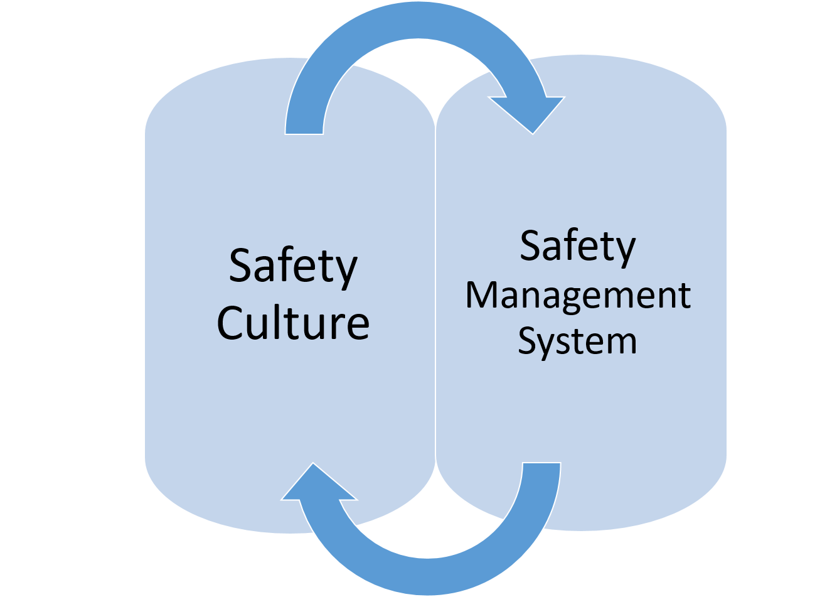

Safety management systems and safety cultures can therefore be seen as having a mutual relationship: an effective safety management system creates a positive culture and a safety culture is key to the success of a safety management system.

Program Requirements

The first step when developing a SMS is to determine if an organization requires a safety program or a policy.

Section 28 (1) of the Nova Scotia OH&S Act requires an organization to develop and maintain a safety program if:

- twenty or more employees are regularly employed by an employer other than a constructor or contractor;
- twenty or more employees are regularly employed directly by a constructor or contractor, not including employees for whose services the constructor or contractor has contracted; or
- the regulations require an occupational health and safety program

In addition, the Act also details what the requirements of the program must consist of:

- The program shall include
  - provision for the training and supervision of employees in matters necessary to their health and safety and the health and safety of other persons at the workplace;
  - provision for the preparation of written work procedures required to implement safe and healthy work practices, including those required pursuant to this Act, the regulations or by order of an officer, and identification of the types of work for which the procedures are required at the employer’s workplace;
  - provision for the establishment and continued operation of a committee required pursuant to this Act, including maintenance of records of membership, rules of procedure, access to a level of management with authority to resolve health and safety matters and any information required under this Act or the regulations to be maintained in relation to a committee;
  - provision for the selection and functions of a representative where required pursuant to this Act, including provision for access by the representative to a level of management with authority to resolve health and safety matters;
  - a hazard identification system that includes
    - evaluation of the workplace to identify potential hazards,
    - procedures and schedules for regular inspections,
    - procedures for ensuring the reporting of hazards and the accountability of persons responsible for the correction of hazards, and
    - identification of the circumstances where hazards must be reported by the employer to the committee or representative, if any, and the procedures for doing so;
  - a system for workplace occupational health and safety monitoring, prompt follow-up and control of identified hazards;
  - a system for the prompt investigation of hazardous occurrences to determine their causes and the actions needed to prevent recurrences;
  - maintenance of records and statistics, including reports of occupational health and safety inspections and occupational health and safety investigations, with provision for making them available to persons entitled to receive them pursuant to this Act; and
  - provision for monitoring the implementation and effectiveness of the program.
- The employer shall make available a copy of the program
  - to the committee or representative, if any; and
  - on request, to an employee at the workplace. 1996, c. 7,

Not every organization will require a detailed plan, some may only require a policy. Section 27 outlines the requirements for organizations that do not require a program but may need a plan:

(1) Where:
- five or more employees are regularly employed by an employer other than a constructor or contractor;
- five or more employees are regularly employed directly by a constructor or contractor, not including employees for whose services the constructor or contractor has contracted;
- the regulations require an occupational health and safety policy; or
- an officer so orders, the employer shall prepare and review, at least annually, a written occupational health and safety policy, in consultation with the committee or representative, if any.
- Where this Act or the regulations do not require there to be a committee at a workplace, consultation on the development of the policy shall be carried out by the employer and shall include discussion of the proposed policy at one or more workplace health and safety meetings involving the employees.
- The policy shall express the employer’s commitment to occupational health and safety and shall include
  - the reasons for the employer’s commitment to health and safety;
the commitment of the employer to co-operate with the employees in pursuing occupational health and safety; and the responsibilities of the employer, supervisors and other employees in fulfilling the commitment required pursuant to clause.

The SMS Development and Implementation Process

A good safety management system does not just happen. It requires effective organization, beginning with the top levels of management. In order to develop an effective safety management program, top level management should develop a logical and organized process in order to help them meet their goal. To aid organizations in meeting their goal, this guide provides a 7-step development and implementation process as show in Figure 1.
Figure 1
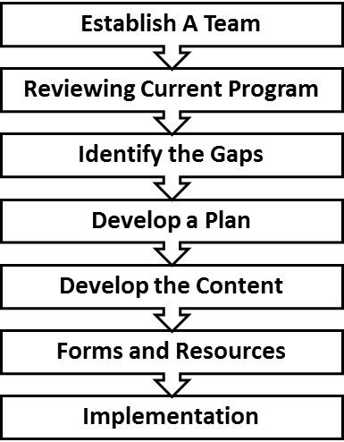
Step 1: Establish a Team

Before an organization begins to develop its SMS, management should consider building a development team. This team should consist of individuals who will be best suited for developing the plan. Individuals may include managers, supervisors, experienced or specially trained employees. Organizations may also consider using external agencies or professional consultants if they feel they need expert advice.

When the team has been finalized, team members should start to collect and familiarize themselves with the following tools:

The Safety Management Checklist – Appendix A
The Safety Management System Program Guide
The Safety Management System Template
The various Safety Management System Planning Worksheets

Step 2: Review Current Plan

This step should have the team collect and review all the organization’s current safety program materials and resources. Such information could include: all safety policies and procedures, training records, emergency procedures, workplace inspections and incident reports, etc.

The team should compare their current safety program against the SMS Checklist. The checklist provides a detailed list of the required sections and subsections as outlined in the template. The team can simply review the checklist and determine and record if they have or do not have that particular section or topic. This information will then be used in the next step.

Step 3: Identify the Gaps

At this step, the team should review the SMS Checklist and identify which sections and/or topics they currently need to develop.

Step 4: Developing and Planning

This step should see the team starting to develop a plan to address the gaps in their program as identified in Step 3. In this step, the organization should utilize the SMS Planning Worksheet.

Each worksheet corresponds to a specific element of the AWARE-NS SMS Templated program and outlines the various sub elements that the team members may wish to include in their SMS program. Next to each sub-element is a space where team members can organize and record what content they may wish to use on that particular topic. Team members can either complete the content information in the spreadsheet or they can print all (or as many) of the sheets as they wish.

Special Note: in order to enter a new line of text in the spaces provided, users will need to press ""ALT-ENTER"". This will allow the user to add multiple lines of text in one section"

The following is an example of what a planning sheet may look like:

Roles and Responsibilities | -we have to make sure we discuss the following positions - senior management, supervisors, manager, employees and JOHSC (ALT-Enter for new line)  - they have to make sure there is a program and (ALT-ENTER for new line)  - ensure all the policies are taught and implemented (ALT-Enter for new line)

Step 5: Develop the Content

This step is where the team will start to write the various element and sub-elements of their plan.

Using the SMS Planning Worksheets, the SMS Template and the organization’s current safety material and resources, the team can start to write the final version of their safety management system. Team members can either simply enter their information into the templated format or can alter the template to meet and match what topics they feel they need for their organization.

Step 6: Forms and Resources

As the team completes each element of their program, they should consider what forms and any additional resources they feel are needed as part of that element.

The SMS Template provides a number of forms and additional resource templates that organizations can alter and modify to meet their organizational requirements.

Step 7: Implementation

At this point, the team should have completed their written safety management system and should be deciding the best method for implementation.

The success of the safety management system will be making sure that policies and procedures have been effectively developed. This stage should see teams comparing what they have developed in their workplace.

Somethings that should be considered are:

- Acquiring approval from top management.

- How they will communicate the safety management system to the organization employees - this will greatly be determined on the organization’s structure but the team should coordinate with top management.

- How the implementation will be monitored and evaluated – the team will need to develop a process that allows team members to see and review the new system against the actual workplace.

The remainder of the guide will discuss each of the various elements of the SMS Templated program. It will provide a variety of suggestions and tips when an organization is developing its safety management system.

Element 1: Commitment, Leadership and Participation

The commitment of management and employees to safety is essential in developing and maintaining an effective workplace safety management system. This element should outline management’s commitment and leadership and employees’ active participation for the purpose of creating a safe working environment.

Safety Policy Statement

A safety policy is a written document that outlines management’s expectations and commitment to its occupational health and safety culture.

Under the Nova Scotia OH&S Act, a policy must contain the following three items:

- The reason for the employer’s commitment to health and safety
- The commitment of the employer to co-operate with the employees in pursuing occupational health and safety and
- The responsibilities of the employer, supervisors, and other employees in fulfilling the commitment

In addition, the safety policy should also be:

- signed each year by management
- posted on the organization’s OH&S board or an area where all staff has access for viewing
- placed in OH&S manual
- written in conjunction with JOHS Committee
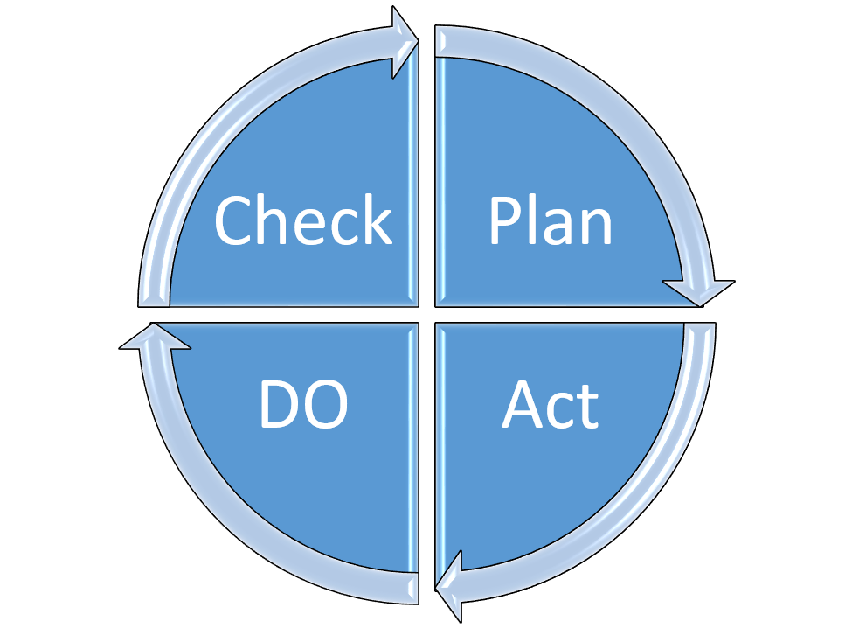
- reviewed during new employee orientations

Safety Management Cycle

SMS is built on the well-recognized management cycle of Plan, Do, Check and Act which repeats in a continuous improvement cycle.

Within the SMS, the major elements of the management cycle have sub-elements, which provide the framework for the organization of the SMS.

Roles and Responsibilities

Employees at all levels of the organization need to have a clear understanding of their roles and responsibilities as it pertains to occupational health and safety. These roles and responsibilities should be listed and communicated to each employee. This includes both the legislative and company specific rules. The SMS template provides a generic list of responsibilities for various roles within an organization. This generic list of responsibilities should be customized to reflect each of the origination’s positions.

By defining employee’s roles and responsibilities, each employee will have a better understanding of where and how they fit within the organization’s safety culture.

Occupational Health and Safety Regulations

In Nova Scotia, the legislation that governs health and safety at the workplace is the Occupational Health and Safety Act (OHS Act) 1996 c7. The Act uses an Internal Responsibility System that is based on the concept that all members of the workplace are both responsible and held accountable for the workplace safety, of themselves and all others at the workplace.

The Act places certain duties on employers, employees, self-employed persons, constructors, contractors, professionals, owners, suppliers and providers of occupational health and safety services.

A copy of the OHS Act may be found on the Nova Scotia Government website at:

http://nslegislature.ca/legc/statutes/occph_s.htm

A plain language guide to the OHS Act; your rights, responsibilities and the Occupational Health and Safety Act is also available at:

http://www.gov.ns.ca/lwd/healthandsafety/docs/YourRightsandResp-en.pdf

The Act is further defined by a set of legislations, commonly referred to as regulations.

Below, are the Regulations in Nova Scotia that need to be considered in the development of the SMS:

- Administrative Penalties Regulations
- Controlled Products Regulations
- Occupational Health and Safety First Aid Regulations
- Occupational Safety General Regulations
- Smoke-free Places Regulations
- Violence in the Workplace Regulations
- Workplace Hazardous Materials Information System (WHMIS)
- Workplace Health and Safety Regulations

Element 2: Hazard Management

The Nova Scotia Occupational Health and Safety Act requires that the employer is responsible for the identification and control of hazards. It states that:

(e) Hazard identification system that includes:

    - evaluation of the workplace to identify potential hazards,
    - procedures and schedules for regular inspections,
    - procedures for ensuring the reporting of hazards and the accountability of persons responsible for the correction of hazards, and
    - identification of the circumstances where hazards must be reported by the employer to the committee or representative, if any, and the procedures for doing so;

Hazard Identification, Risk Assessment and Control are critical to the success and effectiveness of a safety management system.

Section 2 of the SMS lays out the framework for the policies and procedures for a hazard management system.

Hazard Management Process

The Hazard Management Process is a proactive approach to identify hazards and eliminate or reduce the risk of injury and illness to workers and damage to property, equipment and the environment

R.A.C.E

The SMS template uses the R.A.C.E concept for its hazard management process. The R.A.C.E concept consist of four steps:
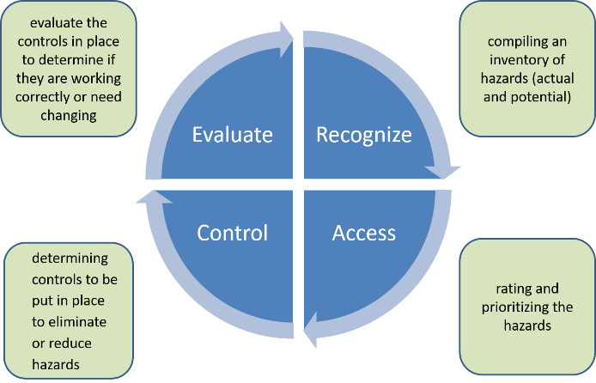

It is a continual process where employees and management are recognizing, assessing, controlling and evaluating its workplace for hazards all of the time.
Hazard Identification

Recognizing hazards is the first step in preventing illness, injury, and property damage in a workplace. Moreover, recognition means being aware of those substances present in the workplace that would put workers at risk.

Hazard Categories

Hazards are commonly categorized in 5 forms:
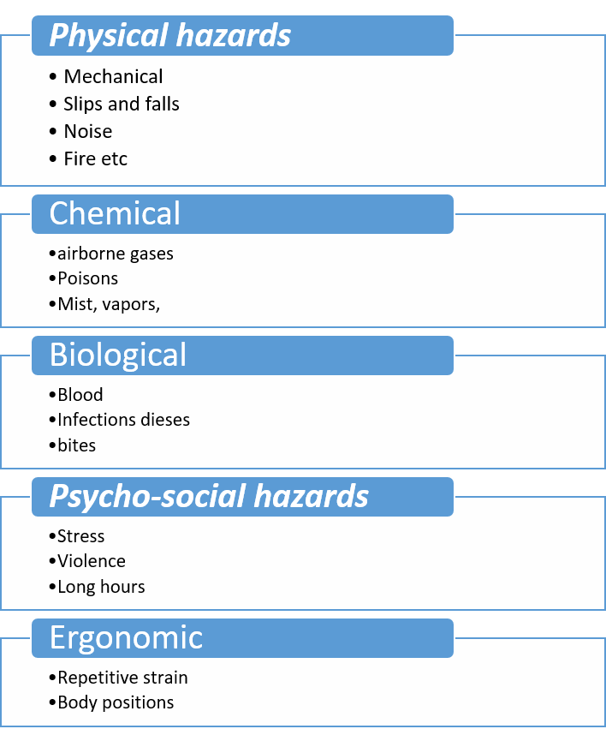

Hazards tend to have 4 contributing factors:

- Product or service produced;
- Process or tasks undertaken to produce the product or service, including any equipment, which is used;
- Place or work environment, including the physical environment (building, vehicle, outdoors, etc.) and ventilation, lighting, weather, etc. where the work is done; and
- People or employees who do the work, including their occupations and duties. Also, consider residents/clients and members of the public and the potential for acts of violence.

Workplace Inspections

Participation in workplace inspections is one of the best ways to recognize hazards. Workplace inspections consist of employees examining the workplace in an attempt to identify potential hazards. More on Workplace Inspections will be covered in Element 3 of this guide.

Reporting Hazards

Current safety law in Nova Scotia states that all employers are required to have a process in place for employees to report any hazards, to receive these reports and follow up on reporting including putting in corrective actions. In addition, the NS OHS Act requires all employers to notify and ensure employees understand the hazard reporting process used in their workplace

Assessing Hazards

Following the identification and reporting of hazards it is important to assess the level of risk for each hazard. Assigning a numerical risk factor for identified hazards allow for the organization to prioritize hazards as to develop an action plan on which hazards to combat first and what controls are required.

The Hazard Management Process works on two key topics when assessing risk – hazards and risk.

Hazards vs Risks

In general, a hazard is seen as anything that can potentially cause harm to something or someone. Risk is the chance or probability that a person will be harmed or experience adverse health effects if exposed to a hazard. Risk is the relationship between probability and severity.

Probability – is the likelihood that an incident will occur, regardless of
PPE Legislation

Section 9a of the General Safety Regulation specifies that employees must wear the protective equipment. Sections 11 through 15 deal with hazards to specific parts of the body and identify standards, which the personal protective equipment must meet.
what the outcome might be. This asks the question – how likely will the
hazard cause the expected harm?

Severity - is a way of rating the consequence or impact of a hazard, if
an incident does occur. It asks the basic question – how much harm will
the hazards create?

Risk management is therefore one of the processes that ensures
that an organization identifies and understands the risks to which it is
exposed. Risk management is a tool for an organization to create
and implement an effective plan to prevent losses or reduce the impact
if a loss occurs. It accomplishes this by determining the probability that
a hazard will cause an incident and what level of severity the hazard
will create if exposed to the hazard.

Risk Ranking Matrix

The SMS template uses a Risk Ranking Matrix to calculate and assign its risk factors. A risk matrix is an easy and effective way for organizations to calculate risk. The template outlines the requirements and the process for using the Risk Ranking Matrix.

Hazard Controls

After hazards have been prioritized based on their risk factor, the appropriate hazard controls need to be determined and implemented. Hazard controls are the layers of protection that are applied to the workplace to keep it and its employees safe. These include, policies and procedures, training, physical barriers, administrative controls and supervision.

Hierarchy of Controls

The SMS template uses a five level hierarchy of hazard control process when determining what control methods are best suited for a particular hazard. This hierarchy of controls follow the concept of the greatest level of protection first and then use lesser levels of protection, only if the higher level of protection does not work.

The five-level hierarchy of controls are as follows (in order of greatest to least):

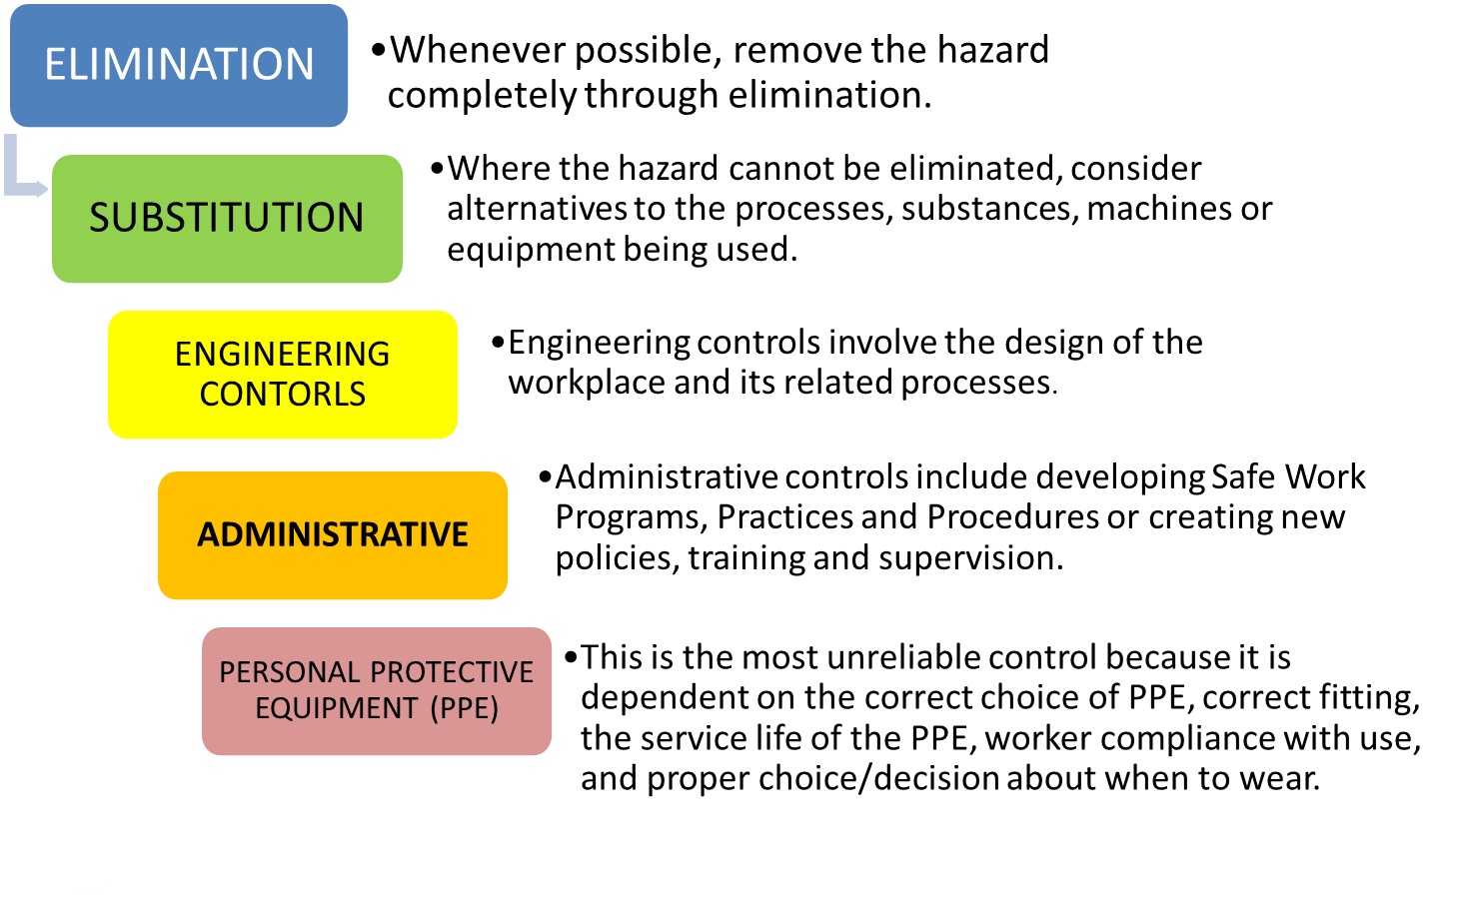
Job Safety Analysis (JSA)

A Job Safety Analysis is a safety tool that can be used to define and control hazards associated with a certain process, job, or procedure. It is a systematic examination and documentation of every task within each job to identify health and safety hazards and the current controls of each task.

The SMS provides a Hazard Control Process flow chart that can assist organizations with a job safety analysis. This chart works in conjunction with the R.A.C.E model by providing a logical step by step process for completing a hazard assessment of the workplace.

Evaluate

The final step in the Hazard Management Process is to evaluate how well the controls are working.
The methods to evaluate are:

  - Talk to the employees who report to you about the work being done and the controls that have been put in place;
  - Watch them do their work;
  - Listen to what they say and look for ways to improve their health and safety.

Element 3: Workplace Inspections

In defining the requirements for an Occupational Health and Safety Program, the Nova Scotia Occupational Health and Safety Act establishes a requirement for inspections of the workplace.
“Section 28 (2) The program shall include:
(e)(ii) procedures and schedules for regular inspections”

Element 3 of the SMS lays out the framework for the policies and procedures for workplace inspections. The following will discuss some key considerations when developing a workplace inspection program.

Roles and Responsibilities

An effective workplace inspection program needs to define who is and what they are responsible for in terms of workplace inspections. This element should also define who is responsible for making sure that the proper corrective action is taken. The SMS template supplies a generic list of roles and responsibilities but this list should be customized to meet the organization’s needs.

Organizations should also review current legislation and regulations on specific inspection needs they may require and determine if qualified personnel are needed to perform these inspections.

Training

Organizations need to provide employees who are conducting inspections the proper training on the workplace inspection programs. Organizations should review their current work practices and determine if they require employees to have specialized inspection training or if the organizations needs to have external inspections performed by qualified people.

Type of Inspections

Senior Management inspections are inspections that should be conducted by senior management personnel which may include Board Members and/or CEOs. It is imperative that senior managers frequently perform inspections of their facilities and of their employees. This allows for senior managers to reaffirm their commitment to their employees they are taking their safety seriously and not merely viewing safety through the lens of statistic and financial considerations

Departmental inspections are formal inspections required to be done by management in order to meet legislative requirements. They can consist of one or more individuals (depending on the nature of the organization) that conduct a systematic review and inspection of the complete workplace.

They should be conducted using a standardized inspection form. These types of inspections should be conducted monthly to make sure adequate hazard identification is required. Certain high risk areas or areas with regulatory requirements may need to have more frequent inspections

A copy of the report should be given to the JOHS Committee and made available to any employee when requested.
JOHS Committee inspections are formal workplace inspections that are conducted by a member or members of the JOHS Committee. JOHS Committees are not required to inspect the entire facility but normally will inspect certain areas on a less frequent basis.

These inspections should be conducted using a standardized inspection form. JOHS Committee members will determine where and how frequent they wish to conduct their inspections.

A copy of the report should be given to management to review and correct any hazards in a timely matter to the satisfaction of the committee.

Employee inspections are informal inspections performed by each employee before they begin to start a task. These forms of inspections are not normally documented, but organizations should consider making this policy. This type of inspection will help with continually evaluating and recognizing hazards

Forms

Organizations should use a standardized form when conducting an inspection. Forms allow for consistent inspections, easy record keeping and allows for analyzing of trends.

Forms need to be consistent and relevant to the area that is being inspected. They should consist of the date, time, location and the name of the inspector(s) performing the inspection. They should have a detailed checklist of what needs to be inspected as with a description of what hazards are being looked for. Forms should also have a section for additional note taking, a section for recommendations and an area for the inspector(s) to sign off on.

Forms should be located in an easy to locate area. Forms should also be evaluated annually to make sure they are still relevant.

Element 3 of the SMS Template provides a generic Workplace Inspection Form that can be modified to match an organization’s needs.

Inspection Procedures

The SMS template provides a generic list of procedures for conducting a workplace inspection. The following will summarize the four basic components of the procedure. Organizationss should modify these procedures to meet their individual needs:

- Preparing for the Inspection – some basic things to consider are who is selected to perform the inspection, where to inspect and what materials you need to take on the inspection

- Conducting the Inspection – some basic things to consider when conducting an inspection is looking at all aspects of the work area. The 4 P’s method is an effective way to assist when preforming workplace inspections:

- Product or service produced;
- Process or tasks undertaken to produce the product or service, including any equipment, which is used;
- Place or work environment, including the physical environment (building, vehicle, outdoors, etc.) and ventilation, lighting, weather, etc. where the work is done; and
- People or employees who do the work, including their occupations and duties. Also consider resident/clients and members of the public and the potential for acts of violence.

- Completing the Report – some things to consider when completing the report are who is responsible for receiving a copy of the report and where a copy should be posted.

- Follow up/Monitoring – some things to consider when doing follow up is creating a reasonable time line for completing corrections and frequency of monitoring.

Immediate Safety Concerns during the Workplace Inspection

If during an inspection a hazard (either physical or a person preforming an unsafe act) is identified, a procedure must be put in place to deal with the situation.

Equipment and Other Inspections

Organizations may have specialized equipment that requires individual inspection times and procedures. Organizations should create a written procedure for each piece of equipment with a logging system for each piece of equipment.

Element 4: Incident Management

All organizations (regardless of how well their safety culture is) will encounter some form of unplanned and unwanted incident. The Nova Scotia Occupational Health and Safety Act states:

(f) a system for the prompt investigation of hazardous occurrences to determine their causes and the actions needed to prevent recurrences;

Adequate response reporting and investigation will allow the organizations to identify the root cause of these incidents. By identifying the root causes of these incidents, organizations can develop steps to prevent future incidents from reoccurring. Element 4 of the SMS lays out the policies and procedures for the incident management program.

Roles and Responsibilities

An effective workplace incident management program needs to define who is and what they are responsible for in terms of incident management. The SMS template supplies a generic list of roles and responsibilities but this list should be customized to meet the organization’s needs.

General Incident Procedures

This section outlines a general procedure for responding of incidents. Not all incidents can be listed in this area and not all incidents are of a large emergency nature. For larger scale emergencies, employees should refer to the Emergency Preparedness section of the SMS for specific response procedures.

The SMS should make reference to the Nova Scotia OH&S Act which has legislation on the Disturbance of a Serious Incident Scene. Section 64 of the OHS Act requires that the scene of an incident (the Act uses the word “accident”) that results in a serious injury or death not be disturbed.

Incident Reporting

General Incident Reporting

Reporting of incidents are key for organizations. They allow the organization to see what types of issues are present in the workplace. Many people are reluctant to report incidents out of fear, embarrassment or retaliation. For this reason, organizations have to create a workplace culture that encourages employees to report incidents without the fear of retaliation.

Near Miss Reporting

Organizations should develop a near miss reporting program. Many employees see near miss situations as not being relevant. Near Miss reporting is a vital component of the hazard management process as it helps aid management to identify potential workplace hazards before they occur.

Reporting to External Agencies

The Nova Scotia OH&S Act legislates that certain incidents need to be reported to the Department of Labor and Advance Education. Therefore, organizations should include procedures for this.

Reporting Forms

Organizations should develop a standard incident reporting form for both General and Near Miss programs. The reports should match the organization’s needs and all employees should be trained on where these forms are located, how to fill them out and who to submit them to. The SMS template provides a generic reporting form that can be customized to the meet the organization’s needs.

Incident Investigating Procedure

After the incident is made safe and reported, organizations need to investigate incidents in an effort to determine the root cause and develop steps that will prevent reoccurrence. Investigations need to be prompt and conducted as soon as possible after the incident.

Incident investigation procedures should include:

- Selection of investigators – which people and parties need to be involved with the investigation

- Method of investigation – the method of the investigation will depend on the severity and situation of the incident. For example – some incidents can be done within the organization while other larger, more complicated investigations, may require external assistance. The method of the investigation should always focus on the goal of determining the root cause of the accident and not a method for designating blame. Organizations can use the Root Cause Analysis Reference Document of the SMS template to aid in this process.

- Documentation – this describes how the investigation will be documented. Organizations should develop standard investigating forms. The Incident Reporting Form of the SMS template can be used to aid in this process.

- Investigative process – this outlines the procedure followed when conducting the investigation. This will outline how to prepare for the investigation, the procedures for conducting interviews and reviewing and analyzing data. The Quick Reference Investigation Process document of the SMS template can be used to aid investigators when conducting investigations. Investigators can also use the Interview Tips document of the SMS template to aid them when interviewing employees.

- Monitoring and Evaluation – this outlines the organization’s procedure for how it evaluates and monitors the corrective actions taken

Post Investigative Debriefing

Organizations should debrief all individuals of the results and findings of the investigation. The Post Investigation Debriefing document of the SMS template provides organizations on how to conduct these debriefs.

Training of Incident Investigators

An important element of any investigator is the level of experience and training the designated investigator(s) have. Organizations are required to provide adequate training to the employees who will be designated as investigators. Organizations should evaluate and determine what level of training is required for their organization.

Element 5: Emergency Preparedness

An important element of every SMS is a method of handling sudden and unexpected situations to reduce possible consequences of an emergency. This may include fire, natural disaster, bomb or explosion. When these situations happen, quick and effective response is required to minimize and the loss of life and organizational assets.

Elements 5 of the SMS outlines the framework for building an effective Emergency Preparedness program.

Emergency Preparedness Plan

The types of emergencies that an organization will face depends on a variety of factors including the type of work performed, location of the organization, the local physical and weather patterns of the area and the general neighborhood environment.

Some examples of the types of emergency situations that can be encountered are: floods, fire, sever weather systems, violent acts, bombs, facility explosions and many others.

The SMS template cannot list all possible emergency situations an organization may encounter, therefore the organization’s employee and management need to collectively evaluate their own situations and develop its own emergency preparedness plans.

To develop an Emergency Preparedness Plan, organizations should follow the following steps:

- Identify as many possible emergency situations – Develop a list of potential emergency situations that could arise. This can be done by looking at hazard assessments, workplace inspections, local environment and other similar organizations and industry findings.

- List the major consequences of the emergency – Develop a list of all the potential outcomes that can be faced during the emergency. This may include casualties, damage to facilities etc.

- Determine the correct countermeasures – This may include evacuation, rescue, medical assistance etc.

- Inventory available resources – Determine what resources you need to sufficiently deal with the emergency. Then itemize the resources you have available and acquire the items you need.

- Develop necessary emergency plans – Develop the procedures for each emergency.

The following are some other considerations an organization should consider when developing an emergency response plan.

Communication – organizations should consider what types of emergency communication systems they have in place. This includes emergency numbers and what types of communication devices they will use during an emergency.

Training – employees should be provided with all the necessary training required for the variety of different emergency situations. This includes training on any required emergency equipment that is required. Certain employees may require additional or specific training depending on their role during an emergency. In addition to the initial training, organizations should conduct training drills with employees annually to make sure the procedures are still adequate and to evaluate the response time for responders.

Emergency Equipment – all emergency equipment must be maintained and in good working order when needed. All emergency equipment must be placed in the appropriate locations in order to maximize its effectiveness. All staff required to use the emergency equipment must be trained on that equipment.

Element 6: Training

Under the Nova Scotia OHS Act and Regulations, employers must have:

- provision for the training and supervision of employees in matters necessary to their health and safety and the health and safety of other persons at the workplace;

The objective of any training is to ensure the implementation of health and safety policies into specific job practices and to ensure the skill level needed to do the job safely. An effective training program is an essential part of any SMS, as effective training gives employees the necessary skills to do their job in a safe manner.

Element 6 outlines the framework for creating a training program.

Roles and Responsibilities

An effective workplace training program needs to define who is responsible and what they are responsible for in terms of training. The SMS template supplies a generic list of roles and responsibilities but this list should be customized to meet the organization’s needs.

Determining Training

Organizations need to determine what training an employee needs in order to perform their duties safely. Organizations should consider the following when determining what type of training is required:

- if a new person is hired --general safety orientation including an overview of company safety rules, and why those rules must be followed
- employee is given a new job assignment
- new work procedures have begun
- new equipment is installed
- new substances are used

To better help organizations, the SMS contains a Sample Training Matrix that can be customized and used. A training matrix is a planning and selection tool that allows an organization to categorize what types of training is required for each position. In essence, the Sample Training Matrix has the list of courses or topics needed to be completed in one column and a list of the various positions are listed on the top. Organizations can then place an “X” in the required training area. Organizations are encouraged to develop their own training matrix to match their organization’s needs.

Orientations

New Hire

Organizations need to develop and administer new hire orientation programs that cover the required knowledge the new employee needs before they start work. New employees should be given critical health and safety training on the first day of their employment before they begin their tasks. This includes:

- company policies
- responsibilities
- work place policies and procedures
- hazards and controls
- general safety rules
- how to identify and report hazards
- refuse work policy
- any emergency procedures

Employee Transfers

Many larger organizations may see permanent or temporary transfer of its personnel from one location to another. These employees may have job-specific training, but may not be familiar with the new location’s hazards and emergency procedures. Transferred employees need to be orientated to the new location, and evaluated on their current training to determine if it is adequate to meet the new location’s health and safety standards

Contractor and Visitors

Any external contractor performing work needs to have the appropriate orientation before they begin any work. The level of orientation needed will depend on the type and length of work the contractor will perform. Element 9 of the SMS provides the policies and procedures for contractors performing work. It includes a Contractor Safety Orientation Handbook that organizations can customize for training contractors. The Contractor Safety Orientation Handbook provides only the generic and basic safety information needed by contractors. Organizations will need to develop site specific training topics not covered under the handbook.

Any visitors to the organization should be provided with a basic orientation to the organization.

Job Specific Training

In addition to orientations, employees will require job specific training on how to do the various tasks they are assigned to. These type of training should reflect the procedure as outlined in the various safe work policies and procedures. Organizations need to perform and record any new training the employee is given. Organizations will need to retrain employees if and when the task changes.

OHS Training Matrix

A training matrix is a planning and recording tool that allows an organization to determine what forms of training each employee needs based on their role and position. Training Matrix is an example training matrix that organizations can customize and use. To complete the matrix, organizations simply put an ‘X” next to the required training for the particular position. The advantage to the matrix is it allows the organization to quickly determine what training is required for each position without having to search through regulations.

Selection of Trainers

In-House Training

After an organization determines what training is required, the correct trainer needs to be selected. Trainers should be selected based on competency to train the positions. Many Nova Scotia regulations require trainers to be deemed competent. Competent requires an individual to have proper training knowledge and experience which the organization will need to determine. Organizations should document the qualifications of whoever they deem to be a trainer.

External Training

Certain training requires professional certification from an external body. Organizations need to verify that these organizations are properly accredited to meet their needs.

Training Records

All organizations need to have accurate training records of its employees. By having records, organizations can make sure that their employees are trained properly and help support the organization’s due diligence to health and safety. In addition, training records help employers track recertification and refresher requirements.

Training records should contain:

- what training was taken
- the date, time and location of the training
- who provided the training
- who took the training
- how long the training is adequate for
- re-certification or refresher time frames, if applicable

Element 7: Safe Work Procedures and Practices

Safe work procedures and practices are essential to an effective SMS. Safe work procedures and practices provide employees with the necessary instructions on how to safely perform their assigned tasks. Knowing how to properly do their tasks will reduce the likelihood of workplace incidents and injuries. This element outlines how organizations create and maintain safe work procedures and practices

The Nova Scotia OH&S Act states that:

Section 28 –

b. provision for the preparation of written work procedures required to implement safe and healthy work practices, including those required pursuant to this Act, the regulations or by order of an officer, and identification of the types of work for which the procedures are required at the employer’s workplace;

Section 7 outlines the framework for developing and implementing safe work practices and procedures.

Safe Work Procedures and Practices

A Safe Work Procedure is a procedure which describes how work is to be carried out in a safe and standardized process. SWPs outline the hazards, risks and control measures to be applied to ensure the task/activity is performed to reduce the risk of injury.

Safe Work Practices are a set of guidelines to help workers with tasks that may not have a step-by-step process. It can also be seen as the "do's and don'ts" on how to perform a specific task.

Roles and Responsibilities

An effective safe work practice and procedure program needs to define who is and what they are responsible for. The SMS template supplies a generic list of roles and responsibilities but this list should be customized to meet the organization’s needs.

Developing Safe Work Procedures

A safe work procedure is often developed proactively. They may also be developed as needed, such as:

- corrective actions in an incident/hazard report, or
- risk control measure in a risk assessment. Some specific examples where this may be the case include:
  - if there was an incident in the past involving that job
  - new jobs where a risk assessment determines the need
Persons creating the safe work practices and procedures must be familiar with the process and understand hazard identification and methods of control. It is important that employees who perform the actual tasks participate in the development process. Supervisors should choose individuals they believe would best help in the development process. This may include experienced employees, industry experts, other supervisors, managers, safety specialists, trainers, engineers etc.

Steps for Creating a Safe Work Practices and Procedures:

- Consult legislative requirements and best practices
- Observe and record the sequence of basic job step
- Complete a Job Safety Analysis (JSA)
- Develop the new procedure
- Test the Procedure

Job Safety Analysis (JSA)

JSA is a safety tool that can be used to define and control hazards associated with a certain process, job, or procedure. It is a systematic examination and documentation of every task within each job to identify health and safety hazards, and the steps to control each task.

Test the Procedure

Ensure that the documented SWP is tested to ensure it is accurate and reflects the actual job steps. Observe employees following the safe work procedure and adjust the procedure as necessary. This should include discussion with the employee.

Obtain Approval

Before it can be finalized, ensure that the SWP goes through an approval process. This approval process needs to be obtained from management.

Monitor and Review

The safe work procedures should be reviewed whenever:

- the task/activity changes
- when a new hazard is identified
- after a near miss, injury or illness occurs with the task/activity
- there is a change to legislation, standards or codes of practice
- at a minimum of __ years

Accessibility and Display

Organizations need to make all policy and procedures available to all employees. All employees should be trained on each procedure they need and where to locate the procedures in case they need to refer to them.

Records Management

Safe work policies and procedures should be uniquely identified. Each document should contain the following:

- Name of the policy
- Date of Creation: the date the document was first approved
- Date of Last Update: the date the document was last approved

Element 8: Joint Occupational Health and Safety Committee

A Joint Occupational Health and Safety Committee is a group of worker and employer representatives working together to identify and solve health and safety issues at the work site. The Health and Safety Committee offers employees an opportunity to become more actively involved in creating and maintaining interest in health and safety. Equal representation from all levels of the organization should be included on the committee.

The purpose of the committee is to address health and safety concerns that cannot be dealt with in the course of daily work, and to offer recommendations for improvement to site health and safety. The committee does not have the power to make changes, but instead acts as an important communication link between the workers and management.

Legislative Requirements for JOHS Committees and OHS Representatives

Section 29 of the OHS Act establishes the requirement of a JOHS Committee in a workplace where there are 20 or more employees who are regularly employed. This is one of the principal mechanisms for ensuring that the Internal Responsibility System for OHS is functioning at the workplace, providing an opportunity for employee participation and a mechanism for assisting management with the effective implementation and ongoing review of the SMS.

Sections 30 and 31 of the OHS Act identify the composition, procedures and functions of the committee.
Section 33 of the OHS Act establishes the requirement of an OHS Representative in a workplace where no JOHS Committee is required pursuant to Section 29 and there are five or more employees who are regularly employed. This Section also defines the functions of the OHS Representative, which are generally similar to those of a JOHS Committee except for the requirement to hold meetings.

Composition of JOHS Committee

The OHS Act mandates that a JOHS Committee shall consist of a number of persons as agreed to by the employer and the employees and their union(s). At least half of the members shall be employees at the workplace who are not connected with management of the workplace. The employer may choose up to one-half of the members of the JOHS Committee.

Roles and Functions of Committee

JOHS Committees provide an opportunity for employees to participate in the development and maintenance of the SMS in keeping with the requirements of the OHS Act and the Safety Policy. The primary roles of the JOHS Committee is to provide advice and recommendations on health and safety issues within the workplace.

JOHSC is involved in the following activities:

- Identify and respond to hazards;
- Monitor the Safety Management System
- Investigation and prompt disposition of matters and complaints with respect to workplace health and safety;
- Participation in workplace inspections,
- Advising on individual protective devices, equipment and clothing that are best adapted to the needs of the employees,
- Advising the employer regarding a policy or program required and making recommendations to the employer,
- Maintaining minutes of committee meetings and records of committee activities.

Terms of References

Section 30 (7) of the OHS Act states that each JOHS Committee shall establish its own Rules of Procedure (including Terms of Reference, when the organization decides to separate Terms of Reference from Rules of Procedure). This provides the framework within which the committee functions.

The sample Terms of Reference and Rules of Procedure for a Joint Occupational Health and Safety Committee may be found at: awarens.ca/programs/safety-management-system/joint-occupational-health-safety/

Workers should be encouraged to report their health and safety concerns to the committee, and should expect a response, but cannot expect action by committee members. The committee is responsible for recommending how health and safety problems might be solved, not for carrying out the necessary changes.

Supervisors and managers are obligated to take reasonable steps to ensure the health and safety of their workers. Communication from committee members through regular meetings, and by posting meeting minutes allows everyone on-site an opportunity to bring concerns forward for consideration.

Some other key topics that need to be addressed when it comes to JOHS Committee responsibilities are:

- training – how committee members will be trained
- work refusal under the act
- incident investigation
- notifications
- written recommendations to management
- written request for information
- participation in OHS program evaluation
- annual report
- records

The SMS template provides a number of forms and resources. These forms and resources provide additional information and support when developing a SMS. These forms and resources should be modified to meet the organization’s needs. These include:

Tools
- Appendix 1: Terms of Reference for the JOHS Committee
- Appendix 2: Rules of Procedure for the JOHS Committee

Forms
- Appendix 3: JOHS Committee Agenda Template
- Appendix 4: JOHS Committee Minutes Template
- Appendix 5: JOHS Committee Recommendation Template
- Appendix 6: JOHS Committee Request for Information Template
- Appendix 7: JOHS Committee Yearly OHS Summary Report Form

Additional Resources
- JOHS Committee Effectiveness Checklist
- Tip Sheet 1 – What Should Be on JOHS Committee Agenda?
- Tip Sheet 2 – Tips to an Effective JOHS Committee and Common Mistakes
- Tip Sheet 3 – Typical Duties of a Committee
- Tip Sheet 4 – Tips for a JOHS Committee to Set Annual Safety Goals

Element 9: Contractor Safety

Most organizations will, at some point, require an independent contractor or external services to complete some sort of work at their organization. Even though these contractors are not employed directly by the organization, the organization does have a responsibility for their safety. In addition, the organization is also responsible for making sure that the contractor’s actions maintain a safe work environment for the organization’s employees as well:

Section 14 of the Nova Scotia OH&S Act states:
Precautions to be taken by contractors:

14 Every contractor shall take every precaution that is reasonable in the circumstances to ensure
- the health and safety of persons at or near a workplace;
- that the activities of the employers and self-employed persons at the workplace are coordinated;
- communication between the employers and self-employed persons at the workplace of information necessary to the health and safety of persons at the workplace;
- that the measures and procedures prescribed pursuant to this Act and the regulations are carried out at the workplace; and
- that every employee, self-employed person and employer performing work at the workplace complies with this Act and the regulations.

Section 9 of the SMS outlines the policies and procedures for contractor safety.

Roles and Responsibilities

An effective contractor safety program needs to define who is and what they are responsible for. The SMS template supplies a generic list of roles and responsibilities but this list should be customized to meet the organization’s needs.

Procedures

The SMS outlines a generic procedure for how contractors are to conduct themselves in a safe manner. This document should be customized to meet the organization’s needs.

In many instances, contract work may require certain trade qualifications and/or permits in order to be completed. Organizations should make sure they have all necessary documentation and permits from the contractor before the work is started. Some of these forms of documentation may include:

- Work permits
- WCB Clearance letter
- Liability insurance
- Trade seal qualifications
- Letter of good standing from a Safety Organization
- Contractor safety policy
- List of specific training requirements and certifications
Contractors should also not be allowed to start any work without first going through some sort of orientation program. This orientation program needs to address the necessary safety concerns the contractor needs to know and should be documented and signed off before work starts. This orientation program may include:

- Emergency procedures
- Reporting procedures
- Specific location hazards
- Communication procedures etc.

Element 9 of the SMS provides a generic orientation guide titled Contractor Safety Orientation Handbook. This orientation guide was developed as a template for organizations to modify to their needs.

Element 10: Stay-at-Work/Return-to-Work

Organizations do their best to ensure that every employee is not injured on the workplace. Unfortunately, there are times when workers become injured at the workplace. When these incidents happen, organizations need to have in place a system that assists employees to return to the workplace both in a timely manner and in full working condition.

Stay-at-Work/Return-to-Work (SAW/RTW) program helps to improve health outcomes for injured/ill employees, increases the likelihood of employee returning back to the work force on a full time basis, and reduces costs for the company. Employee involvement and cooperation is vital for the success of the SAW/RTW program.

Element 10 outlines the policy and procedures for an effective Stay-at-Work/Return-to-Work Program. The SMS template is a very thorough and comprehensive template that organizations can alter and customize as needed.

It should be noted that the following information provides a brief overview and some points of consideration when developing the program. Organizations should consider having more extensive training for employees who will be dealing with SAW/RTW.

Roles and Responsibilities

A good SAW/RTW program requires the coordination of a number of individuals and outline their roles and responsibilities. These roles may include:
- a Claims Coordinator
- supervisor and/or manager
- the employee,
- their health professional,
- The WCB Claims Manager/Adjudicator

It should be noted that not all organizations require all of the above positions, but organizations should make sure that any individuals that are used are updated on any changes to the program.

Benefits

The benefits of the Stay-at-Work/Return-to-Work program:

- It helps speed up the employees recovery process and get them back to work quickly and safely
- It greatly improves the likelihood of them returning to full job duties, full hours and full wages
- Helps them to maintain contact with co-workers and the workplace
- Demonstrates support for the employees well-being
- Reduces the likelihood of a disability (physical or mental)
- Lower associated costs
- It helps with future and current income stability (Wages, benefits, pensions are some examples).

Workers' Compensation Act

The Workers' Compensation Act (the Act) provides the legal framework for the administration of the WCB’s prevention, return to work, assessment, and compensation programs. The regulations made under the Act provide further guidance on the application of the requirements in the Act. Workers' compensation legislation is complimented by the Occupational Health and Safety Act and regulations which establish workplace health and safety standards and are administered by the Occupational Health and Safety Division of the Nova Scotia Department of Labour and Advanced Education. (1)

WCB

The Worker’s Compensation Board of Nova Scotia (WCB) is the organization that provides workplace injury insurance to those employees that are affected by workplace injuries. In addition, they not only provide assistance to injured employees, but have a number of programs and resources to assist employers when it comes to developing and implementing a SAW/RTW program. Organizations should take the time and familiarize themselves with all the services and resources they provide when developing their programs.

How does a SAW/RTW program work?

A SAW/RTW program has five main steps. The following will list and provide a brief description of each:

Step 1: Initial Incident Reporting – reporting of the incident and determining what level of care the employee requires – do they need immediate medical help (for life threating or serious injuries) or do they need physio therapy (for strains and sprains)

Step 2: Assessments – determines what the extent of the injury is and what duties the employee can perform

Step 3: Developing a SAW/RTW Program – all required individuals will come together and decide and develop a plan that best suits the employee. This will determine what (if any) transitional or modified duties the employee will perform, and if/when they start to return or stay at work

Step 4: Implementing the SAW/RTW Plan – the plan is put into practice and all required individuals will perform their required tasks. This step includes any monitoring of the plan and any changes or modifications to the plan as needed

Step 5: Return to Full Duty – this is if/when the employee is able to return to full duties.

Element 11: Communication

Communication with employees regarding all aspects of the SMS is fundamental to the Internal Responsibility System (IRS). Communication allows collaboration between management and employees to share information regarding hazards, concerns, suggestions and updates, reporting incidents, submitting work refusals and participating in inspections.

Element 11 outlines the organizations communication policy and procedures.

Workplace Hazards

In order to be able to take action regarding hazards, all employees need to understand their responsibility to report hazards and that management communicates known hazards in the workplace.

Management can communicate this information through:

- Orientation
- Safe work procedures
- Incident investigation and Root Cause Analysis
- Hazard concern report forms
- Work refusals
- Safety Huddles/email/memo/OHS board

Employees can communicate this information through:

- Reporting to their Supervisor
- Incident report forms
- Hazard concern report forms
- JOHS committee member (See Section 8: JOSHC)

Referral to the JOHS Committee

When the hazard has not been remedied to the employee’s satisfaction, the Hazard Report Form will be forwarded to the JOHS Committee. The JOHS Committee Co-Chair will determine whether the matter is urgent or can be taken to the next meeting of the committee.

Work Refusals under the OHS Act

Every employee has the right to refuse to do any act which he/she believes is likely to endanger his or her health or safety, or the health or safety of another person, but they must follow the procedure for doing so which is set out in Section 43 of the OHS Act. Employers should ensure they have trained employees on the work refusal process.

Employee Making OHS Suggestions to the Supervisor

Employees are encouraged to make suggestions regarding health and safety. These suggestions should be directed to their supervisor or manager. Organizations should communicate and ensure that employees know the process for making suggestions. Employees are encouraged to write their suggestions down so that they can be easily considered and forwarded.

OHS Bulletin Boards

The OHS Act requires that certain information be “posted” for ready access by employees. This supports the employee’s “right to know”, which is an important element of the Internal Responsibility System for maintaining OHS at the workplace. Organizations will maintain either a physical OHS Bulletin Board(s) or electronically on intranet sites.

The following information must be posted on each OHS Bulletin Board:

- The OHS Act and Regulation
- OHS Policy
- The 24 hour phone number for the Occupational Health and Safety Division of the Department of Labour and Advanced Education: 1-800-952-2687
- JOHS Committee information, including the names of the committee members, work locations and phone numbers
- The most recent JOHS Committee minutes
- Any order, compliance notice, notice of appeal or decision from the Occupational Health and Safety Division of the Department of Labour and Advanced Education
- Requests for a deviation
- Names of qualified First Aid attendants

The following information must be readily available (but does not need to be posted on the OHS Bulletin Boards):

- The fire/emergency evacuation plan for this location
- SMS Program
- SDSs for Hazardous Materials used or stored at this location
- Records of Workplace OHS Inspections
- Records of Workplace OHS monitoring or tests

Safety Huddles

One of the most important elements of an effective safety management system is conducting regular discussions on safety topics that are relevant to the work being done. The safety meeting has proven very effective in reminding employees about the importance of safety in their daily tasks. Safety Huddles are brief safety talks or meetings about a specific subject, often at the beginning of the shift. SMS standards require these discussions be held on a weekly basis. These talks can be done in a variety of ways but are typically brief (2-5 minute) interactive discussions on something safety related. Safety Huddles are used to cover a variety of short safety training subjects and to remind employees the importance of being safe. Anyone can conduct a Safety Huddle. However, it is a good idea to select individuals who have expertise on the given topic.
Element 12: Documentation

The Occupational Health and Safety Act also includes a provision for program documentation of Occupational Health and Safety Programs:

- (2) The program shall include:
….
    - maintenance of records and statistics, including reports of occupational health and safety inspections and occupational health and safety investigations, with provision for making them available to persons entitled to receive them pursuant to this Act;

Documentation is a key way in which an organization can prove it is being both legislatively compliant and taking employee safety seriously. By creating and maintaining effective documentation, employers can further communicate to their employees their commitment to their safety and well-being.

This section should outline the organizations policies and procedures for creating and controlling of documents, ensuring current documents and information are available is an essential element of a SMS. All employees should have quick and easy access to all the SMS documentation that they may require during the course of their work activities.

New and revised documents should go through a formal approval process before being included in the SMS. When any changes are made to the SMS there should be a plan in place to assure that all employees are aware of those changes.

All SMS documentation should be written in language that can be understood by all employees.

The SMS template uses the following categories when dealing with documentation:

Creating and Maintaining Records – should list and outline who is responsible, how documents are to be stored and how documents and records are to be maintained.

Records at the Department level – outlines the way each department will look after its records, who they are to be given to and what types of records they are in responsible for.

Record Retention – should outline how long the various records need to be kept.

Element 13: Monitoring

The Occupational Health and Safety Act also includes a provision for program monitoring of Occupational Health and Safety Programs:

“28 (2) The program shall include
...
- provision for monitoring the implementation and effectiveness of the program.”

Measuring performance is as much part of a safety management system as financial, production or service delivery management.

The primary purpose of measuring health and safety performance is to provide information on the progress and current status of the strategies, processes and activities used by an organization to control risks to health and safety.

The SMS template uses Key Performance Indicators (KPIs) format to assist in monitoring and evaluating its safety management system. These KPIs use the following as its criteria:

- Leading indicators - measures that determine safety performance prior to loss or potential events. These are referred to as proactive indicators.
- Lagging indicators - measures that determine performance based on loss events. These are referred to reactive indicators.

Assessing health and safety performance requires a combination of reactive and proactive measures.

The SMS template provides a recommendation of a number of KPIs that an organization may wish to monitor. They are:

- Workplace Inspections
- Workplace Incidents
- Occupational Health Monitoring

Organizations are encouraged to select and develop other KPIs they feel would best suit their organizational needs.

Key Points about KPIs

Keep the following points in mind when using KPIs:
- Quantity does not equal quality - measure the most important things, not everything
- Ensure field and line management buy-in
- Consider piloting metrics before rolling them out company-wide
- Don’t let the cost of measuring exceed the value of the results

References

The Nova Scotia Occupational Safety Act, chapter 7 of the acts of 1996

Nova Scotia Labour and Advance Education Website – Health and Safety,
https://novascotia.ca/lae/healthandsafety/legislation.asp

Workers Compensation Board of Nova Scotia Website: https://www.wcb.ns.ca/

“Safety Management System Basics” Saskatchewan Association for Safe Workplaces in Health, 2015

“Building an Effective Health and Safety Management System” Province of Alberta



Safety Management System Checklist

Item | Yes | No | Unsure | Under Review
Section 1 - Commitment Leadership and Participation
Policy Statement
Safety Management Cycle
Roles and Accountability
Nova Scotia Act and Regs
Section 2- Hazard Management
Introduction
Definitions
Roles and Responsibilities
Employees Reporting of OHS Hazards
Hazard Assessment Flow Chart
Hazard Identification
Hazard Categories
Contributing Factors
Risk Assessment
Hazard Control
Selecting Controls
Implementation
Evaluate
Monitoring Controls
Forms and Resources
Hazard Assessment Flow Chart
Hazard Control Process Flow Diagram
Risk Control Assessment Tool
Hazard Control Action Plan Tool
Section 3 - Workplace and Equipment Inspections
Introduction
Definitions
Roles and Responsibilities
Training
Departmental Inspection
JOHS Inspection
Workplace Inspection Methodology
Procedure For Workplace Inspection
Preparing for Inspections
Conducting Inspections
Completing Inspection Report
Follow-up / Monitoring
Imm. Safety Concern During Inspection
Equipment and Other inspections
Forms and Resources
Workplace Inspection Checklist
B.A.R Form
Section 4 - Incident Management
Introduction
Definitions
Responsibilities for Incident Reporting and Investigation
General Incident Procedures
Incident Response
Disturbance of Serious Incident Scene
Incident Reporting
Notice to Department of Labour
Incident Investigation Procedures
Selection of Investigators
Method of Investigation
Documentation of Investigation
Investigative Process
Monitoring and Evaluation
Post Incident Investigation
Training of Investigators
Forms and Resources
Incident Report Form
Occurrence Report
Quick Reference Investigation Process
Interview Tips
Quick Reference Root Cause Analysis
Post Investigation Debriefing
Section 5 - Emergency Preparedness
Introduction
Roles and Responsibilities
Emergency Procedures
Emergency Codes
Fire Safety and Emergency Evacuation Plans
Workplace Violence Prevention Plan
WHMIS
First Aid for Injuries and Illnesses
Training
Forms and Resources
Appendix A: NS First Aid Kit #2 Checklist
Appendix B: NS First Aid Kit #3 Checklist
Code White
Section 6 - Training
Introduction
Definitions
Roles and Responsibilities
Determination of Training
Orientations
New Hire
Employee Transfer
Contractor / Visitor
Job Specific Training
Selection of Trainers
In-House Trainers
External Trainers
Training Records
Forms and Resources
Training Matrix Sample Form
Section 7 - Safe Work Procedures and Practises
Introduction
Definitions
Responsibilities.
Developing Safe Work Procedures
Person(s) Creating Procedure
Steps for Creating Procedures
Obtain Approval
Implementation
Monitoring and Review
Accessibility and Display
Records Management
Safe Work Procedures
Safe Work Practices
Forms and Resources
Section 8 -Joint Occupational Health and Safety Committee
Introduction
Legislative Requirements for JOHS Committees and OHS Representatives
Composition of JOHS Committee
Roles of JOHS Committee
Functions of JOHS Committee
Terms of Reference
Training
Hazard Assessments
Employee Health and Safety Concerns
Work Refusals under the OHS Act
Work Refusal
Workplace Inspections
Incident Investigations
Notifications
Hazard Awareness and Elimination
Written Recommendations to Management
Written Request for Information
Participation in OHS Program Evaluation
Annual Report
Records
Forms and Resources
Appendix 1: Term of Reference
Appendix 2: Rules of Procedure
Appendix 3: JOHS Committee Agenda
Appendix 4: JOHS Committee Minutes
Appendix 5: JOHS Committee Recommendation
Appendix 6: Request for Information
Appendix 7: JOHS Committee Yearly OHS Summary Report
Section 9 - Contractor Safety
Introduction
Roles and Responsibilities
Procedure
Before Work Begins
During Work
Completion of Work
Forms and Resources
Contractor Safety – Orientation Handbook
Section 10 - Stay-at-Work / Return-to-Work
Introduction
Definitions
Responsibilities
Legal Obligations
SAW / RTW Process
Measuring and Reporting
Forms and Resources
Section 11 - Communication
Introduction
Definitions
Roles and Responsibilities
Awareness of the Safety Management System
Communicating Workplace Hazards
Communicating Workplace Incidents
Employee Reporting OHS Hazards
Report to the Supervisor Or Manager
Referral to the JOHS Committee
Work Refusals under the OHS Act
Employee Making OHS Suggestions to the Supervisor
OHS Bulletin Board(s) and Other Information
Safety Huddles
Forms and Resources
Safety Huddle Template
Section 12 - Documentation
Introduction
Definitions
Roles and Responsibilities
Creating and Maintaining of Documents and Records
Creation of Documents and Records
Maintaining of Records
Records at the Department Level
Records Retention
Forms and Resources
Section 13 - Monitoring
Introduction
Definitions
Roles and Responsibilities
Key Performance Indicators
Forms of Monitoring Information
Workplace Incidents
Workplace Inspections
Occupational Health Monitoring
Reports and Statistics
JOHS Committee OHS Summary Report
Forms and Resources
JOHS Committee Yearly OHS Summary Report Form

