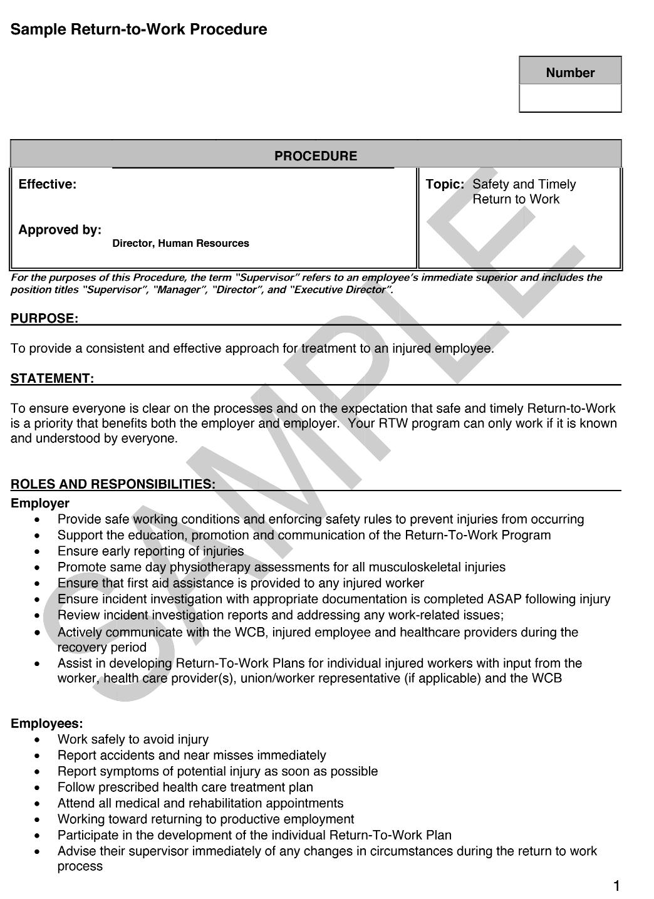
Appendix 10.5, Sample Return-to-Work Procedure

