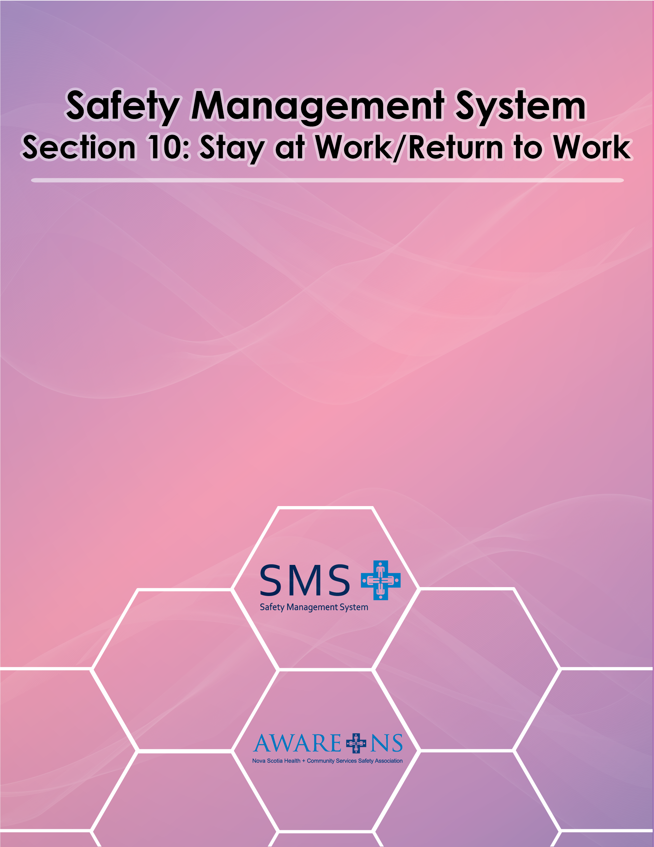

Table of Contents
Objective ……………………………………………………………………………………………………….……….……………………………………………………3
Application……………………………………………………………………………………………………………….......................................................3
Scope: Stay-at-Work/Return-to-Work (SAW/RTW) - 8 Program Elements………………….....................................................3
- Element 1: Policy Statement
- Element 2: Appointment of an Internal SAW/RTW Program Coordinator
- Element 3: Roles and Responsibilities
- Element 4: Documentation of Job Demands for All Permanent Job Classifications
- Element 5: Identification and Documentation of Available, Meaningful Job Tasks that can be Utilized as Transitional Duties for SAW/RTW Planning
- Element 6: Stay-at-Work/Return-to-Work Process
- Element 7: Communication and Training
- Element 8: Measurement and Reporting of Results

Element 1: Policy Statement……………………………………………………………………………………………………………………………………….4
Element 2: Appointment of an Internal SAW/RTW Program Coordinator…………………………………………………..……………….4
Element 3: Roles and Responsibilities………………………………………………………………………………………………………………………….5
Senior Management………………………………………………………………………………………………………………………………………..5
Internal SAW/RTW Program Coordinator Coordinator………..…………………………………………………………………………..5
Managers………………………………………………………………………….……............................................................................5
Supervisor………………………………………………………………………………………...…………………………………………………………….6
Human Resources Department……………………………………………...............................................................................7
Injured/Ill Employee………………………………………………………………………………………………………………………………………..7
Union Worker Representative…………………………………………………………………………………………………………………………7
Legal Obligations………………………………………………………………………………………………………………………………………………………….8
Obligation to Re-employ…………………………………………………………………………………………………………………………………8
Duty to Accommodate……………………………………………………………………………………………………………………………………8
Obligation Not to Discriminate……………………………………………………………………………………………………………………….8
Establish a Direct Access Relationship with a Physiotherapy Clinic(s)………………………………………………………………………....9
Element 4: Documentation of Job Demands for All Permanent Job Classifications………..……………………………..…………….9
Element 5: Identification and Documentation of Available, Meaningful Job Task That Can be Utilized as Transitional
Duties for SAW/RTW Planning…………………………….………………………………………………………………………………………...10
Document Transitional Duties and Provide to Internal SAW/RTW Program Coordinator……………………………….10
Element 6: Stay-at-Work/Return-to-Work Process…………………………………………………………………………………………….……….12
Step 1: Initial Incident Reporting…………………………………………………………………………………………………………………………………12
Work Related Employee Reports Injury/Illness Incident………………………………………………………………………….…….12
Step 2: Assessments……………………………………………………………………………………………………………………………………………………13
Functional Job Analysis …………………………………………………………………………………………………………………………………13
Step 3: Developing a SAW/RTW Plan……………………………..…………………………………………..………………………………………………13
Selection of Transitional Duties for SAW/RTW Plan……..……..………………………………….………………………………..…..13
Pre-injury/Illness Position……………….……………………………………………………………………………………………………………..14
Step 4: Implement SAW/RTW Plan…………………………………………………………………………………………………………..…………………15
Implementing and Communicating a SAW/RTW Plan…..……………………………………………………………………………….15
Employee Fails to Agree to/Sign the SAW/RTW Plan…………..………………………………………………………………………..15
Monitor the SAW/RTW Plan……………..…………………………………………………………………………………………………………..16
Revising the SAW/RTW Plan…………………….……………………………………………………………………………………………………17
Employee is not Fulfilling Requirements of SAW/RTW Plan………....………………………………………………………………17
Step 5: Return to Full Duty…………………………………………………………………………………………………………………………………………17
SAW/RTW Program Training………..……………………………………………………………………………………………………………….17
Outline SAW/RTW Program Training………………………..…………………………………………………………………………………..18
Element 7: Communication and Training……………………………………..……………………………………………………………………………18
Element 8: Measurement and Reporting of Results……………………..……………………………………………………………………………19
Stay-at-Work/Return-to-Work Measures…………..………………………………………………………………………………………….19
Reporting of Results………………………………………………………………..…………………………………………………………………….20
Objective

[Organization Name] is committed to the health and well-being of our employees. We recognize the importance of ensuring that employees are supported through a health-related absence due to illness or injury by:
- Addressing the potential impact of loss of income;
- Recognizing the importance of maintaining normal relationships and routines as much as possible to assist in full recovery;
- Obtaining clarification of any aspects of the illness or injury that may affect the ability to perform all or part of the job duties; and
- Restore the employee to their fullest physical, psychological, social, vocational and economic level possible and, where possible, provide the worker with transitional duties at [Organization Name].

[Organization Name]’s Stay-at-Work/Return-to-Work (SAW/RTW) program helps to improve health outcomes for injured/ill employees, increases the likelihood of an employee returning back to the work force, and reduces costs for the company. Employee involvement and cooperation is vital for the success of the SAW/RTW program. [Organization Name] will make every effort to provide the employee with transitional duties when they are unable to do the essential duties of their pre-injury/illness job.

- Stay at Work planning is directed at those individuals who have sustained a minor injury/illness and do not need to lose time from work, but may benefit from temporary transitional work modifications.
- Return to Work planning is directed at those individuals who have lost time from work due to an injury/illness and need to be re-introduced back into the workplace.

Application
All employees of [Organization Name] are required to participate in the SAW/RTW program.

Scope: Stay-at-Work /Return-to-Work Program Elements

This SAW/RTW program consists of eight elements. These are:
- A Stay-at-Work/Return-to-Work Policy
- Appointment of an Internal SAW/RTW Program Coordinator
- Defined roles and responsibilities
- Documentation of the current physical and mental demands of all of our permanent job classifications at [Organization Name]
- Identification and documentation of available, meaningful job tasks that can be utilized as transitional duties for SAW/RTW planning
- A documented Stay-at-Work/Return-to-Work process
- Communication and training for managers, supervisors and all front-line employees
- Measurement and reporting of results

This SAW/RTW program was developed in consultation with the members of [Organization Name]’s Joint Occupational Health and Safety Committee.

Element 1: Policy Statement

[Organization Name] will make every effort to provide a SAW/RTW program to help employees return to meaningful, productive employment following an injury/illness. The SAW/RTW program provides opportunities for any employee of [Organization Name], who was injured or became ill either on or off work, to remain at work or return to work at a functional capacity, and defines the process and methods for reintegrating the employee back into their regular position and workplace. [Organization Name] will make a reasonable effort to provide the injured or ill employee with transitional duties that is consistent with a health care provider’s recommendation. Early intervention and regular communication are major components of this process.

[Organization Name] will proactively work with the employee and their health provider to assist in the SAW/RTW plan. The employee is also expected to work with the employer or employer’s representatives to facilitate this process. Management and employees of [Organization Name] are expected to support and fully comply with this policy and the accompanying procedures.

Injured or ill employees participating in the SAW/RTW program are expected to provide feedback in order to improve the program’s future developments. All employees are required to participate in [Organization Name]’s SAW/RTW program.

Signed by: _________________________________________ Date: _____________________
(President/CEO/Administrator/ Executive Director)

Element 2: Appointment of an Internal SAW/RTW Program Coordinator

[Organization Name] will ensure that an employee from the Human Resources Department or designate is given the role and responsibilities of an Internal SAW/RTW Program Coordinator. The Internal SAW/RTW Program Coordinator will be provided with appropriate information and training in matters related to this SAW/RTW program, Workers’ Compensation of Nova Scotia, Short- and Long-Term Disability, etc.

Element 3: Roles and Responsibilities

To be effective and to serve the interests of both [Organization Name] and our employees, the SAW/RTW program requires the full involvement, commitment and support of all employees at all levels. The key responsibilities of [Organization Name] employees are outlined below:

Senior Management
Senior management at [Organization Name] has a vital role to play in our SAW/RTW program. There are significant links between the level of senior management commitment and the overall success of the SAW/RTW program.

- Annually review the SAW/RTW policy and program to ensure that it is meeting its stated goals and objectives, including the costs and cost benefits.
- Ensure managers understand their roles with respect to the SAW/RTW program and are held accountable for fulfilling these responsibilities.
- Ensure that all organizational departments work to identify and/or create transitional duties that can be utilized in the SAW/RTW program.
- Assist the Internal SAW/RTW Program Coordinator and managers to identify possible accommodations for complex cases.

Internal SAW/RTW Program Coordinator:
The Internal SAW/RTW Program Coordinator will be responsible for:
- Management, tracking and reporting performance of the SAW/RTW program (see Appendix 10.2, Return-to-Work Check List and Tracking Form).
- Establishing and maintaining Direct Access Relationships (DAR) with approved Physiotherapy clinics. Communicating with these clinics and ensuring they are meeting defined performance expectations.
- Ensuring all [Organization Name] employees are informed about and trained on the SAW/RTW program.
- Liaising with supervisors and managers to help identify suitable transitional or alternative duties to enable the implementation of effective SAW/RTW plans for injured or ill employees.
- Ensuring that supervisors establish and maintain contact with employees who are off work due to injury/illness and that this contact is documented.
- Communicating with employees, and where appropriate their health care providers, to determine readiness to participate in a SAW/RTW program and to develop a SAW/RTW plan.
- Maintaining contact with employees on a SAW/RTW plan to ensure that it is being followed and is appropriate.
- Maintaining contact with the WCB and providing them with required information, attending case conferences as required, etc.
- Arranging for Physical Demand Descriptions to be created for jobs/tasks, where required, providing these to the employee’s health care professional(s) and the WCB.
- Ensuring that all documentation required by the WCB and/or insurance carriers is complete and submitted on time.

Managers
Managers play an important role in the SAW/RTW program. They need to ensure that the supervisors/designate working under them are aware of and fulfill their roles under the SAW/RTW program.

- Will support supervisors, employees and Internal SAW/RTW Program Coordinators in the development of a SAW/RTW plan for the ill or injured worker.
- Ensuring supervisors understand their roles with respect to the SAW/RTW program and are held accountable for fulfilling these responsibilities.
- Ensuring that all work areas within the department identify and/or create transitional duties that can be utilized in the SAW/RTW program.
- Maintaining regular contact with the employee to provide support for the employee return to work as soon as it is reasonably possible.

Supervisor

The supervisor has two primary responsibilities related to SAW/RTW:
- Maintaining regular contact with injured/ill employees, if they are off work and while they are participating in a SAW/RTW plan, as well as addressing issues and answering questions as they arise.
- To support the goals of the SAW/RTW program by helping to identify and/or create suitable transitional duties and by helping to ensure the success of employees who are performing these duties as part of their SAW/RTW plan.

Other SAW/RTW responsibilities of the supervisor include:
- Participating in SAW/RTW planning meetings with:
    - the Internal SAW/RTW Program Coordinator;
    - the employee, as required;
    - their health care professional;
    - WCB claims person.
- Providing an injured/ill employee with all necessary information and forms.
- To communicate to the employee all roles and responsibilities as they relate to the SAW/RTW program.
- Where possible, facilitating access to treatment (i.e. making an appointment with one of the approved physiotherapy clinics when an employee reports a non-complicated soft tissue injury).
- Requesting complete, up-to-date abilities report to support the need for the accommodation.
- Respecting the employee’s right to confidentiality.
- Advising the Internal SAW/RTW Program Coordinator when an employee reports an injury or illness.
- For non-work-related injuries/illnesses, making contact the employee as soon as possible after being notified.
- Regularly monitor the success of each employee’s SAW/RTW plan.
- Identifying and overcoming possible barriers that could hinder the success of the SAW/RTW program.
- Keeping the responsible parties informed of any issues, concerns, or barriers that arise when an employee is participating in a SAW/RTW plan. Responsible parties include:
  - the Internal SAW/RTW Program Coordinator
  - the employee
  - health care professional
  - WCB claims person
- When an injured/ill employee returns to full duties, ensure that all the appropriate changes have been made and all issues/concerns are addressed.

Human Resources Department
- Ensures managers are informed of the accommodation policy.
- Provides education and guidance to the manager throughout the accommodation process to ensure that all legislative requirements have been met.
- Liaises with union representatives, as appropriate, regarding specific accommodation requests.

Injured/Ill Employees
It is important that employees understand what their roles and responsibilities are under the SAW/RTW program.
These roles and responsibilities include:
- Reporting all work-related injuries and illnesses to their supervisor as soon as possible.
- Advising their supervisor, as soon as possible, of any non-work-related injury or illness that may keep them away from work for more than _ days.
- Participating in the investigation of the causes of work-related injury/illness.
- Ensuring that the supervisor and Internal SAW/RTW Program Coordinator have their up to date contact information.

- Responding to questions from their supervisor and/or the Internal SAW/RTW Program Coordinator as soon as possible.
- Providing information related to the causes of the injury/illness and about their ability to return.
- Attending appointments for treatment, assessment, or tests that are required by their health care providers, the WCB, and/or [Organization Name].
- Providing all required medical, treatment, and abilities documentation to the Internal SAW/RTW Program Coordinator as soon as possible after it is received.
- Cooperating with their supervisor, Internal SAW/RTW Program Coordinator, health care professional(s), and, if applicable, the WCB case person in the creation of a SAW/RTW plan.
- Actively participate in the identification of suitable transitional duties that are consistent with their current functional abilities.
- Participating in an agreed SAW/RTW plan, ensuring performance of tasks that do not exceed their current capabilities.
- Reporting any issues or concerns with the SAW/RTW plan to their supervisor as soon as possible.
- Following OH&S guidelines and other workplace safety practices to prevent illness or injury at work.

Union Worker Representative (where applicable)
Union worker representatives can help to ensure the success of the SAW/RTW program by:
- Participating in the planning and development of the SAW/RTW program.
- Assisting in the education of workers on the value of SAW/RTW planning.
- Liaises with the employer those provisions within the collective agreement that facilitate the return to work of injured/ill employees/members.

Legal Obligations

Obligation to Re-employ
As [Organization Name] is an organization with 20 or more employees, we are required under the re-employment provisions found in Sections 89 to 101 of the Nova Scotia Workers’ Compensation Act, to re-employ a worker after a work injury/illness. Our legal obligation is to employees who have at least 12 months of continuous employment prior to a work injury/illness. This responsibility extends to 2 years following the work injury/illness.

Duty to Accommodate
There are several types of accommodations that can be considered based on the nature of the request and can include things such as changes to the employee’s work, tasks, work environment or schedule. Some accommodations may include a financial cost while others are administrative and have no direct costs. Modifications to the employee’s current position and or work environment are the preferred first steps in meeting the needs of the employee to fully participate in the work environment. Some examples of this type of accommodation are the following:
- Job restructuring: the order or manner in which the essential functions of the job are completed, altered or changed, without reducing or eliminating these essential functions.
- Task simplification: taking a complex task and reducing it to its most basic elements so that the employee can easily complete the task.
- Assistive work aides: there may be simple, but useful work aides that would make the work easier (i.e. improved lighting, use of a step ladder, cart).

The duty to accommodate in the workplace is generally regarded as a requirement by employers to take reasonable measures to enable an employee’s SAW/RTW without “undue hardship” on a case-by-case basis. The following factors will be considered in assessing the reasonableness of the accommodation:
- Financial costs to the organization
- Health and safety risks for the employees
- Impact on co-worker’s morale
- Size of the employer
- Disruption of workforce
- Business efficiency
Where modifications to an employee’s work or work environment are not appropriate and/or successful, the next step is to complete a scan of vacant jobs within [Organization Name] that matches the employee’s job qualifications and the functional job demands.

Obligation Not to Discriminate
In keeping with Section 5(1) of the Nova Scotia Human Rights Act, [Organization Name] and its employees shall not discriminate against any injured/ill employee. Section 5 (1) of the Act states in part that “No person in respect of (d) employment shall discriminate against an individual or class of individuals on account of (o) physical disability or mental disability”.

Establish a Direct Access Relationship with a Physiotherapy Clinic(s)
[Organization Name] will establish a Direct Access Relationship (DAR) with one or more Physiotherapy and/or Chiropractic clinics that are approved by the Workers’ Compensation Board of Nova Scotia. Our DAR will help to ensure that employees who experience uncomplicated sprain/strain injuries have expedited access to functional scans, assessments and treatment services. This is beneficial to both the employee and [Organization Name], as it helps to facilitate early, safe and effective SAW/RTW planning.

The Internal SAW/RTW Program Coordinator will be responsible for establishing and maintaining these relationships, and for communicating with the clinics regarding the abilities of employees who have experienced uncomplicated sprain/strain injuries. The Internal SAW/RTW Program Coordinator will also ensure that:
- Performance measures/results for each Physiotherapy/Chiropractic clinic which [Organization Name] has a DAR are reported to senior management.
- All employees, at all levels, are fully aware of the goals of the SAW/RTW policy and the role that our DAR play.
- Information about our DAR is provided to all employees. Supervisors are informed of how employees with uncomplicated sprain/strain injuries should be referred to these clinics.

[Organization Name] will request that all employees with work-related, uncomplicated sprain/strain injuries, see a physiotherapist or chiropractor at a clinic with whom [Organization Name] has a DAR. While it is expected that all employees with work-related, uncomplicated sprain/strain injuries will see a physiotherapist or chiropractor as soon as possible after experiencing their injury, [Organization Name] recognizes that employees may choose to see a physiotherapist or chiropractor at any clinic that has been approved by the WCB of Nova Scotia. In addition, [Organization Name] recognizes that employees with work-related, uncomplicated sprain/strain injuries have every right to see their family doctor. However, even if employees haven’t seen their family doctor, they are still required to see a physiotherapist or chiropractor at an approved clinic when requested by [Organization Name] or the WCB of Nova Scotia.

Element 4: Documentation of Job Demands for All Permanent Job Classifications
The Internal SAW/RTW Program Coordinator will work with the HR department to ensure that all up-to-date descriptions of physical demands are available for all permanent jobs at [Organization Name]. These descriptions will detail the physical demands required of all tasks normally performed by employees assigned to the specific job. Also, job tasks and/or activities are considered to be essential duties and will be clearly identified.

The physical demand descriptions for all permanent jobs at [Organization Name] will be created by individuals who have specialized training and knowledge regarding how to document and measure the physical demands related to work tasks.

Element 5: Identification and Documentation of Available, Meaningful Job Tasks that can be Utilized as Transitional Duties for SAW/RTW Planning

As noted above, one of the responsibilities of supervisors is to identify jobs and job tasks that can be utilized as transitional duties and incorporated into SAW/RTW plans. This is a vital and necessary step if [Organization Name]’s SAW/RTW program is to be successful. Supervisors have been given the primary responsibility for identifying transitional duties because they will, ideally, have a complete and detailed understanding of the jobs and tasks that are performed, in their work areas.

Document Transitional Duties and Provide to Internal SAW/RTW Program Coordinator
Once the supervisor has identified transitional duties that are available within their work area, these duties should be documented and the details regarding the transitional duties should be provided to the Internal SAW/RTW Program Coordinator. A copy of the information about the transitional duties should also be kept in the department /work area to be available if and when they are needed.

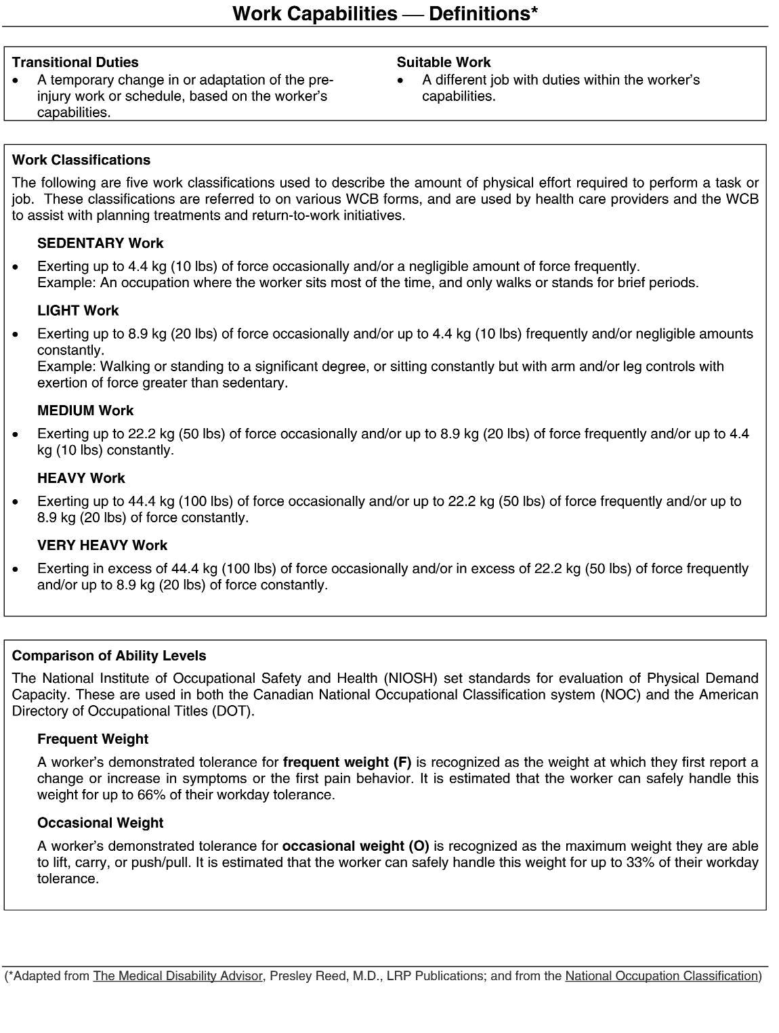

Element 6: Stay-at-Work/Return-to-Work Process

There are five steps to the SAW/RTW process, whether the employee became injured or ill at work, or not. The process is detailed over the following pages:

- Step 1: Initial Incident Reporting
- Step 2: Assessments
- Step 3: Developing a SAW/RTW Plan
- Step 4: Implementing SAW/RTW Plan
- Step 5: Return to Full Duty

Step 1: Initial Incident Reporting

Work Related: Employee Reports Injury/Illness Incident

Employee
- Employee should seek first aid treatment, if required; and
- As soon as safely possible report this to his or her immediate supervisor. (In-person, via telephone/voice mail or email.)
Supervisor
- Will ensure that first aid treatment has been provided and/or arrange for the employee’s transportation to a hospital if emergency medical aid is needed.

Documentation of the Incident
As soon as possible following the incident, the employee completes [Organization Name]’s Incident report form. In cooperation with the employee, the supervisor will complete the WCB of Nova Scotia’s Injury Report Form (within 5 days), conducting, if necessary, an investigation to complete the forms.
- If the injury requires first aid attention and no time is lost from work, a WCB Injury Report does not need to be filed with WCB, but it is important that an event report be entered.
- If the injury or illness is a recurrence of a previous injury, this should be noted on the WCB form.
- A note should be made on the WCB Injury Report indicating that transitional duties will be made available, if required.
- Both completed forms should be copied, with one copy being kept by the supervisor, and one forwarded to the Internal SAW/RTW Program Coordinator.
- The completed WCB Injury Report Form should then be sent to the WCB, either by fax or by submitting it online via the WCB’s My Account system.
- The supervisor should also verbally notify both his/her manager and the Internal SAW/RTW Program Coordinator of the employee’s injury or illness

Step 2: Assessments
Upon receipt of a Physical Abilities Report, Functional Scan or any other medical documentation, the manager or supervisor will review the information to determine one of the following three options:

- Employee returns to regular duties: the employee is returned to their pre-injury/illness duties/hours.
- Transitional duties: if transitional duties/work modifications are indicated on the assessment, the manager/supervisor, employee and Health Care Professional will work together to develop a temporary transitional SAW plan. This SAW plan will be designed to provide transitional duties, so the employee can return to work for their next scheduled shift.
- When the employee is not capable of returning to work and time loss is indicated from the assessment received, the manager and employee, in consultation with the employee’s health care professional and WCB claims person, will determine the earliest date possible for the employee to participate in a RTW Program.

Once a date is determined, the manager/supervisor, employee, WCB claims person and health care professional will develop a RTW plan based on the recommendations of the health care professional.

The manager/supervisor ensures that all received claim and medical documentation is forwarded to the Manager of Organizational Health or delegate.

Functional Job Analysis
The Internal SAW/RTW Program Coordinator will determine if an up-to-date functional job analysis for the employee’s pre-injury/illness job exists. If not, the Internal SAW/RTW Program Coordinator will arrange to have a functional job analysis completed for the employee’s job as soon as possible.

Step 3: Developing a SAW/RTW Plan (see Appendix 10.4, Stay-at-work/Return-to-work Plan)
If there are no restrictions or limits to the employee’s functional abilities indicated by a health care professional, the employee will return to their pre-injury/illness duties/hours. If the employee is unable to perform all of his/her pre-injury/illness job tasks, the Internal SAW/RTW Program Coordinator will identify options for transitional duties that are available for the employee, (i.e., accommodations when performing regular job tasks, alternative job tasks, etc.).
This plan is as an essential guide and will be designed to include temporary transitional duties or work modifications, if appropriate, such as:
- Returning to the pre-injury/illness job with temporary transitional/modified duties.
- Returning to the pre-injury/illness job with temporary modified hours.
- Working in a comparable job somewhere else within the [Organization Name] until they are able to return to their pre-injury/illness job.

SAW / RTW Program – Selection of Transitional Duties (Appendix 10.1) will assist in determining appropriate job duties/transitional duties for the employee’s SAW/RTW plan. In all instances, the position offered to the employee must be consistent with his or her physical capabilities, bona-fide work that is meaningful and necessary, and established in consultation with the Internal SAW/RTW Program Coordinator, the employee and his/her supervisor.

The details of the plan should include:
- Functional abilities (what the employee can do)
- Restrictions/limitations (what the employee cannot do)
- Duties the employee will perform
- Any modifications to the employee’s work schedule
- Plan start date, review date(s) and projected plan end date
The RTW /SAW plan should be designed with the intention of returning the employee to full duties at the earliest possible/appropriate time.

This return to full duty indicates that the employee is capable of performing all essential and non-essential functions of their pre-injury/illness position.

Pre-injury/Illness Position
If an employee is not able to perform all of his/her pre-injury/illness job duties, the goal should be to accommodate the employee to perform the essential job functions of the position with modifications to the work schedule, work methods, and/or output. Any modifications/accommodations should be made with the goal of gradually increasing the job demands for the employee until he/she is able to perform all required job duties, at pre-injury/illness levels.

The modification to the employee’s schedule could include fewer days per week, fewer hours per day, or both. Examples of a modified schedule include the following:

- Increase frequency and length of breaks;

- Performing pre-injury duties for half-days, working towards full days;
- Change of shift;
- Different start/end times;
- Varying the hours of work;
- Job rotation;

- Tele-work/work from home;

- Allowing time away for medical appointments/therapy.

The modification to the employee’s assigned duties could include using mechanical devices to assist performance and/or having other employees within the department assist with job duties. In some cases, these modifications will be permanent.

Examples of modified duties include the following:

- Not performing duties requiring a specific action for a specified period of time (i.e. climbing ladders; eliminating activities that require lifting items over a specific weight or height);
- Providing assistance to the employee for specific tasks;

- Modifications/additions to the work area/work station (provision of sit/stand stool, raise/lower work surface);
- Provide assistive devices (manual handling devices, specific software to enable completion of tasks, wireless headset);
- Supply additional personal protective equipment, dependent upon the injury (over and above what is required by regulation or corporate policy).

The employee’s assigned duties may also be modified by having them perform some of their pre-injury/illness job duties, as well as some job duties that may or may not be part of another job. These additional duties will only be assigned to the employee if he/she is both trained and physically capable of performing them.

Step 4: Implement the SAW/RTW Plan

Implementing and Communicating a SAW/RTW Plan
The Internal SAW/RTW Program Coordinator, manager/supervisor and employee will review the SAW/RTW plan and the manager/supervisor answers any questions regarding the implementation, monitoring and completion of the plan.

- If the employee accepts and signs off on the plan, they are expected to perform all tasks identified and ensure they comply with any restrictions and adhere to the identified in the plan.
- The employee will continue any treatment deemed necessary by the health care professional throughout the duration of the plan.
- Any concerns the employee has regarding their physical abilities not being a match for the proposed plan, needs to be supported with evidence.
- The employee is advised that the consequences of his/her decision not to co-operate/participate in the SAW/RTW program can be a suspension of WCB benefits and WCB will be notified.
- Once the plan is finalized and a start date is determined, the supervisor submits a copy of the SAW/RTW plan to the employee’s health care provider and the WCB claims person.
- Pertinent details of the employee’s SAW/RTW plan will be communicated to affected team members.

Employee Fails to Agree to/Sign the SAW/RTW Plan

If the employee does not agree to participate in the proposed SAW/RTW plan, the Internal SAW/RTW Program Coordinator should:
- Verify that the employee’s documented, current physical abilities are a match for the duties outlined in the plan,
- meet with the employee to review specific concerns they have with the SAW/RTW plan.
- If the employee is unable to support these concerns with evidence (i.e. new medical information, identify specific task demands that exceed current capabilities, etc.) then the Internal SAW/RTW Program Coordinator should review the employee’s responsibilities under [Organization Name]’s SAW/RTW program and under the Nova Scotia WCB Act.
- The Internal SAW/RTW Program Coordinator should also indicate the consequences of not participating in the SAW/RTW program may include:
- Suspension of WCB benefits and closure of his/her claim file.

- Termination of employment with [Organization Name] with a report being filed with the WCB regarding the employee’s lack of cooperation and participation in [Organization Name]’s SAW/RTW program.

Monitor the SAW/RTW Plan
Once the plan is implemented, the supervisor and Internal SAW/RTW Program Coordinator should both ensure that the employee is performing in accordance with the plan and any specified limitations. The supervisor should be in frequent contact with the employee. The employee has a responsibility to:
• Abide by the plan;
• Not perform work outside of the plan;
• Notify their supervisor if they are experiencing any difficulties with fulfilling the plan.

The supervisor assumes responsibility for the practical application of the plan, which involves:
- daily monitoring of the employee’s attendance and performance during the transitional period
- reporting the employee’s performance to the Internal SAW/RTW Program Coordinator at least weekly.
- make frequent contact with the employee during the work day/shift to ensure that the employee is abiding by the agreed specified limitations and not experiencing any difficulties (physical, psychosocial, etc.).
- identify the causes of any difficulties/concerns and eliminate them, if possible.
- notify the Internal SAW/RTW Program Coordinator of any concerns they have regarding the employee’s performance, participation in, or compliance with the SAW/RTW plan.

At all times the supervisor should remember that the goal of the SAW/RTW program is to support the employee so that they are able to return to their full pre-injury/illness duties as soon as possible. The supervisor should ensure that communication with the employee is supportive and encouraging, letting the employee know that they are valued members of [Organization Name]’s team.

The Internal SAW/RTW Program Coordinator should:
- contact the employee on a regular basis, at least once weekly, to ensure/verify that the SAW/RTW plan is being complied with, that it is being effective and to address any concerns the employee may have.
- Ask for and document the employee’s own views on their readiness to return to their full pre-injury/illness duties.
- ensure that they receive regular updates from the health care provider regarding the employee’s physical abilities and to address any concerns that may arise with the SAW/RTW plan.

Revising the SAW/RTW Plan
The SAW/RTW plan may have to be revised based on either [Organization Name]’s operational constraints or changes to the employee’s ability and/or medical situation. It is expected that the SAW/RTW plan will need to be updated periodically to ensure new rehabilitation goals are incorporated as progress is made towards the employee’s return to full duty. The plan will need to be revised if the employee is experiencing unexpected difficulties, or the supervisor identifies one or more issues regarding the employee’s performance or ability to complete all tasks identified in the plan.

When concerns arise about the SAW/RTW plan, the Internal SAW/RTW Program Coordinator will meet with the supervisor and the employee to address them. The Internal SAW/RTW Program Coordinator will review the SAW/RTW plan with both the employee and his/her supervisor, review the employee’s responsibilities under the plan, and, where necessary, identify if changes to the plan are required.

If changes are necessary, they will be done following the same process used for the creation of the initial SAW/RTW plan. The plan should only be changed with the agreement of the employee, the supervisor, and the Internal SAW/RTW Program Coordinator. The supervisor will notify the WCB case manager of any changes to the SAW/RTW plan.

Employee is not Fulfilling Requirements of SAW/RTW Plan
If the injured/ill employee is not participating in his/her agreed to SAW/RTW plan, or is not cooperating with his/her supervisor or the Internal SAW/RTW Program Coordinator on issues related to the plan, then the employee’s continued employment shall be considered based upon [Organization Name]’s HR policies, employment legislation, and any Collective Agreement.

Step 5: Return to Full Duty
The SAW/RTW plan is designed to return the employee to full duty, at their pre-injury/ illness job whenever possible. The release to full duty indicates the employee is capable of performing all essential and non-essential functions of the employee’s pre-injury/illness job. The employee will not be released to full duty until the Internal SAW/RTW Program Coordinator has been provided with evidence to support that the employee’s abilities are a match for all non-modified duties required in his/her pre-injury/illness job.

SAW/RTW Program Training
All [Organization Name] staff, will be required to attend a mandatory training session on the SAW/RTW program. The purpose of the mandatory training is to ensure that all staff clearly understand the purpose and goals of the program, understand the key steps involved in the SAW/RTW process, and are aware of individual responsibilities under the program. All staff should feel that they are, if necessary, able to participate in the SAW/RTW program, whether they be an injured employee, a manager, a supervisor, a member of senior management, etc.

Outline of SAW/RTW Program Training

Senior Management Awareness Session:

- SAW/RTW policy, goals and objectives -Background & Purpose
- Overview: steps in the SAW/RTW process
- Key roles and responsibilities for senior management
- Communication methods and senior management Involvement

SAW/RTW for Managers and Supervisors:
- SAW/RTW policy, goals and objectives
- Steps in the SAW/RTW process

- Key roles and responsibilities of managers/supervisors
- Identifying transitional/modified duties
- Developing & Implementing SAW/RTW plans
- Dealing with injured and ill employees
- Communicating with employees regarding SAW/RTW plans
- SAW/RTW scenarios

Employee Awareness Session

- SAW/RTW policy, goals and objectives
- Steps in the SAW/RTW process
- Employee roles, responsibilities, and expectations

- Communicating with supervisors and Internal SAW/RTW Program Coordinator while on SAW/RTW plan

The Internal SAW/RTW Program Coordinator will maintain annual records of training provided, participation by employee (name and position), dates, and training evaluations. Participants should sign-off attendance at sessions.

Element 7: Communication and Training

The SAW/RTW program shall be communicated to all employees at all levels and positions at [Organization Name] in order to ensure that they:
- Are aware of the program;

- Understand their roles and responsibilities under the program;

- Understand the process to be followed when a worker is injured/ill;

- Understand the benefits to both the injured/ill workers and the [Organization Name] by implementing this program.

Management and employees of [Organization Name] are expected to support and fully comply with the procedures for implementing this program. Examples of methods for communicating this program are as follows:

- During employee orientation sessions

- During staff/department/team meetings
- During one-on-one discussions
- As a safety huddle/pre-shift session

- In an employee newsletter or other written communications, i.e. notes on pay stubs, mass email messages, etc.
- Notices/posters on [Organization Name] bulletin boards

- Information and ‘spotlight notices’ on the company intranet

- During JOHSC meetings and health and safety related events.

The distribution and receipt of the information regarding the SAW/RTW policy must be tracked and documented. The HR department will document the communication methods used to provide this information to employees.

Once the initial communication regarding the SAW/RTW program has been completed, the HR department will ensure documentation of updates are distributed and confirmation of receipt of these updates.

An annual review of the SAW/RTW program’s goals and procedures, and the roles and responsibilities of employees will be conducted by the HR department or designate.

Element 8: Measurement and Reporting of Results

In order for [Organization Name] to understand and communicate the benefit of our SAW/RTW program, it is important that a set of leading and lagging indicators be measured, analyzed and reported.

It is the Internal SAW/RTW Program Coordinator’s responsibility to collect and report on these measures, but all employees must take an active role in ensuring that the data required for these measures are reported in a timely and accurate manner. Again, the supervisors play a key role in the collection of these measures.

Stay-at-Work/Return-to-Work Measures

Key measures for the SAW/RTW program include:
- Number of jobs with formal physical demand descriptions completed
- Number of employees on a SAW/RTW plan, by department, by month
- Total number of days/hours worked on a SAW/RTW plan, by department, by month
- Number of ill/injured employees for whom transitional duties could not be found, by department, by month
- Reasons why transitional duties were not provided, by department

- Number of employees who returned back to full duties after participating in a SAW/RTW plan
- Results of feedback surveys from employees who participated in a SAW/RTW plan
- Cost avoided by having employees participate in the SAW/RTW program, by department, by month
- Costs for any employee for whom transitional duties could not be found, by department, by month
- Number of case conferences attended, by supervisor, by department, by month

Reporting of Results
It is expected that the results of the key measures will be reported to [Organization Name] senior management team and the Joint Health and Safety Committee (JOHSC) on a monthly basis.
Summary results will be communicated to all of [Organization Name] employees on a quarterly basis. The costs/benefits of the SAW/RTW program at [Organization Name] will be presented to and discussed at all meetings of the Executive/Board of Directors.

