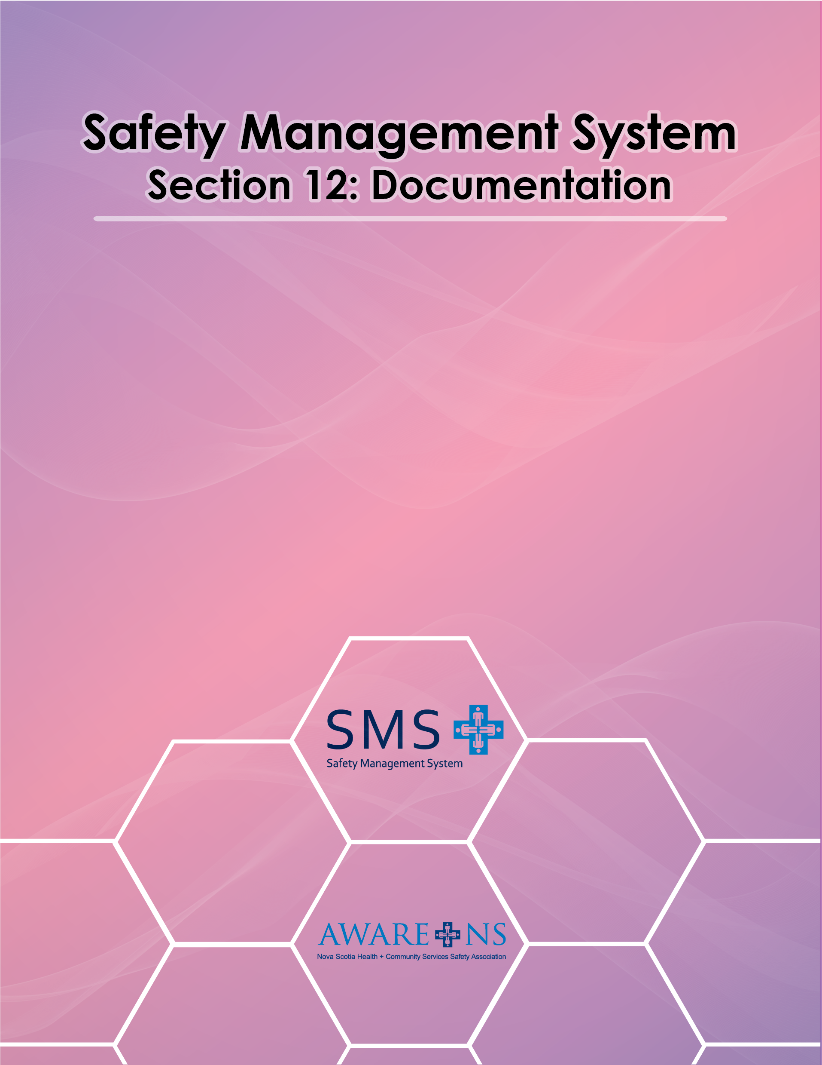

Table of Contents

Section 12: Documentation

Introduction 3
Creating and maintaining SMS Documents and Records 3
Control of the SMS and Related Documents 3
SMS Policy records 3
Records of SMS 4
Records Retention 5

Introduction

[Organization Name] has a strong SMS consisting of documents and records that have been reviewed, approved, and updated. Documents may be maintained at either the organization level or the department/unit level.

Creating and Maintaining SMS Documents and Records

Documentation is essential to meet OHS legal requirements. In addition, this supports the creation, implementation, evaluation and continuous improvement of [Organization Name]’s SMS. The SMS shall be reviewed on an annual basis in conjunction with the JOHS Committee.

Control of the SMS and Related Documents

_____________________ is responsible to oversee the development of all documents created for the [Organization Name] SMS.

Documents will be provided to management and the Joint Occupational Health and Safety Committee for review and comment, and revised as required following the review.

OHS Policy Records

An Occupational Health and Safety Policy has been established and will be reviewed annually with input from the JOHS Committee.

SMS Records

_______________ will maintain SMS records. Each department/work area is responsible to ensure that they forward the necessary documents, as required, to________. Records may be kept in various departments.

Records will include, but are not limited to:

- The SMS Manual and all related forms;
- Yearly departmental & JOHSC SMS objectives, targets and activities;
- Joint Occupational Health and Safety Committee meeting agendas, meeting minutes, written communications,
- Workplace hazard identification, assessment and control activities and inventories;
- Safe Work Practices development and maintenance;
- Fire Safety and Emergency Evacuation Plans;
- First Aid Attendant and Fire/Floor Warden records;
- Workplace Violence Prevention Plans;
- Reports of environmental testing and monitoring;
- Reports of employee concerns or complaints and management responses and the resolution of each;
- Reports of workplace incidents and investigations and any corrective actions;
- Records of Department of Labour, Skills and Immigration Occupational Health and Safety Division visits/inspections/orders/investigations/compliance notices;
- Records of inspections/orders from Regional Fire and Emergency Service or the Provincial Fire Marshall’s office; or
- Reports of SMS monitoring activities and statistical reports respecting OHS performance.

Some SMS records are maintained separately, due to their confidential nature.

- Workers’ Compensation files;
- Statistical summaries of injuries, illnesses and incidents;
- Employee Discipline Records; and
- Records of employee OHS orientation and training.

Records Retention

SMS records will be accessed, maintained and retained for 5 years.

First Aid Record books must be kept for 5 years as per the First Aid Regulations.

