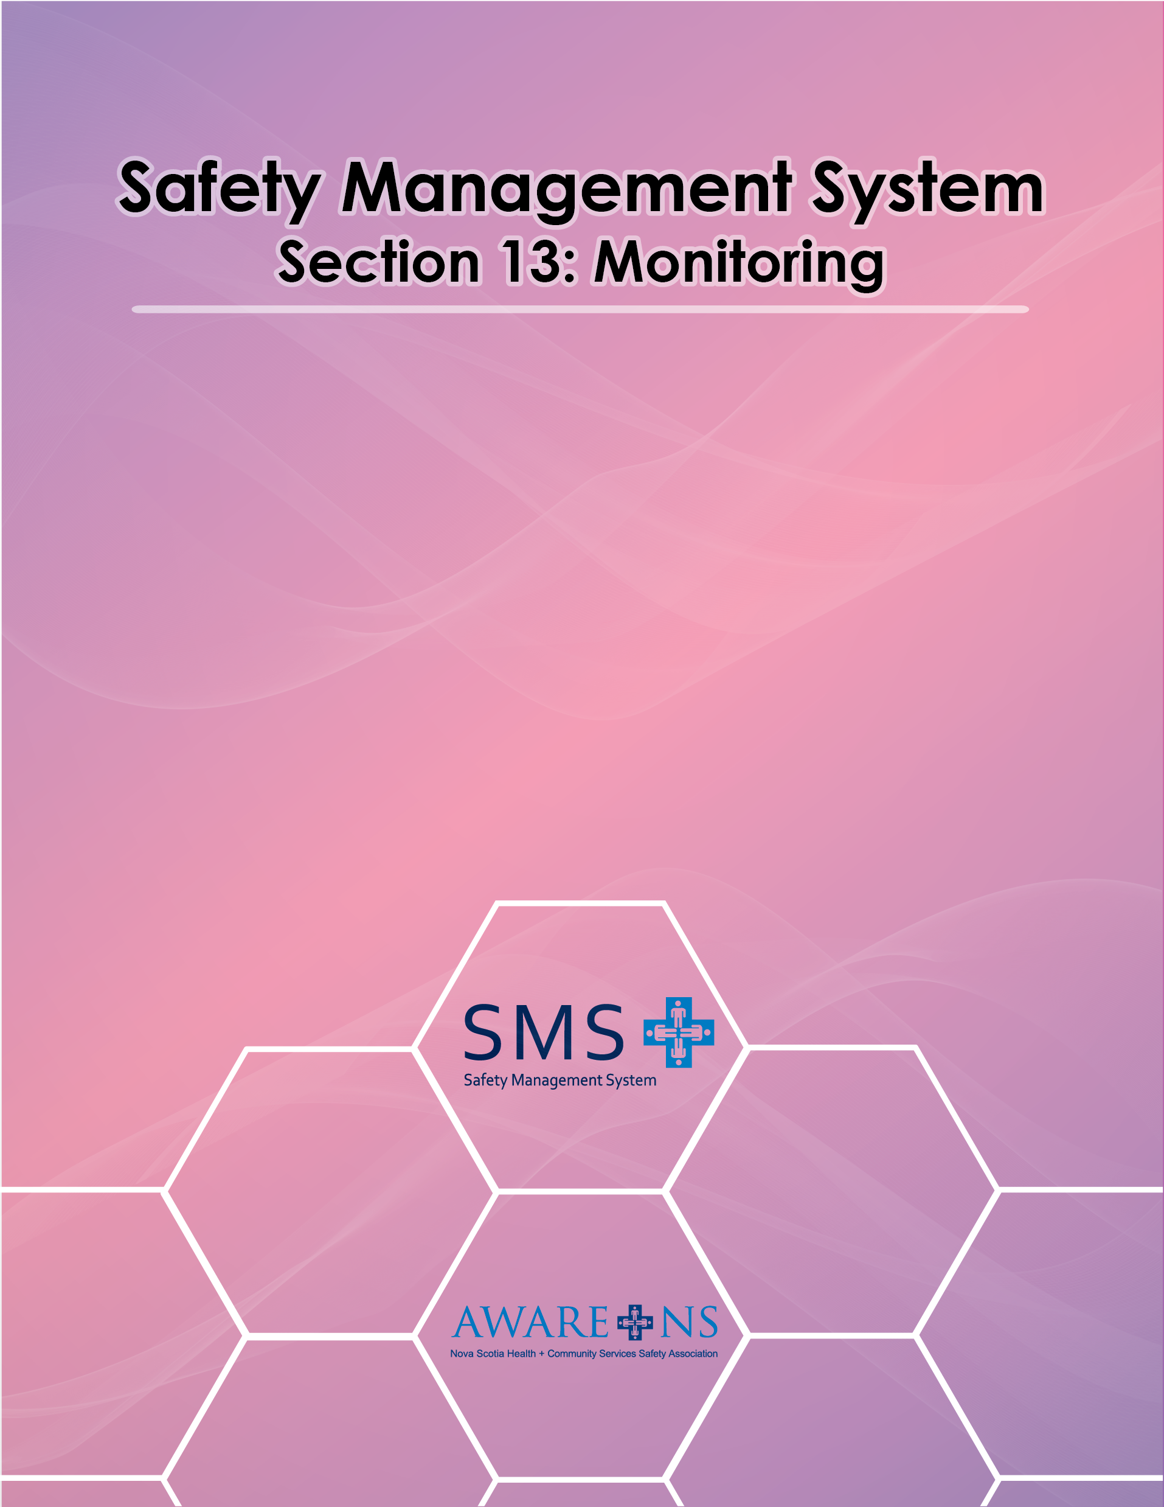
Table of Contents

Section 13: Monitoring

Introduction 3
Measurement of performance related to OHS objectives and Targets 3
Examples of Leading Indicators 3
Examples of Lagging Indicators 4
Reports and Statistics 4
Performance Appraisals 5
JOHS Committee OHS Summary Report 5

Introduction

The Occupational Health and Safety Act includes a provision for program monitoring of Occupational Health and Safety Programs:

“28 (2) The program shall include
...
- provision for monitoring the implementation and effectiveness of the program.”

Measurement of Performance Related to OHS Objectives and Targets

Key Performance Indicators (KPIs)

[Organization Name] has set Key Performance Indicators (KPIs) that will assist in the ongoing evaluation of the OHS objectives. KPIs will be monitored annually through leading and lagging indicators. Leading indicators tend to be more proactive in nature, whereas lagging indicators tend to be reactive in nature. By controlling leading indicators, such as the amount of safety training you provide, you will control your lagging indicators, such as your injury rate.

[Organization Name]’s leading indicators include:

- yearly review of the OHS Policy;
- complete OHS Annual Report;
- number of developed safe work practices;
- number of developed safe work procedures;
- number of reviewed safe work practices;
- number of reviewed safe work procedures;
- number of workplace health and safety inspections completed;
- number of OHS training sessions completed; and
- completion of or updating of a section of the SMS manual.

Leading indicators measure OHS activity. They do not measure whether the activity resulted in an improvement in OHS performance.

[Organization Name]’s lagging indicators include:

- total number of reported incidents;
- total number of reported near miss incidents;
- number of lost time incidents;
- number of medical aid incidents (i.e. doctor, hospital visit); and
- number of first aid incidents.

Lagging indicators measure results, but do not measure the various efforts which are going into the SMS program elements.

Reports and Statistics

[Organization name] will have an on-going summary of Incident Reports received, including a breakdown of non-injury incidents, first aid incidents, medical aid incidents, lost time incidents and incidents resulting in a claim to the Workers’ Compensation Board. These reports will also provide additional detail regarding the nature of the injury or illness.

The Joint Occupational Health and Safety Committee will receive a copy of the following reports, when available, for consideration at its meetings, upon request:

- Monthly Summary of Incident Report;
- Workplace Inspection Reports;
- Hazard Reports.

Internally generated reports can be found at _____________. Other reports may be available via WCB Nova Scotia’s MyAccount service at: https://onlineservices.wcb.ns.ca/myaccount.

Performance Appraisals

[Organization name] will ensure management and employee positions have established standards for performance regarding safety.

Annual management performance appraisals will include standards for performance in:

- Planned inspections;
- Incident investigation;
- Hazard reporting;
- Emergency preparedness;
- Employee training;
- Use of personal protective equipment;
- Health and hygiene control;
- Hiring and Placement; and
- Adherence to any other safety policies, practices and procedures.

Annual employee performance appraisals will include standards for performance in:

- Planned inspections;
- Incident investigation;
- Hazard reporting;
- Emergency preparedness;
- Employee training;
- Use of personal protective equipment;
- Health and hygiene control; and
- Adherence to any other safety policies, practices and procedures.

JOHS Committee OHS Summary Report

At the end of each calendar year, the JOHS Committee will complete the OHS Summary Report Form. This report will summarize activities and progress for statistical purposes and to document OHS performance.

A copy of the completed Summary Report Form will be given to the Senior Leadership team and Board. (See Section 8, Appendix 7: JOHS Committee Yearly OHS Summary Report Form)

