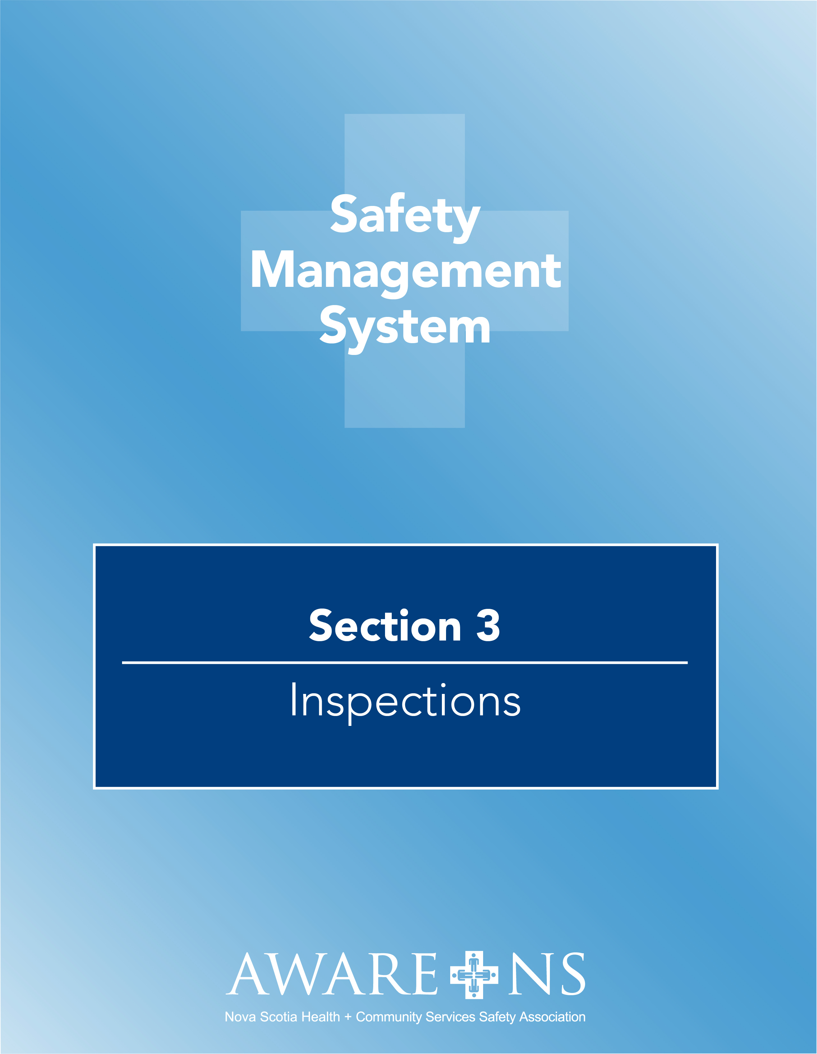

TABLE OF CONTENTS

Section 3: Workplace and Equipment Inspection

Introduction 3
Definitions 3
Roles and Responsibilities 3
Senior Leadership Team 3
Supervisors/Managers 3
Joint Occupational Health & Safety Committee / Health and Safety Representative 4
Employees 4
Training 4
Work Area Inspection 4
Workplace Inspection Methodology 5
Procedure for Inspecting Workplaces 5
Preparing for Inspections 5
Conducting the Inspection 5
Completing Inspection Report 6
Follow-Up/Monitoring 6
Immediate Safety Concerns during the Work Area Inspection 6
Equipment and Other Inspections 7
Mechanical Lifting Equipment: 7
Safety equipment: 7

Appendix 3.1, Workplace Inspection Form

Introduction
[Organization Name] recognizes that regular inspection of the workplace is key to preventing injuries and illness. [Organization Name] also recognizes that inspections are a shared responsibility between all levels of the organization. [Organization Name] had developed a workplace inspection program with the purpose of continually identifying workplace hazards.

Definitions
Workplace Inspections - An inspection is a physical tour of a workplace to determine if safe work practices, safety rules, engineering controls are being followed and are effective. This includes evaluating the controls for hazards that have been identified along with identifying new hazards.

Formal Inspections - Are planned and regularly scheduled inspections requiring formal documentation. For example, a monthly workplace inspection.

Informal Inspection - A practiced awareness which identifies potential hazards of processes, conditions and activities. Daily routines, such as a supervisor’s walk-through or an employee’s equipment check, are examples of informal inspections.

JOHS Committee Inspections - A formal workplace inspection performed to by JOSH committee members.

Work Area Inspections - A formal workplace inspection of a designated area conducted by management or a management representative. This may include community homes, neighbourhoods and/or facility departments.

Roles and Responsibilities

Senior Leadership Team
- Implement the workplace safety inspection process and ensure inspections are being completed as prescribed.
- Provide the designated representative with the required information and assistance they may require for the purpose of carrying out an inspection of the workplace.
- Ensure all inspection reports are reviewed by senior management and that hazards identified are corrected and controlled.

Supervisors/Managers
- Conduct formal and informal workplace inspections and ensure corrective action is taken to address any hazards identified. Make available documentation of formal and informal workplace inspections in accordance with this policy.
- Co-operate with any persons performing a workplace inspection.
- Where possible, participate with the Joint Occupational Health and Safety Committee (JOHSC)/Health and Safety Representative (H&S Rep.) inspection process.
- Review and ensure all items identified on the Workplace Inspection Report are addressed in a timely manner by initiating the appropriate corrective action.
- Discuss the results of the inspections and the corrective actions taken with employees.
- Ensure that employees have completed pre-use inspections in accordance with designated departmental written procedures.

Joint Occupational Health & Safety Committee / Health and Safety Representative
- JOHSC/H&S Rep. will perform workplace inspections to identify situations that may be a source of danger or hazard to employees.
- Members of the JOHSC representing employees may appoint an employee member to inspect the physical condition of the workplace.
- JOHSC/H&S Rep. will make recommendations to the employer for workplace improvements to protect employees’ health and safety.

Employees
- Cooperate with any persons performing a workplace inspection
- Ensure identified hazards are communicated to their supervisor
- Complete pre-use inspections in accordance with designated written procedures

Training
[Organization Name] recognizes the importance in providing effective training to all of its employees that are responsible for conducting workplace inspections. All employees performing workplace inspections will receive the following training: [Organizations should insert any specific workplace training that is required for their organization]

- AWARE-NS Workplace Inspection
- Internal training
- Have the knowledge of the fundamentals of workplace inspection (i.e. safe work practices and procedures)
- Instruction on use of checklist
- Know the subject matter experts within [Organization Name]

Work Area Inspection
Planned management inspections will be conducted [organization to add the frequency of the planned inspections – i.e. monthly, bi-monthly]. These inspections will be conducted by trained employees as designated by management.

Each hazard that is found will be clearly described on the Workplace Inspection Checklist (Appendix 3.1] noting its deficiency and the corrective action to be taken.
As inspections are completed for each area, copies of the workplace inspections will be both signed and provided to [insert name and position of designated person]. Copies of the inspection reports will also be forwarded to the JOHS Committee or H&S Representative for review.

The checklist will be reviewed and revised on a regular basis to ensure it reflects current workplace conditions and practices.

Workplace Inspection Methodology
[Organization Name] recognizes that hazards may not contain one single factor but are made up of various contributing factors. For this reason, when workplace inspections are being performed, the following contributing factors will be considered:
To ensure each area is covered/inspected:
Senior Leadership – one member of the senior leadership team will inspect one area (quarterly)
Department Inspection – each department will complete an inspection of their area (Monthly)
JOHSC Member(s) – will inspect one area monthly, ensuring over the course of a year, they will have inspected all areas

Procedure for Inspecting Workplaces

Preparing for Inspections
- Review the following to establish priorities and inspection focus:
  - Employee incident reports
  - Previous workplace inspection records
  - Applicable organizational policies and procedures
  - Review control measures, emergency procedures and PPE being used
  - Equipment and tools
- Plan and review the inspection route
- Inform the manager/supervisor or designate of the location when the inspection is to take place and invite them to participate in the inspection process
- Ensure there are adequate copies of the Monthly Workplace Inspection Checklist for the location being inspected.
- Each location should develop and review its own workplace inspection checklist that considers situations and hazards specific to that area.

Conducting the Inspection
- Inspections are to be documented using the Monthly Workplace Inspection Checklist.
- During the inspection, the inspector(s) will:
  - Record any hazardous conditions or acts observed
  - Speak with employees and supervisors to gather any information regarding hazardous conditions or actions of which they may have knowledge.
  - Where immediate corrective action is required, contact the manager/supervisor or their designate. Immediately deal with high-risk hazards before anyone can get hurt. Note the corrective action taken.
  - Make a note of successes during the inspection; positive feedback encourages safe work practices
  - Focus on fact finding and issues related to workplace health and safety
  - If the manager/supervisor or their designate did not participate in the inspection, consult them before leaving the location or as soon as reasonably practical (within 24 hours). Report all identified hazards and make note of any corrective actions that have been put in place.

Completing Inspection Report
- The Workplace Inspection Form must be completed following the inspection and signed by the inspector(s) performing the inspection.
- A copy of the report will be posted at _____________.
- Additional copies of the report and recommendations will also be provided to managers/supervisors responsible for implementing corrective measures.
- A copy of the report will also be distributed to the JOHSC, where applicable, for review.

Follow-Up/Monitoring
- The inspector(s) will discuss and agree upon a date and time to meet and follow up on corrective actions taken to eliminate the identified hazard noted during the inspection, if deemed necessary.
- In cases where an item(s) from the inspection have not been addressed in a reasonable time period, the JOHSC/H&S Rep. will contact the manager/supervisor or their designate.
- In cases where an item(s) from the inspection has not been addressed in a reasonable time period by the manager/supervisor or their designate, communication with the next level of management from the JOHSC/H&S Rep. requesting corrective action will occur.
- Review and update hazard assessments as required.

Immediate Safety Concerns during the Work Area Inspection
Where unsafe conditions, practices or procedures are noted:
- Act immediately to rectify the problem, if possible.
- Place warning signs and barricades to keep employees away. Use verbal warnings, if applicable.
- Notify Supervisor of any concern or action taken.
- All affected employees should be informed of the location of the hazard and the required interim controls.

When an employee is noted performing an unsafe act, advise as follows:
- Inform them of the unsafe situation
- Discuss the unsafe condition with them
- Advise on how to correct the unsafe condition
- Re-visit the area to ensure the safe practice is being followed
- Discuss with the supervisor

Equipment and Other Inspections

Mechanical Lifting Equipment:
- All Mechanical Lifting Equipment is to be visually inspected before each use, including slings.
- Annually, all Mechanical Lifting Equipment will be inspected and certified by an authorized service agent.

Safety equipment:
- Eyewash station
- Fire extinguisher- check monthly/annually by________________
- Emergency lighting- to be checked by_________ in accordance with licensing requirements.
- First Aid Kits are checked monthly by_________

