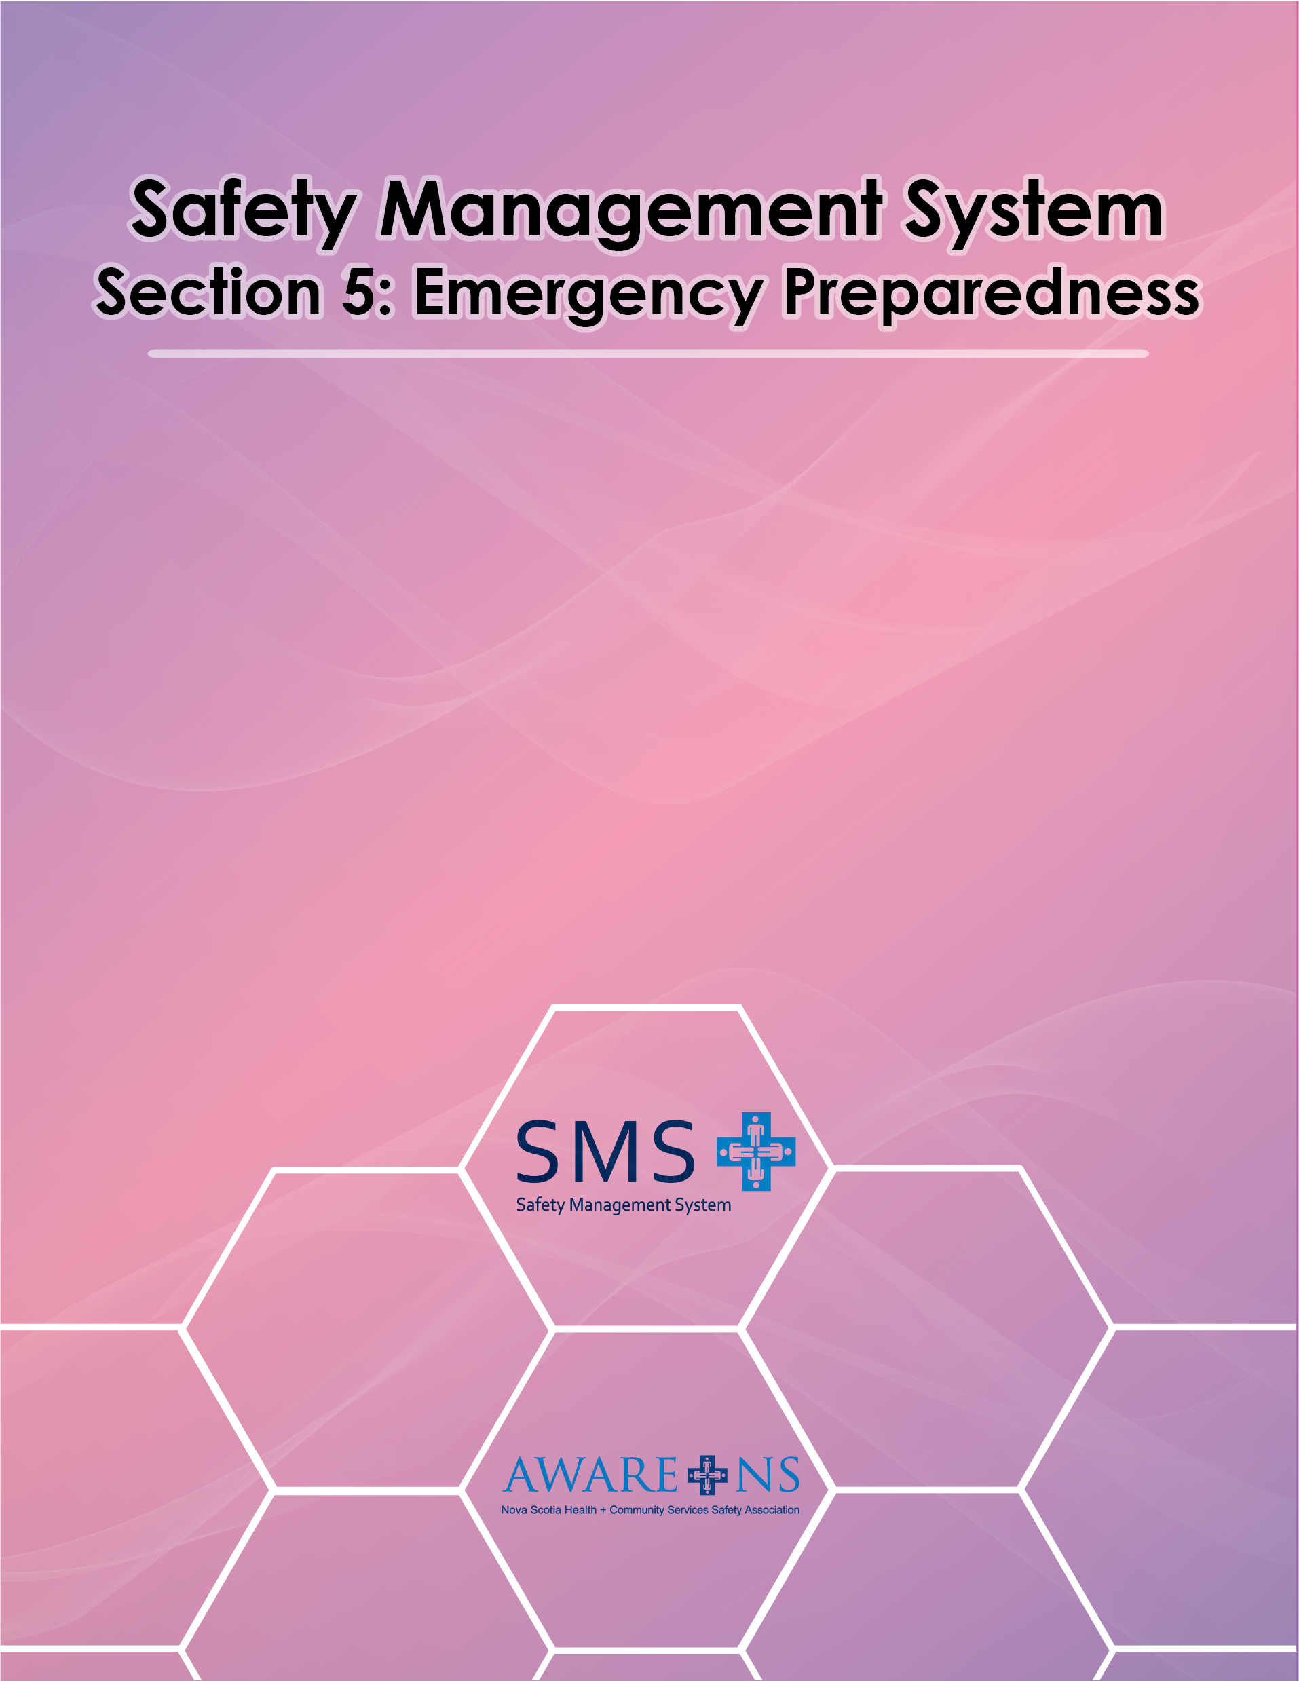

Table of Contents

Section 5: Emergency Preparedness

Introduction 3
Roles and Responsibilities………………………………………………………………………………………………………………………. 3
Prevention, preparation for and response to emergencies 4
Emergency Codes 4
Fire Safety and Emergency Evacuation Plans 4
Workplace Violence Prevention Plan 5
Workplace Hazardous Materials Information System 6
First Aid for Injuries and Illnesses 6
Responsibility for First Aid 6
Transportation of the Injured or Ill 6
First Aid Record keeping 7
First Aid Supplies 7
Fire and Fire Extinguishers 7
Eye Wash Station 9
Inspection and Maintenance 9
Eye Wash Bottles 9
Training 10
Pandemic Plan 10

Appendix 5.1, Number of First Aid Kits and First Aiders Required
Appendix 5.2, Isolated Workplace First Aid Plan
Appendix 5.3, First Aid Compliance Worksheet
Appendix 5.4, Types of First Aid Kits and their Contents
Appendix 5.5, Workplace Violence Prevention Statement
Appendix 5.6, Workplace Violence Prevention Plan

Introduction

An important element of every Safety Management System is a method of handling sudden unexpected situations to reduce possible consequences of an emergency. The following is considered in the development of [Organization Name]’s program.

- identification of potential emergency situations where there is risk of illness or injury;
- plans to respond to emergency situations and to prevent or mitigate any illness or injury;
- identification of the necessary resources to implement the plan effectively;
- periodic testing of emergency plans through drills and similar activities;
- periodic review and updating of procedure(s);
- communication with employees and provide training so that they can fulfill their duties and responsibilities with respect to the plans and procedures; and
- communication with contractors, visitors, relevant emergency response services, government authorities, and the local community, as appropriate

Roles and Responsibilities

Senior Leadership Team:
- ensure that appropriate emergency procedures and policies are implemented;
- ensure that all departments/units have the required emergency resources available;
- ensure that all emergency situations are investigated to determine any corrective action that may be needed to prevent recurrence;
- ensure that managers, supervisors and employees are trained in conducting emergency procedures

Managers and Supervisors:
- ensure that employees are trained in all emergency response situations;
- ensure all emergency response equipment and procedures are up-to-date and are in working order;
- conduct investigations and determine the root cause(s) of emergency situation;
- recommend corrective action and monitor implementation to prevent recurrence of emergency situations

Employees:
- comply with all emergency procedures and policies in the event of an emergency;
- co-operate fully with any investigation of any emergency situation, providing all information relevant to the investigation

Prevention, Preparation for and Response to Emergencies

[Organization Name] has identified a wide variety of potential emergency situations, ranging from work related injuries and serious illnesses occurring at work to fires, building system failures, incidents of violence, and adverse weather conditions. Wherever possible, [Organization Name] has acted to reduce the opportunity for emergency situations to occur, including design of facilities, modifications to procedures, staff training and security features.

Even with the best preventive efforts, it is recognized that emergency situations will develop from time to time.

Emergency Codes

CODE BLUE – Cardiac Arrest | CALL _____________
CODE PINK – Paediatric/Neonatal Arrest | CALL _____________
CODE WHITE – Violent Person/Hostage | CALL _____________
CODE RED – Smoke, Fire or Fumes | CALL _____________
CODE BLACK – Bomb Threat | CALL _____________
CODE YELLOW – Missing Adult | CALL _____________
CODE AMBER – Missing Child/Infant | CALL _____________
CODE BROWN – Internal or External Incident Involving Hazardous Material | CALL _____________
CODE GREY – Loss of Utilities | CALL _____________
CODE ORANGE – Mass Casualty Reception | CALL _____________
CODE GREEN – Facility Evacuation | CALL _____________
CODE PURPLE – Nurse Needed (optional) | CALL _____________
CODE SILVER – Individual(s) with a weapon | CALL _____________

Fire Safety and Emergency Evacuation Plans

[Organization Name] has the responsibility to ensure that;
- fire safety and emergency evacuation plans have been developed
- all the provisions of fire and building codes are being observed,
- protective systems are in place and are operational
- building systems are tested
- drills are performed as required by the plan
Details of these plans and other supporting documentation are kept at/by ________________.

[Organization Name] has appointed Fire Wardens to assist in evacuating the building. It is important for all employees to cooperate with the Fire Wardens and to follow any instructions they are given.

Workplace Violence Prevention Plan Overview
Violence in the Workplace Regulations (N.S. Reg. 209/2007) require healthcare and community services employers to do a Workplace Violence Risk Assessment and establish and implement a workplace violence prevention plan based on the results/corrective actions of the Workplace Violence Risk Assessment. Acts of violence do not necessarily require intent to harm. In healthcare and community services, it is often while providing resident/client/participant care that a situation of workplace violence can arise.
The “Violence in the Workplace Regulations” define “violence” as:
- Threats, including a threatening statement or threatening behaviours that gives an employee reasonable cause to believe that the employee is at risk of physical injury
- Conduct or attempted conduct of a person that endangers the physical health or physical safety of an employee
Types of violence that employee may experience in the workplace include hitting, grabbing, pinching, pushing, physical assault, sexual assault, stalking, criminal harassment, robbery, or threats of violence.
Although harassment, abusive behaviour, and bullying are not addressed by the regulation, [Organization Name] has considered these in the development of the workplace violence prevention plan.
[Organization Name] will review the Workplace Violence Prevention Plan annually in conjunction with the JOHS Committee. The risk assessment will be completed at least every five years or when there is a significant change i.e. change in care delivery model, facility layout, and resident/client/participant profile changes, near miss that could result in a serious injury or an incident that did result in a serious injury.

Workplace Violence Prevention - Employee Perception Survey will be completed annually as a measure of the effectiveness of the plan and to promote continuous improvement.

The Workplace Violence Prevention Plan also establishes standards for orientation and training for employees who work in various capacities. An orientation session is required for all employees. Training will be provided on Workplace Violence Prevention, examples include:

- De-escalation techniques
- CODE White
- P.I.E.C.E.S ™
- U-First ™
- GPA™
- MANDT™
- Non-violence Crisis Intervention™

[Organization Name]’s full workplace violence prevention plan can be found _____________.

Workplace Hazardous Materials Information System (WHMIS 2015)

In Nova Scotia, the storage and use of hazardous materials (controlled products) at workplaces is governed by the Workplace Hazardous Materials Information System (WHMIS 2015) Regulations.

These regulations require that all employees who work with controlled products or in proximity to a controlled product receive instruction on;
- product classification
- supplier and workplace labels
- safety data sheets
- procedures for the safe use, storage, handling and disposal of controlled products

Procedures are to be followed in case of an emergency involving a controlled product.

Safety Data Sheets are available in the following locations ______________.

WHMIS 2015 training may be acquired through AWARE-NS self-directed learning or____________________.

First Aid for Injuries and Illnesses

Prompt, effective first aid is a priority where individuals are physically and/or psychologically injured or become seriously ill. Provision of an organized first aid response is, therefore, part of [Organization Name]’s commitment to providing a healthy and safe work environment for our employees.

Responsibility for First Aid

The First Aid Regulations establish general responsibilities for employees at [Organization Name]:

- [Organization Name] will provide first aid attendants, as required, by the regulations unless the organization has an approved DLSI deviation
- Incidents requiring first aid treatment will be reported and investigated to determine the cause and prevent recurrence.
- Number and qualifications of First Aid Attendants will comply with the regulation.
- [Organization Name] shall maintain a list of qualified First Aid Attendants. This will be posted_____________.

Transportation of the Injured and Ill

If the injured/ill worker requires additional medical attention, [Organization Name] will arrange for emergency medical aid. [Organization Name] will ensure that injured or ill employees are provided with appropriate transportation and do not transport themselves when they require immediate medical attention.

First Aid Record Keeping

The First Aid Attendant administering first aid shall complete the record using the booklet in the first aid kit. These records will be maintained for five years.

First Aid Supplies

The contents of first aid kits are prescribed in the First Aid Regulations. At [Organization Name], first aid kits are located_______________. A sign that can be clearly seen by all persons shall indicate the location of the first aid kit(s). The appropriate number of first aid kits and type of first aid kit will be made available in each work area.

[Organization Name] will inspect the first aid kits monthly and restock when appropriate. Any employee taking first aid supplies from the first aid kit must inform the First Aid Attendant so that there is minimum delay in restocking.

A copy of the completed first aid checklist shall be forwarded to the appropriate individual(s) who shall provide the supplies necessary to replenish the first aid kit as required by the First Aid Regulations.

A copy of the first aid checklist can be found in Appendix 5.4 - Types of First Aid Kits and their Contents.

Fire and Fire Extinguishers

Fire extinguishers are available throughout [Organization Name] to extinguish a fire. All personnel should be aware of each location and know the basic operating principle:
P- Pull
A-Aim
S-Squeeze
S-Sweep

Portable fire extinguishers are intended as a first aid measure to cope with fires of limited size. Portable extinguishers are rated for the corresponding classes of fire. Only use extinguishers if trained and there is a safe route of escape from the area.

Classes of Fire:

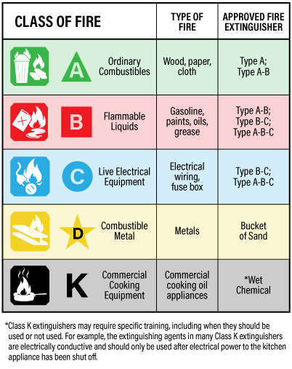

Do not block access for any length of time to any fire extinguisher. Extinguishers are to remain is their designated location and are not to be removed from their wall bracket unless for emergency use or maintenance.
All fire extinguishers will be checked monthly for damages. At this time extinguishers will be recharged if necessary and dates recorded on the attached tag. If a low charge is noticed on the pressure gauge or if extinguisher is used immediately notify your supervisor.

Eye Wash Station
To be effective, the equipment has to be accessible. Employees must be able to reach the equipment in no more than 10 seconds.
The location of each eyewash station should be identified with a highly visible sign.



Eyewash stations should:
- Be located as close to the hazard as possible,
- Not be separated by a partition from the hazardous work area,
- Be on an unobstructed path between the workstation and the hazard
- Be located where employee can easily see them
- Be on the same floor as the hazard
- Be located near an emergency exit, where possible
- Be located in an area where further contamination will not occur
Inspection and Maintenance
Inspecting and operating the eyewash stations should be done on a weekly basis. A weekly activation will help make sure that there is flushing fluid available as well as clear the supply line of sediments and minimize microbial contamination caused by stagnant water. This weekly flush for 5 minutes after the water is clear. Keep a signed and dated record of all inspections. A complete inspection should also be performed on an annual basis.
Eyewash Bottles
Eyewash bottles or personal eyewash units supplement plumbed and self-contained stations, but in no way can replace eye wash stations. They are portable and permit immediate flushing of contaminants or small particles. Once immediate flushing is accomplished, the employee should proceed to a self-contained or plumbed eyewash and flush for the required flushing period. Once used it is to be discarded. When eyewash bottles are received from the supplier, there is an expiration date on the bottle. Performing regular inspections will ensure they have not expired.
Training
All employees will be provided instruction in the proper use and location of eyewash stations before any emergencies occur. Training will also address the potential impact of wearing contact lenses.

Pandemic Plan

Introduction

[Organization Name] Pandemic Outbreak Plan has been prepared in accordance with the Nova Scotia Health System Pandemic Plan and the Nova Scotia DHW, Health Promotion and Protection guidance documents to ensure practices and procedural consistency in the Management of a pandemic.

Definition

Influenza-like illness (ILI) is used throughout this document and is defined as:
Fever and/or cough with one or more of sore throat, myalgia, arthralgia or extreme fatigue. Although other symptoms including diarrhea may be present (especially in children), those noted above remain the most common and prominent.

Purpose

During an outbreak of a pandemic, it is the intention of [Organization Name] to sustain services to priority clients/residents/participants in a manner which will minimize transmission of the virus, and protect employees, clients/residents/participants/family members, and others health and safety.

The Pandemic Management plan is intended to:

- Prepare the Organization for an appropriate response to a pandemic;
- Mitigate illness and death to staff, clients/residents/participants and others;
- Maintain priority/essential services; and,
- Provide a safe environment for staff, clients/residents/participants, and others.

The Pandemic Plan is contained in the ____________________.

