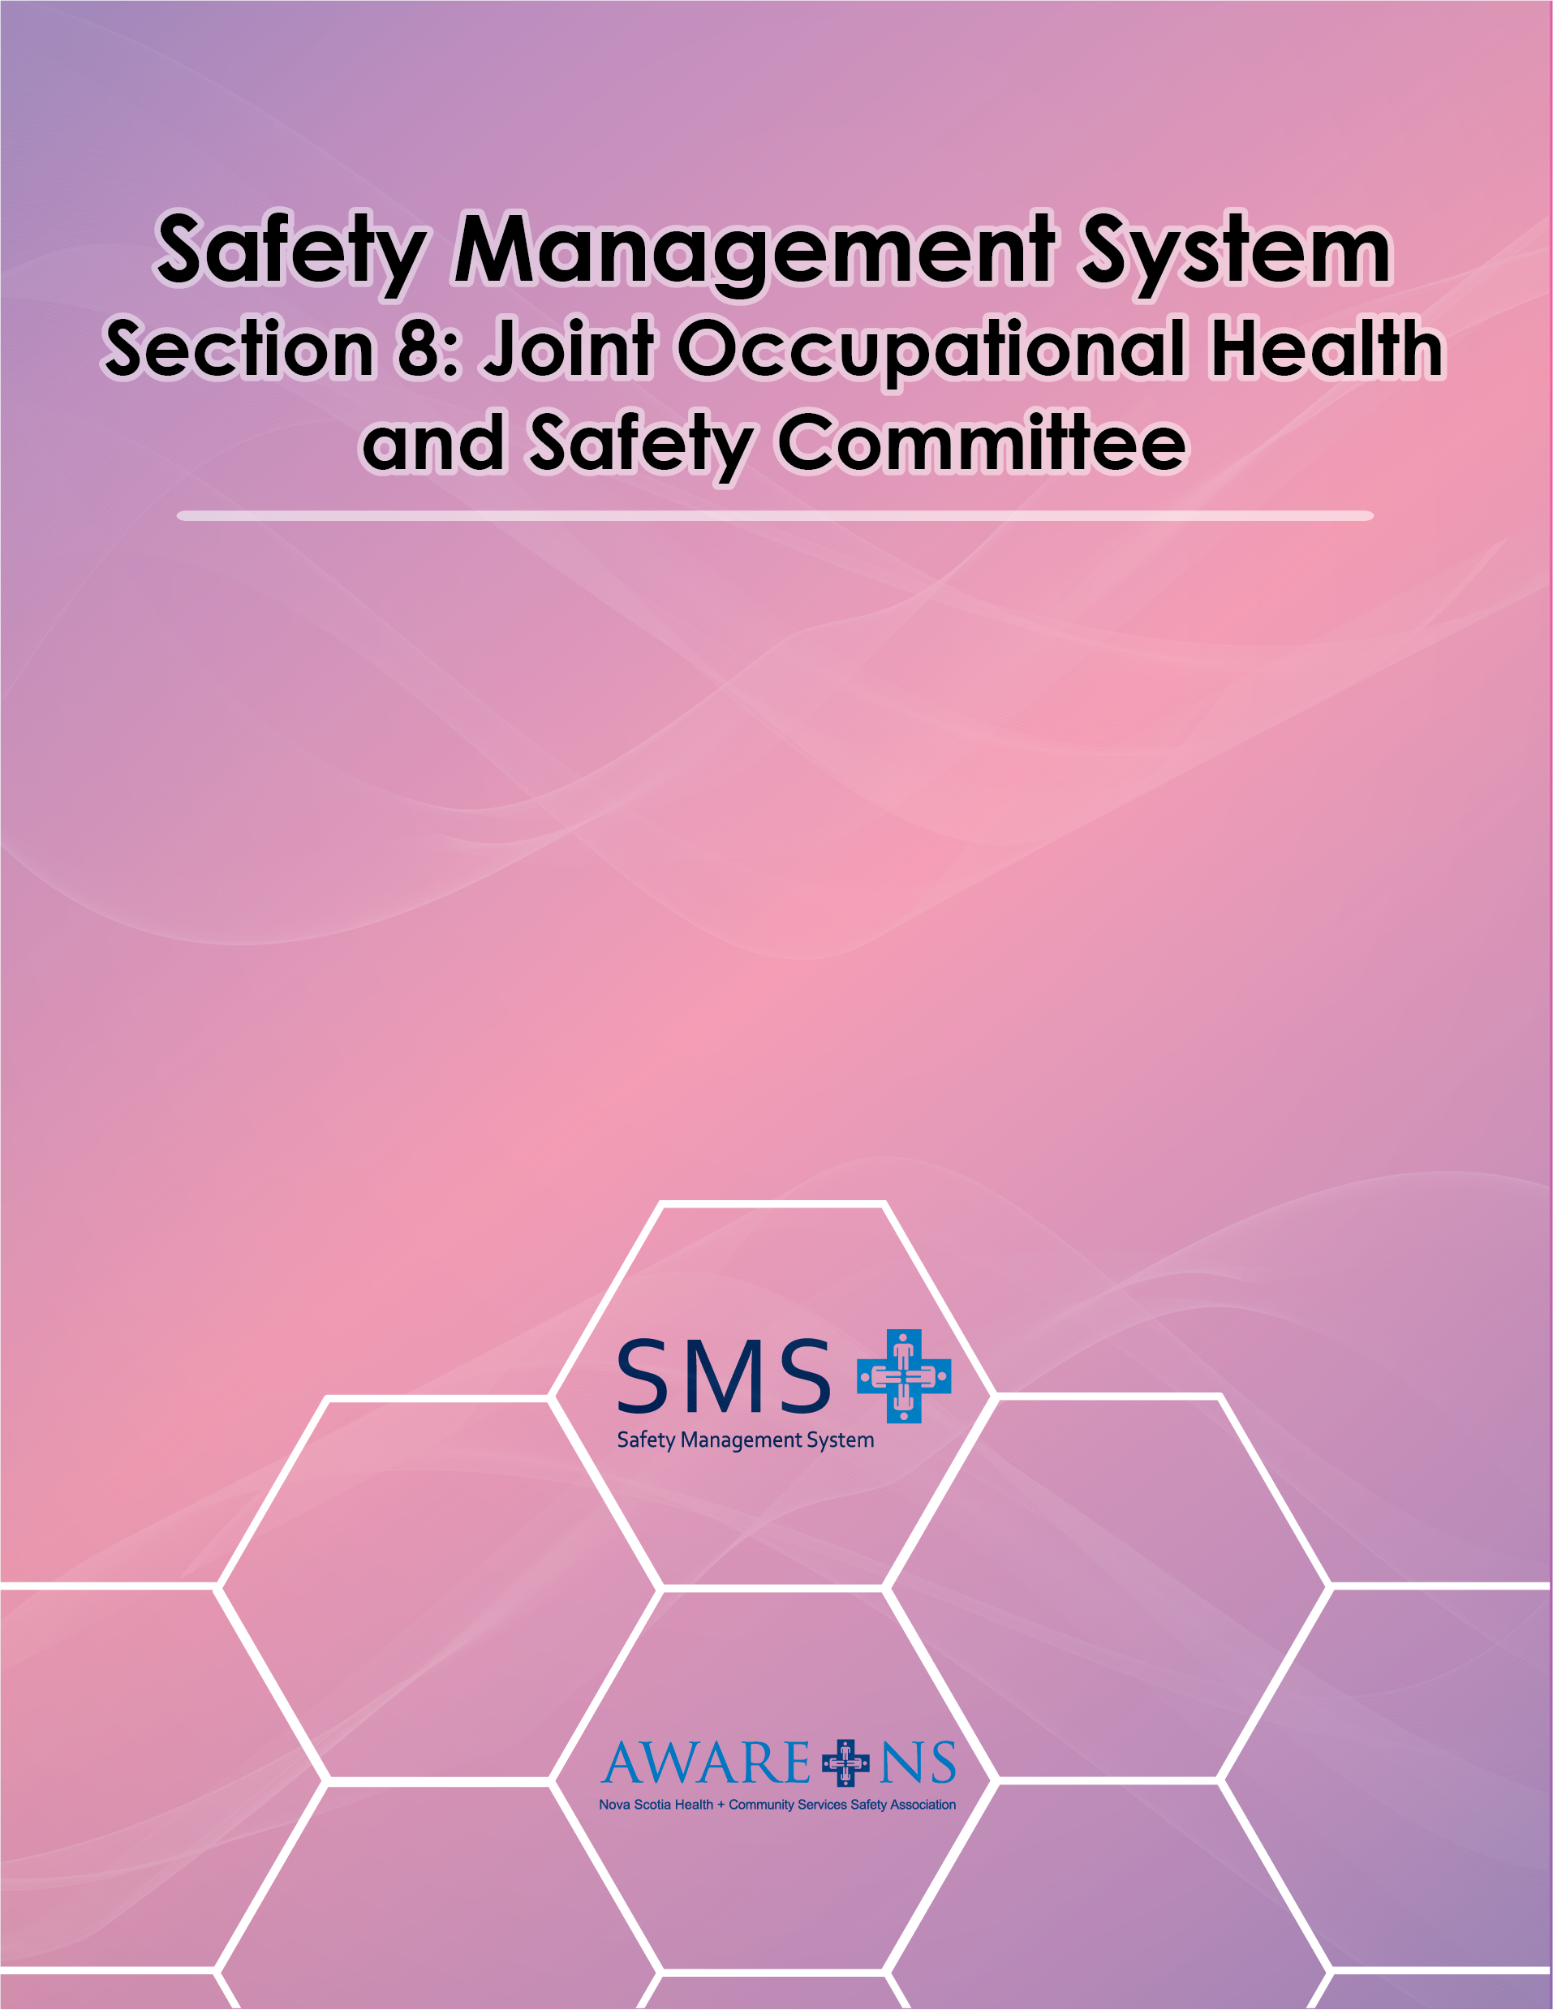
Table of Contents

Section 8: Joint Occupational Health and Safety Committee

Introduction 3
Legislative Requirements for JOHS Committees and OHS Representatives 3
Composition of JOHS Committee 3
Roles of JOHS Committee 3
Functions of JOHS Committee 4
Terms of Reference/Rules of Procedure of JOHS Committee 4
Training………………………………………………………………………………………………………………………………………5
Hazard Assessments 5
Employee Health and Safety Concerns 5
Work Refusals under the OHS Act 6
Referral to the JOHS Committee 6
Formal Referral to the OHS Division, DLSI 6
Workplace Inspections 7
Incident Investigations 7
Notifications 8
Hazard Awareness and Elimination 8
Written Recommendations to Management 9
Written Request for Information 9
Participation in OHS Program Evaluation 10
Annual Report 10
Records 11

Appendix 8.1, JOHS Committee Terms of Reference
Appendix 8.2, JOHS Committee Rules of Procedure
Appendix 8.3, JOHS Committee Meeting Agenda
Appendix 8.4, JOHS Committee Minutes
Appendix 8.5, JOHS Committee Recommendation
Appendix 8.6, JOHS Committee Request for Information
Appendix 8.7, JOHS Committee Yearly OHS Summary Report
Appendix 8.8, JOHS Committee Effectiveness Checklist
Tip Sheet 1 – What Should Be on JOHS Committee Agenda?
Tip Sheet 2 – Tips to an Effective JOHS Committee and Common Mistakes
Tip Sheet 3 – Typical Duties of a Committee
Tip Sheet 4 – Tips for a JOHS Committee to Set Annual Safety Goals

Introduction

A joint occupational health and safety committee (JOHSC) is a forum for bringing the Internal Responsibility System into practice. The committee consists of employee and management representatives who meet on a regular basis to deal with health and safety issues.

Legislative Requirements for JOHS Committees and OHS Representatives

Section 29 of the OHS Act establishes the requirement of a JOHS Committee in a workplace where there are 20 or more employees who are regularly employed. This is one of the principal mechanisms for ensuring that the Internal Responsibility System for OHS is functioning at the workplace, providing an opportunity for employee participation and a mechanism for assisting management with the effective implementation and ongoing review of the Safety Management System (SMS).

Sections 30 and 31 of the OHS Act identify the composition, procedures and functions of the committee.

Section 33 of the OHS Act establishes the requirement of an OHS Representative in a workplace where no JOHS Committee is required pursuant to Section 29 and there are five or more employees who are regularly employed. This Section also defines the functions of the OHS Representative, which are generally similar to those of a JOHS Committee except for the requirement to hold meetings.

Composition of JOHS Committee

The OHS Act mandates that a JOHS Committee shall consist of a number of persons as agreed to by the employer and the employees and their union(s). At least half of the members shall be employees at the workplace who are not connected with management of the workplace. [Organization Name] may choose up to one-half of the members of the JOHS Committee.

Roles of JOHS Committee

The primary roles of the JOHS Committee are:
- to participate in the development and maintenance of the Safety Management System
- to provide advice and recommendations on health and safety issues within the workplace.
- cooperative identification of hazards
- evaluation of the effectiveness of the systems to respond to these hazards
- auditing of compliance with legislative standards.

Functions of JOHS Committee

The JOHS Committee is involved in the following activities:

- Identify and respond to hazards;
- Monitor the Safety Management System
- receipt, investigation and prompt disposition of matters and complaints with respect to workplace health and safety;
- participation in workplace inspections;
- advising on individual protective devices, equipment and clothing that are best adapted to the needs of the employees;
- advising the employer regarding a policy or program required and making recommendations to the employer; and
- maintaining minutes of committee meetings and records of committee activities.

The JOHS Committee may also undertake any other duties assigned by [Organization Name], by agreement between the employer and employees or union(s), where applicable, or as established by the regulations.

Terms of Reference and Rules of Procedure of JOHS Committee

[Organization Name] has established a Terms of Reference/Rules of Procedure in accordance with Section 30 (7) of the OHS Act. This provides the framework within which the committee functions.

Training

All members of the JOHS Committee shall be provided with training on the fundamentals of occupational health and safety and the duties of being a member of the JOHS Committee. This training shall include:

- Internal Responsibility System
- Safety Accountability and Due Diligence
- JOHS Committee Effectiveness
- Hazard Identification/Assessment
- Workplace Inspections
- Incident Investigation and Root Cause Analysis

Hazard Awareness

Where the JOHS Committee becomes aware of a hazard from any of the following sources, it shall address the hazard at the next regular meeting of the committee unless an emergency or special meeting is called to address the hazard:

- departmental notification;
- employee concern or complaint;
- hazard assessment;
- inspection;
- incident report or investigation;
- referral from the Occupational Health and Safety Delegate; or
- any other means.

The JOHS Committee shall address, by recommendation to management, the elimination of the hazard or, where that is not possible, the minimization of the hazard.

Hazard Assessments

[Organization Name] has adopted a formal Hazard Identification, Risk Assessment and Control process in consultation with the JOHS Committee. The JOHS Committee reviews the results of the hazard assessment process and provides feedback and recommendation(s).

Workplace Inspections

The JOHS Committee is to participate in workplace inspections. This involves one or more JOHS Committee members working with management to undertake a monthly inspection of a workplace using a Workplace Inspection Checklist, ensuring all areas of the workplace are covered at least once annually. A report shall be completed and filed for each inspection.

The JOHS Committee should review all inspection reports (management, departmental, JOHSC or others) at its next meeting.

Section 50 of the OHS Act requires that a representative of the JOHS Committee be allowed to accompany an Occupational Health and Safety Officer of the Occupational Health and Safety Division of the Department of Labour, Skills and Immigration as the officer undertakes an inspection of the workplace.

Incident Investigations

Reports of all incidents shall be forwarded to the JOHS Committee for review at its next meeting. Where determined to be desirable by the JOHS Committee, it may carry out additional investigations of any incident. A report or any such additional investigation shall be completed and filed.

Employee Health and Safety Concerns

When a JOHS Committee member receives an employee concern with regard to a health or safety matter:

- The JOHS Committee member will confirm whether the matter was addressed by the employee’s manager/supervisor.
- If the employee has not already reported the concern to their manager/supervisor, the employee will do so.
- If the employee has already reported the concern to their manager/supervisor and the manager/supervisor has not addressed the matter satisfactorily, the JOHS Committee member will document the concern. If the concern poses an immediate safety threat, the JOHS Committee member will contact the Co-Chairs to determine whether a special meeting should be called.
- At the next meeting, the JOHS Committee will review the reports of all employee health and safety concerns referred to it for investigation.
- The JOHS Committee will provide feedback to the employee as to the outcome.

Work Refusals under the OHS Act

[Organization Name] has developed a procedure for reporting and responding to employee work refusals under the OHS Act. (See Section 1)

JOHS Committee will complete the Work Refusal: JOHS Committee Investigation section of the Right to Refuse Unsafe Work Form.

Notifications

Section 28(2)(e)(iv) of the OHS Act requires that the Occupational Health and Safety Program identify the circumstances where hazards must be reported by the employer to the JOHS Committee and the procedure for doing so.

Pursuant to this requirement, the JOHS Committee will be notified within 24 hours of the occurrence of:

- an accident at the workplace where a person is killed or injured in a manner likely to prove fatal;
- a fire or explosion at the workplace whether a person is injured or not; and
- a Stop Work Order being issued by an Occupational Health and Safety Officer of the Occupational Health and Safety Division of the Department of Labour, Skills and Immigration (DLSI).

[Organization Name] shall notify the JOHS Committee within seven days of the occurrence of:

- an accident at the workplace where a person sustains a bodily injury which requires medical treatment or which results in lost time greater than one day, not counting the day of the injury; and
- an order of an Occupational Health and Safety Officer of the Occupational Health and Safety Division of DLSI.

Written Recommendations to Management

Section 34 of the OHS Act requires that an employer shall respond in writing within 21 days to written recommendations from the JOHS Committee. The following procedure is to be used to ensure a response in a timely manner.

The formal recommendation(s) should be reserved for the more serious issues. Routine matters should be dealt with by recording them in the minutes for action by local management or supervisors.

Appendix 8.5 contains the JOHS Committee Recommendation form, which should be used to communicate the recommendation(s) of the JOHS Committee. In most circumstances, this will be addressed to the management person who is responsible for the work, location, or issue about which the recommendation(s) refer. Normally this will be the director of the functional group.

Management must take action to ensure that the recommendation(s) are dealt with expeditiously and that a formal response is provided. Communication regarding recommendations should be acknowledged to the JOHS Committee. A response to the recommendation(s) should be made as soon as possible, within 21 days; accepting recommendation(s) or giving reasons for not accepting them.

Written Request for Information

Section 35 of the Act requires an employer to notify the JOHS Committee of any occupational health and safety reports, inspections, workplace monitoring or tests. Upon request, the employer must make these reports available to the JOHS Committee. If the JOHS Committee wishes to request any of these reports, the JOHS Committee Request for Information form (Appendix 8.6), should be used to ensure a response in a timely manner.

Section 35 of the OHS Act requires that an employer shall respond in writing within 21 days to a written Request for Information from the JOHS Committee.

Participation in OHS Program Evaluation

At least once each year, the JOHS Committee shall review and advise the employer regarding:

- the Safety Policy;
- the SMS;
- employee awareness and training in OHS issues; and
- the respective work area’s Workplace Hazardous Materials Information System (WHMIS) training.

The management representative to whom the JOHS Committee reports shall invite the JOHS Committee to participate and provide input on any program evaluation or audit of OHS programs or the SMS, which is undertaken.

Annual Report

The JOHS Committee should submit an Annual Report to the manager to whom the Committee reports. The following is a list of topics that should be covered in the Annual Report:

- name and membership of the JOHS Committee;
- meetings held;
- hazard assessments undertaken or reviewed;
- safe work practices developed or reviewed;
- inspections and investigations undertaken or reviewed;
- employee concerns investigated
- unsafe work refusals investigated;
- employee OHS education and training programs, including WHMIS, reviewed;
- OHS Policy review;
- recommendations made;
- employer’s response to recommendations; and
- occupational injury/illness statistics.

Records

The JOHS Committee shall keep a full record of its activities, including preparation and maintenance of the following records:

- JOHS Committee members;
- Committee Co-Chairs and the Secretary;
- schedule of regular meetings;
- notices of emergency and special meetings;
- meeting agendas and minutes;
- reports of hazard identification and assessment activities
- reports of inspections;
- reports of concerns investigated
- reports of unsafe work refusals investigated;
- reports of incidents investigated;
- written recommendations to management;
- written requests for information;
- the response to any written recommendations and requests for information; and
- any correspondence which is received or sent.

