[Organization Name]
Contractor Safety Orientation Handbook

Table of Contents

INTRODUCTION 5
Safety Statement 5
Definitions 5
The Internal Responsibility System(IRS)……………………………………………………………………………………………………………………………………..5
Due Diligence…………………………………………………………………………………………………………………………………………………………………………….5
Three Rights……………………………………………………………………………………………………………………………………………………………………….……..6

GENERAL RULES AND INFORMATION 6
Scents 6
Smoking 6
Noise 6
Restricted Area 6
Care Areas 7
Signage……………………………………………………………………………………………………………………………………………………………………………………...7
Cranes & Other Equipment and Barriers 7
Food & Nutritional Services
Working after Hours, Weekends, Holidays 7
Elevator Use 7
Infection Control
Personal Actions 8
Removal of Waste 8
Other…………………………………………………………………………………………………………………………………………………………………………………………9
PROGRAM RESPONISIBILTIES AND REQUIREMENTS…………………………………………………………………………………………………10
Hazard Assessment………………………………………………………………………………………………………………………………………………………………….10
Personal Protection Equipnment 10
Protection from Hazards
Inspection………………………………………………………………………………………………………………………………………………………………………………..11
Medical Gaes/Compressed Air & Gases/Steam 11
Asbestos Management………………………………………………………………………………………………………………………………………………………….11
Protection of Work Property and Persons………………………………………………………………………………………………………………………………..11
Protection of Existing Services 12
Back Safety ………………………………… 12
Fall Protection & Scaffolding 13
Ladders……………………………………………………………………………………………………....................................................................................13
Confined Spaces 13
Hot works
Lock out/Tag out 14

WORKPLACE VIOLENCE PREVENTION……………………………………………………………………………………………………………………………………..14
INCIDENT NEAR MISS REPORTING.…………………………………………………………………………………...……..……………………….........15
FIRE SAFETY 15
Overview of Fire Procedures………………………………………………………………………………………………………………………………………..…..........15
Fire Safety Procedures 15
Fire Prevention 16
Fire Extinguishers 16
Fire Separations / Fire Walls / Stops 16
Discovery of Fire 16
Fire Alarms…………………………………………………………………………………………………………………...………………………………………………………….16
Accidental Activation of Fire Alarms by Contractors 17
Deactivation of the Sprinkler System and/or Smoke.Heat Alarms 17
Chemical Safety 18
Workplace Hazardous Material Inforamtiom Stytem(WHMIS 2 18
Chemical Spill 18
Transportation of Dangerous Goods 18
Chemical Spill 19
Chlorofluorocarbons………………………………………………………………………………………………………………………………………………………………..19
SECURITY 20
Identification 23
Access 23
Parking 23
Thefts 23
APPENDICIES 24
1. Contractor’s Orientation Check List 25

Introduction

The intent of this booklet is to provide direction for any person conducting work within [Organization Name] facilities or sites

Safety Statement

[Organization Name] is committed to providing a safe workplace for all users of its facilities. [Organization Name] recognizes and respects the rights of employees to work and provide service in a safe workplace as defined by the Occupational Health and Safety Act of Nova Scotia, and this policy. [Organization Name] has an obligation to provide a safe environment for employees and other users of the facilities.

Definitions

Project Representative - formally assigned to represent [Organization Name]’s interests during the course of the project and act as a liaison between [Organization Name] and the Contractor.

Manager or Designate – responsible to oversee requirements of the Occupational Health and Safety Act Quality Guidelines.

The Internal Responsibility System (IRS)

The foundation of the OHS Act is the Internal Responsibility System, which is defined in Section 2 of the Act and provides an overall philosophy for the interpretation of this legislation. The Internal Responsibility System is based on the principle that all the parties who can affect the health and safety of persons at the workplace share the responsibility for health and safety. This includes employers, contractors, constructors, employees and self-employed persons at a workplace. It also includes the owner of a workplace, suppliers of goods or providers of occupational health or safety services to a workplace or an architect or professional engineer who provides expertise to the workplace.

Each has primary responsibility for creating and maintaining a safe and healthy workplace to the extent of that party's authority and ability to do so.

The remainder of the OHS Act defines the rights, roles and responsibilities of the various parties in detail, as do the several regulations developed under the Act.

Due Diligence

“Due diligence” is an expression used to refer to the level of judgement, care, prudence, determination, and activity that a person would reasonably be expected to undertake in particular circumstances. This is sometimes referred to as the “reasonable person” standard for preventive activity associated with hazardous operations.

The OHS Act requires parties to take every precaution that is reasonable in the circumstances. It also requires an employer to comply with the Act and regulations and ensure that employees at the workplace comply with the Act and regulations. If a violation of the Act or regulations occurs, Due diligence will be a key defense.

Three Rights

The Right To Know You have a right to information on issues that affect your health and safety.

The Right To Refuse You have the right to refuse unsafe or unhealthy work.

The Right To Participate You have the right to participate in the selection of members of a Joint Occupational Health and Safety Committee or a Health and Safety Representative. You also have the right to report unsafe conditions and voice your concerns or opinions on any issue that affects your health and safety, or the health and safety of anyone at the workplace

General Rules and Information

Scent

[Organization Name] provides a scent reduced environment for the protection and comfort of visitors and employees. Contractors and their employees are responsible for wearing scent free personal hygiene products. Any product brought into the [Organization Name] facility must be low odor and non-toxic. If the Contractor cannot meet this expectation, [Organization Name]’s Project Representative must be informed. Arrangements to accommodate the needs of other staff and visitors must be made prior to starting the work.

Smoking

Smoking or the use of tobacco products, including e-cigarettes, is not permitted in any [Organization Name] building. Smoking and the use of tobacco products is only allowed in the designated area.

Noise

The buildings will remain in full use throughout the duration of work. Therefore, execute work as quietly as possible in and around the work site and schedule noisy operations to achieve the least amount of disturbances to the occupants as possible.

Hearing protection is required when the noise is over 85 decibel.

Restricted Areas

Some areas at [Organization Name] are restricted to authorized personnel only. The [Organization Name] Project Representative will designate the precise areas that may be utilized for work and storage, and where contracted employees are permitted to be present. Entry into some areas will be strictly controlled therefore, special arrangements must be made prior to entry into any restricted area.

Care Areas

Contractors must obtain permission from management and/or the [Organization Name] Project Representative. Joinly develop a plan that create the least amount of disruption to the care area.
Signage
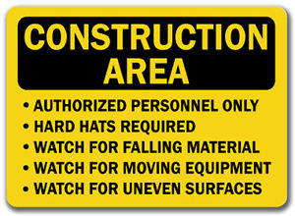
Construction signage is required at the entrance to the site and must note any potential hazards to people in and around the area.

Cranes & other Equipment and Barriers

Cranes and other equipment required for construction must be located so that they will not impede traffic movement around the [Organization Name] grounds and will not pose an overhead hazard.Provide protection around any new openings. This applies particularly where dust barriers are necessary.

Food & Nutrition Services

Approved head covering must be worn when performing work in any food production area.

Working after Hours, Weekends, Holidays

If work is necessary after regular hours, on weekends or holidays, Contractors must coordinate this work with the [Organization Name] Project Representative. Contractors will not permit access without prior approval from the [Organization Name] Project Representative.

Use of Elevators

Contractors must ensure workers traveling through the building with carts or large pieces of equipment use the elevators marked for service use only. Any exceptions or scheduling problems must be prearranged with the [Organization Name] Project Representative. No elevator should be put out of service expressly for the use of a Contractor unless authorized by the [Organization Name] Project Representative.

Infection Control

Air Quality

Contractors are required to follow CSA Standard Z317.13-12 Infection Control during Construction, Renovation and Maintenance of Health Care Facilities

- This work must be performed in accordance with a written infection control plan prepared before the start of the project, by an Infection Prevention and Control Practitioner.
- Post at the entrance to the work area:
- Written infection control plan
- Safe Work Permit
- Required Personal Protective Equipment
- Any other applicable permits
- Create a negative air situation at the work site.
- Tent the doorway with rip stop and fire resistant plastic.
- Cover air diffusers in the construction area with plastic. Check exposed ventilation pipes for leaks and seal where possible.
- Separate the demolition phase of the project and construction phase of the project.
- Tracking mats must be used at the entrance/exit of the workspace.
- Isolation of smoke detectors so that dust does not generate an alarm.
- Before any work begins, it is the responsibility of the general contractor to post at the job site the location of shut off valves to services that pertain to the construction site.
- Construction debris, when transported throughout the facility, must be done using service elevators. All waste materials must be either sealed in plastic bags or covered during transport. Ensure that footwear and equipment is free of dirt and grime, including wheels.
- It is the responsibility of the Contractor to ensure that dust, dirt, vapours, odors and/or contaminants are controlled at the work site.
- In the event that a Contractor discovers mold in a ceiling or wall cavity, the space must be covered immediately and the [Organization Name] Project Representative contacted immediately.
- The General Contractor is responsible to report to the [Organization Name] Project Representative any deficiencies that are seen in the course of carrying out the work even though it may be beyond his/her area or scope of work.

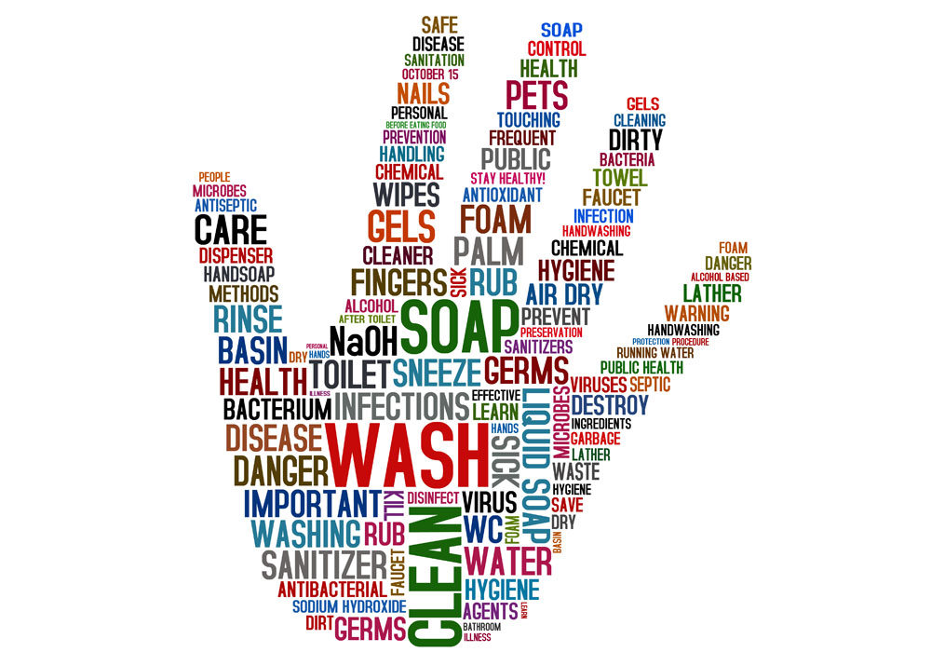

Personal Actions

- Good personal hygiene practices shall be followed at all times. Hands must be washed with approved antibacterial soap following work on toilets, sinks, sewer systems and lab equipment, etc.
- Work in a manner that limits the risk of infection to themselves and to others and limits the possibility of contamination of equipment or furnishings.
- Wash hands with a disinfectant hand cleaner after working on equipment or furnishings that could be a potential source of infection.
- Take extreme care when working with laboratory or other diagnostic equipment to limit the risks of exposure to hazards associated with the equipment.
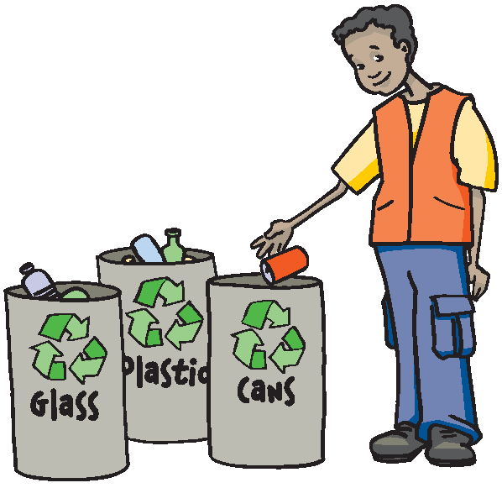
- Make certain that footwear and clothing is clean and free of dirt, mud, grime, etc so as to preserve the cleanliness of the environment.

Removal Of Waste

The Contractor will at all times keep the premises free from the accumulation of waste materials or rubbish caused by the work. At the completion of the work the Contractor will remove all rubbish and all tools, scaffolding and surplus materials from and about the building, leaving the work area clean.

Contractors are responsible for the removal of all waste materials from [Organization Name] facilities. Waste material and construction debris cannot be stored in any part of the facility other than the work site unless space is assigned and permission is given by the [Organization Name] Project Representative. Waste materials that are stored in locations other than the work site, or in areas where permission has not been granted, will be removed by [Organization Name] at the Contractor’s expense.

Other

- Exits must be kept clear at all times.
- Stairwells must be kept clear at all times with the doors closed.
- Pull stations, fire extinguishers and hose cabinets cannot be blocked.
- Flammable liquids must be stored in approved containers and in limited quantities.
- The use of propane or gasoline engines, heaters or machines is strictly prohibited within the facility.
- Materials are not permitted to accumulate on the work site that would constitute a fire safety concern.
- Compressed gas cylinders must be secured to a wall or cart at all times.
- Do Not have products or materials delivered to the facility without prior permission..

Program Responsibilies and Requirements

Contractors are required to follow Occupational Health and Safety Regulations including, but are not limited to sections of the NS Health and Safety Regulations, Fall Protection, First Aid Regulations, Lock-Out, Confined Spaces, Personal Protective Equipment and WHMIS. Addionally, follow all [Organization Name] policy, procedures and guidelines.
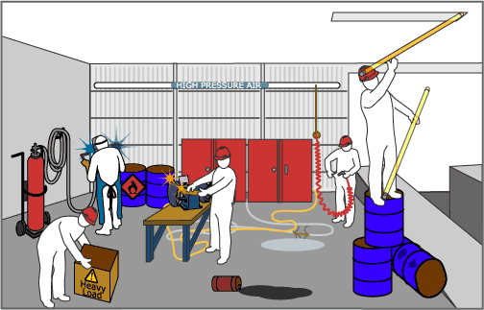

Hazard Assessment

Contractors are required to do an assessment of the hazards involved with the job prior to the start of any job. Hazards are to be eliminated or controlled prior to the start of work. Contractors must ensure the work site is free of hazards that may result in damage to equipment, facilities or injury/illness to persons in the area. This will be documented during the safe work permit process.

Personal Protective Equipment

All reasonable and normal measures must be taken to eliminate any work-related hazards. Where a hazard cannot be eliminated, personal protective equipment provides a final barrier between the worker and a potential hazard or threat to personal health and/or safety. For this reason, it is very important that personal protective equipment is selected, inspected, cared for and used properly to prevent injuries. Personal protective equipment shall be used in accordance with the Occupational Health and Safety Act of Nova Scotia, the Occupational Safety General Regulations (Sections 9-14) and other applicable regulations and standards.

Protection from Hazards
- Ensure that your personal protective equipment (PPE) is designed to provide the protection you need for the potential hazard you are exposed.
- Inspect all equipment before use to ensure it is in good condition.

The following is a list of PPE that should be used when conditions warrant.
When in doubt, wear and use PPE!
Note: Work areas that require personal protective equipment must have signage
that indicates the type of equipment to be worn.

- Eye protection
- Fall protection/arrest
- Steel toed shoes (mandatory at all times)
- Hard hats (mandatory at all times for construction projects)
- Protective clothing
- Hearing protection
- Respiratory protection

Inspection

The [Organization Name] Project Representative will have access to the Contractor’s work at all times, whether it is in preparation or progress. The Contractor must provide such access and inspection as, and when, required by the [Organization Name] Project Representative. If the specifications, ordinances or any public authority require any work to be specially tested or approved, the Contractor will give the [Organization Name] Project Representative two weeks notice (unless otherwise agreed) of its readiness for inspection. If the inspection is by an authority other than [Organization Name], notice must be given of the date and time fixed for such an inspection.

[Organization Name] Representatives have the right to inspect workplaces to ensure that Contractors are compliant with all relevant Occupational Health and Safety Regulations, Fire Safety Regulations and other established Acts and Regulations as may apply, as well [Organization Name] policy and proceduces.

Medical Gases/Compressed Air & Gases/Steam
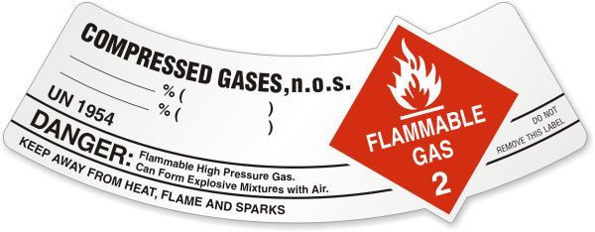
The rupture of lines or vessels carrying gas, compressed air or steam could result in disruption of services, serious injury or death. Contractors must ensure all lines and vessels are identified and proper safety procedures are in place prior to working around existing equipment.

Asbestos Management

[Organization Name] has adopted a strict policy and procedure for working in areas that contain asbestos. This includes appropriate training, specialized equipment, specialized clothing and other protective equipment and on-site procedures such as tenting, cleaning and waste management. Contractors who find (or suspect) asbestos in the course of their work must cease work immediately and contact the [Organization Name] Project Representative.

Only workers who have received proper training in asbestos control and removal procedures may enter or work in areas where asbestos is present.

Protection of Work Property and Persons

- Contractors are responsible for including in their work all necessary methods, materials and construction to ensure that no damage is done to [Organization Name] property and that no harm is done to any person as a result of the work.
- Contractors are responsible to make certain that no tripping hazards result from work being performed on [Organization Name] property. Every effort must be made to identify and correct any and all tripping hazards immediately. There is always potential for guests, visitors and/or staff to wander into worksite areas and every effort must be made for their safety.
- Contractors must ensure that all tools, equipment, supplies, etc. are secured and inaccessible to guests, visitors and/or staff to prevent such being picked up and/or used in an unsafe manner.
- Contractors must ensure that they protect existing mechanical, electrical, telephone, fire and similar services from damage. If necessary, Contractors must relocate active services to ensure that they function continuously in a safe manner and without risk or damage.

Protection of Existing Services

Contractors must take every reasonable precaution to ensure that existing services are not damaged or interrupted during demolition and/or construction. Two weeks notice must be given before any kind of service interruption - i.e., plumbing, gas, electrical, etc. is anticipated. The notice must be in writing (Contractor’s Notice of Service Interruption) to the [Organization Name] Project Representative of the intention to interrupt mechanical and/or electrical services in any area. Should existing services be accidentally uncovered and disrupted, the Contractor must restore those services immediately and ensure adequate protection is provided to avoid further damage. The [Organization Name] Project Representative must be contacted immediately.

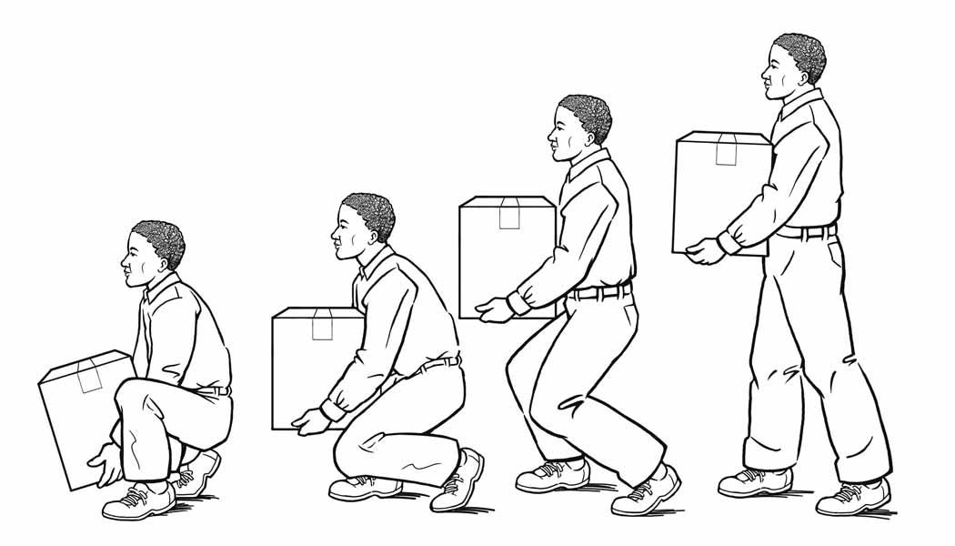

Back Safety

Protecting your back from injury requires good posture and proper lifting techniques. While lifting maintain three gentle curves in your back: inward at the neck, out at the chest region and in at the lower back.

Proper lifting techniques can easily be remembered by using the acronym: BACK
B is for BALANCE. Maintain proper balance. Take a wide stance. One foot ahead of the other, and make sure you have a good grip on the object before you lift it.
A is for ALIGN. Keep your back properly aligned being careful not to twist or bend from the waist.
C stands for CONTRACT. Tighten your stomach muscles, and keep the load CLOSE to your body.
K is for KNEES. Bend your knees when you lift or lower objects so that you use your legs and not you back.

Fall Protection & Scaffolding
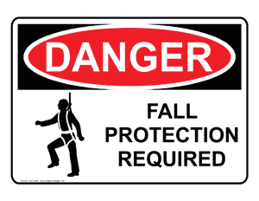
[Organization Name] requires any Contractor working at height of 3m or greater to comply with the Nova Scotia Fall Protection (Workplace Health and Safety Regulations, section 21) and Scaffolding (Workplace Health and Safety Regulations, section 23) Regulations. All roof work must be completed by at least two workers. All appropriate fall protection equipment and devices including full body harnesses, lifelines, lanyards and protective railings is required.

Ladders

When climbing up or down, workers should always be facing the ladder and use three-points of contact at all times. All ladders must be CSA Grade 1. When using a straight or extension ladders, place the ladder on a firm surface. Make sure it has slip resistant feet, use secure blocking as well as, ensure the ladder is secure. The top of the ladder should extend at least 3 feet above the roofline. Follow the “4 to 1” rule; the base of the ladder should be one foot back for every four vertical feet. Do not leave ladder(s) unattended.

Confined Spaces
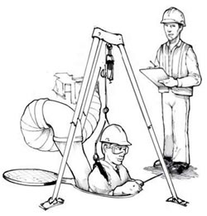
- Any work to be performed in a confined or enclosed space requires at least two persons who have approved confined space training. Contractors must follow the NS Occupational Safety General Regulations (sections 129-137).
- The appropriate testing must occur prior to entering the space and beginning work. Required dovumentation before entry, Safe work permit, confined spaces permit, written entry plan and an emgerngency rescue plan
- Where required, the appropriate respiratory protection shall be worn.

Hot Work

Any hot work to be performed will occur only after a signed hot work permit is obtained. [Organization Name] Representative must observe the work area prior to signing the permit and a fire watch must remain in effect during the work and for a period of time indicated on the safe work permit.
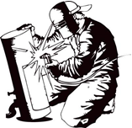

Lock out/Tag out


Lock out/tag out is a six step procedure to control hazardous energy and protect workers who are servicing or performing maintenance on equipment from injury or death.

- Prepare for shut down
- Shut down the equipment
- Isolate the equipment
- Apply lock out/tag out devices
- Control stored energy
- Verify isolation of equipment

When Contractors are performing work for [Organization Name] they are required to:

- Hold a Safe Work Permit issued by a [Organization Name] Representative with their phone number so that they can be contacted if they leave the site and do not complete the permit properly.
- Put his or her lock on any piece of equipment that must be locked out. Open permits are to be posted in a common area for all employees to see.
- Report to the representative when work is complete and request to have the permit closed. The representative will not close the permit until the work and work area has been inspected and that all locks have been removed.
- Sign off for work completed when the representative is satisfied that the work is complete.

Any Contractor that leaves the site and does not properly sign off the permit or does not remove any locks placed on equipment must return to the site immediately and report to the representative.

Workplace Violence Prevention

[Organization Name] is committed to providing a safe and secure work environment for its employees and any other persons whom may be at or near the workplace. [Organization Name] is also committed to providing a safe and secure work environment where all individuals are treated with respect and dignity. [Organization Name] recognizes that violence in the workplace is an Occupational Health and Safety Hazard that can cause physical and emotional harm. All forms of violence in the workplace are unacceptable and every effort will be made to minimize, and to the extent possible, eliminate the risk of violence in our workplace.

[Organization Name] is committed to work with employees to maintain an environment free from violence and threats of violence, as well as complying with the requirements under the Workplace Violence Regulation. Reporting acts of violent behaviour is the responsibility of all employees. All reports of such incidents are taken seriously and will be dealt with appropriately. These incidents will be investigated to reduce the risk of violence in the workplace to ensure continuous improvement.

All Contractors, at all levels, will apply this policy and will actively promote an organizational culture where violence is eliminated or effectively controlled. All employees are essential to achieving this through positive behaviour modelling.

Rough language and behaviour is not permitted at any time.
Incident/Near Miss Reporting

In the event of an incident or near miss, an incident report is to be completed by the Contractor and a copy of this is to go to [Organization Name] Project Representative. Incidents are to be initially investigated by the Contractor and the [Organization Name] Project Representative and reported to Management immediately. The designated person must be immediately notified by the Contractor Project Representative of any accidents or incidents that have or have the potential to result in:

- the injury of any person
- property damage, fire or explosion
- impact on patient/client/resident care services

Note: Any incident/near miss that occurs on [Organization Name] property that is reported to the Department of Labour and Advanced Education, under Section 63 of the Act, must be reported immediately by the Contractor Project Representative to [Organization Name] Designate.

Fire Safety

Overview of Fire Procedures

Fire procedures are written to cover what is to be followed upon the discovery of a fire or the activation of the fire alarm. It is important to know the basic response to fire alert situations in any of the [Organization Name] facilities.

Fire Safety Procedures

Fire procedures are posted in every building and all [Organization Name] staff is expected to be familiar with them and carry out the procedures in any fire alert situation. It is the responsibility of all Contractors and their workers to know the proper response to a fire situation.

Fire Warden [Organization Name] Project Representative are in charge for the duration of the alarm and are authorized to delegate tasks and request assistance from any personnel in the affected area. Contractors and their workers are to follow the directions of the Fire Wardens in a fire alert or fire alarm situation. They are to suspend all work activity until the “All Clear” announcement is made.

Fire Prevention

Contractors are responsible to ensure that work practices and job sites are maintained to prevent the possibility of a fire in [Organization Name] facilities.

Fire Extinguishers

Contractors are responsible for providing approved portable fire extinguishers on the work site.

Fire Separations / Fire Walls / Stops

Any and all openings that penetrate fire walls and walls used for smoke control must be sealed with an approved fire rated material that maintains the overall fire rating of the wall. Penetrations of smoke control walls must be sealed with materials that maintain the fire rating of the wall and maintain smoke control integrity.

Discovery of Fire

Every fire situation is different. The principal actions listed below however, must be applied whenever possible in the event a fire is discovered in the work site.

– Remove persons in immediate danger of fire.
– Activate the alarm system using the nearest pull station.
– Confine smoke and fire by closing doors in your area.
– Extinguish the fire if safe to do so, or continue to evacuate.

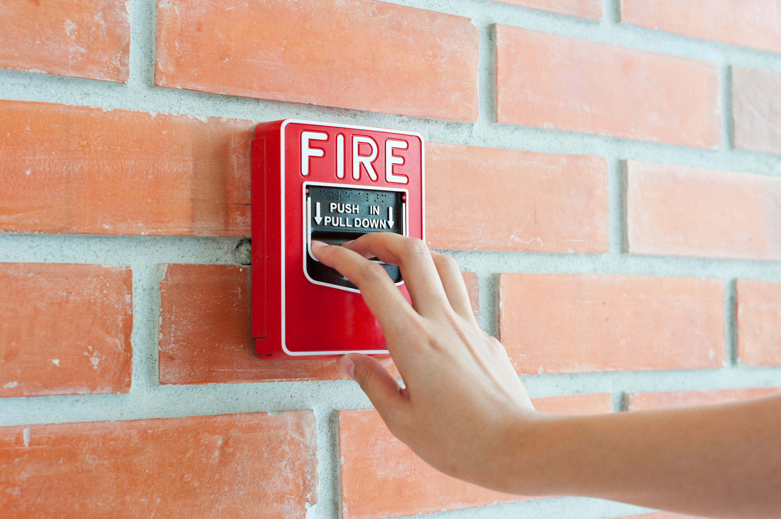
Contractors are responsible to:

- Know where the closest fire extinguishers are located.
- Know where the closest fire alarm pull station is located.
- Know where the emergency fire exits are located.
- Know the fire alert procedures for their work site.

Fire Alarms

An organization may use a single stage fire alarm, a two stage fire alarm or a combination of both.

Single Stage Fire Alarm

[Organization Name] has a single stage fire alarm system.

Upon activation of the fire alarm at these sites, all persons are to:
- Close all doors
- Immediately evacuate the building using the nearest, safe fire escape route.
Or

Two Stage Fire Alarm

[Organization Name] has a two stage fire alarm system.

Upon activation of the fire alarm in any of the [Organization Name] facilities, all persons are to:

- Close all doors.
- Remain in the area and wait for directions via the public address system before resuming work activities or returning to the building.

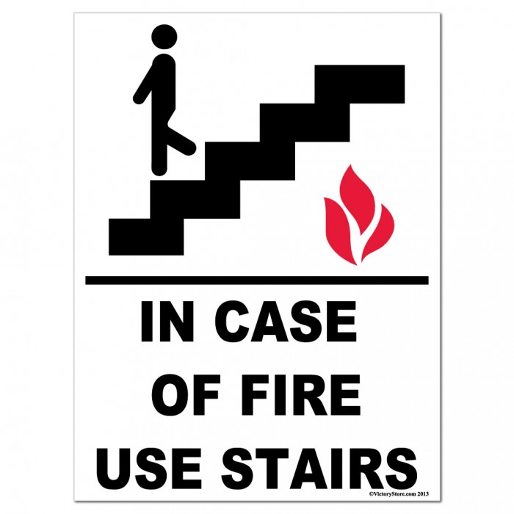
Be prepared to evacuate the area if:

- The situation in your area threatens the safety of resident/client/patient, visitors and staff.
- Directed by the Fire Department or Facility Personnel.

Await the “All Clear” announcement over the public address system.

Remember…

- Do not continue routine work during the fire alarm.
- Do not use the elevators during the fire alarm.
- Ensure that people in your area are aware of the alarm.
- Prevent panic by reassuring others that everything is all right.
- Know where the closest fire extinguishers are located.

Accidental Activation of Fire Alarms by Contractors

Preventable, false alarms are disturbing and potentially harmful in a healthcare or community service setting. Failure to arrange with Plant/Maintenance for the deactivation of fire protection devices that may be affected by work, and a subsequent accidental activation of the fire alarm system, may result in a fine levied against the primary Contractor responsible for the workers involved.

Deactivation of the Sprinkler Sstem and/or Smoke/Heat

Excessive dust, fumes, mists, heat or smoke can activate the fire alarm system. All requests for the deactivation of any fire protection device to allow for work that may accidentally activate the fire alarm are to be forwarded to the site plant maintenance personnel at least 48 hours in advance of the proposed start time. Contractors will contact plant maintenance when the work is completed or when stopped at the end of a workday. See Section “Accidental Activation of Fire Alarms by Contractors”

Chemical Safety

Workplace Hazadous Materials Information System WHMIS 2015

WHMIS 2015 is a nationwide system designed to provide information on hazardous materials used in the workplace. All Contractors must be WHMIS 2015 compliant and be able to demonstrate that their employees have had the appropriate training. WHMIS 2015 consists of:

- Classifications and Labels on hazardous materials that alert workers and staff to hazards.
- Pictograms that reflect the severity of the hazard.
- Safety Data Sheets (SDS) that provide detailed information on the physical and reactionary hazards, appropriate protective equipment, first aid and cautionary data, etc., on various aspects of the product.
- Worker Education that provides instruction on hazards and training in work procedures.

Contractors are required to:

- Ensure that a Safety Data Sheet (SDS) is readily available on site to their employees working with a controlled product. In the event of a spill, the SDS must be available to the spill responders.
- Ensure that all controlled products used on the job site are properly labeled with supplier labels or any other labels required by law. If a label is accidentally damaged, or if the hazardous material is transferred to another container, a workplace label must be used.
- Storage of controlled products on site must adhere to appropriate regulations and safety controls.
- Workplace labels must contain the following information:

- The identity of the product
- How to handle it safely
- The availability of the SDS

- Demonstrate that WHMIS 2015 training has been provided to employees who are required to work with or near controlled products. The program that Contractors teach, must deliver the information that an individual needs in order to work safely with a hazardous material.

Controlled hazardous products must be labeled as follows:

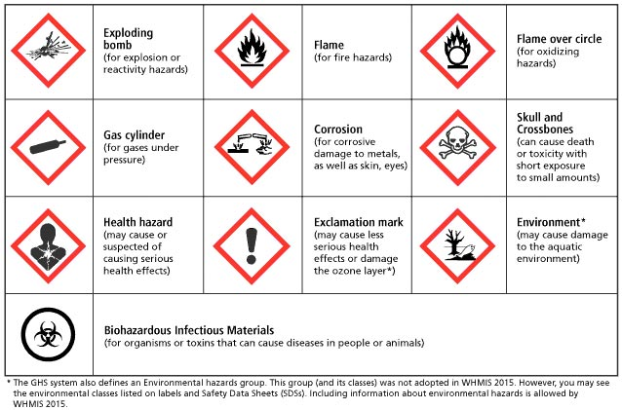

Chemical Spills

In the event of a chemical spill the SDS shall be utilized to provide direction regarding containment and cleanup.

The spill must be reported immediately to the facility representative. Appropriate facility and/or Fire Department resources will be contacted to respond to the situation. The SDS must be available to emergency personnel. (See WHMIS information.)
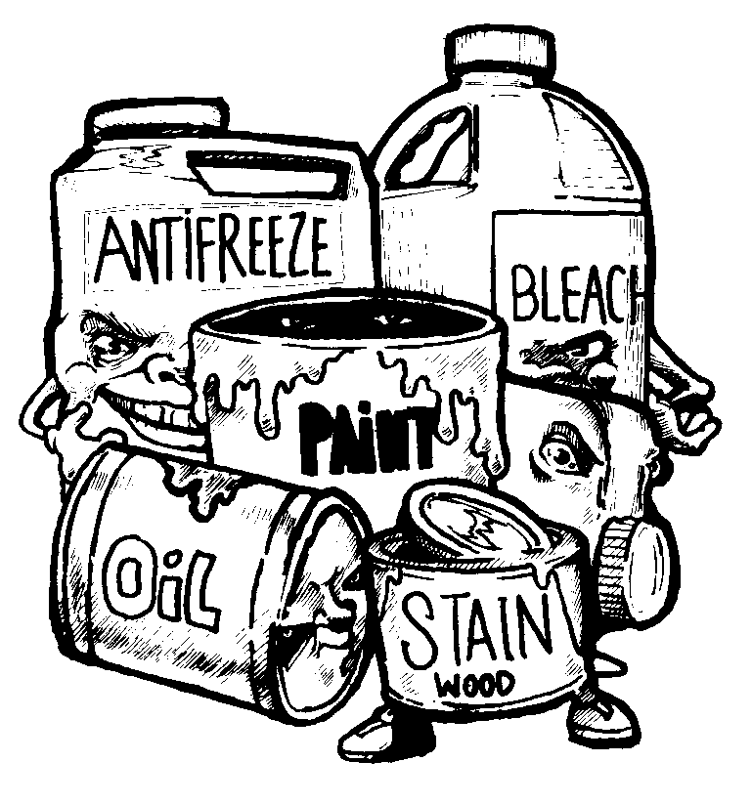

Transportation of Dangerous Goods

Workers transporting dangerous goods into the facility must have the proper certification and abide by the laws and regulations governing the Transportation of Dangerous Goods in Canada.

Chlorofluorocarbons

[Organization Name] follows the Codes of Practice for the Reduction of Chlorofluorocarbon Emissions from Refrigeration and Air Conditioning Systems EPS1/RA1 March 1991.

Contractors coming into the facility must abide by all current rules and by-laws regarding Chlorofluorocarbons.

Security

Identification

- All Contractor employees entering [Organization Name] facilities must;
  - at any time must be able to identify themselves
  - Follow the sign in and out procedured

Access

- Contractors needing to gain access to locked areas (e.g. mechanical and electrical rooms) during the day should call [Organization Name] Project Representative at the sites.
- Contractors must make any necessary arrangements to work after hours with the [Organization Name] Project Representative before the start of work. If access is needed to locked areas after hours (Monday – Friday 5 p.m. – 8 a.m. and anytime on weekends and holidays), Contractors must make arrangements with the [Organization Name] Project Representative.

Parking

- [Organization Name] will tow policy any vehicle that is parked in a fire lane or any designated No Parking area.

Thefts

- All criminal acts, thefts or security violations must be reported to [Organization Name] Project Representative immediately.
- Contractor’s property lost through deliberate damage or theft, while not the responsibility of [Organization Name], should be reported to [Organization Name] Project Representative.

Contractor’s Orientation Check List

Name (print):____________________________

Company: ______________________________

- Check in/out procedure ____

- Emergency Evacuation/Muster Area ____

- Safety Policy signed off ____

- Confidentially agreement signed off (if applicable) ____

- Contractor Policy signed off ____

- Safe Work Permits( if applicable) ____

- PPE ____

- Washroom Lunchrooms ____

- All Required Documentation ____

- WCB

- Insurance

- Handbook read and understood ____

This will certify that I have been given __________________(name) orientation briefing on the above noted subjects as indicated by me with an “X” and that I fully reviewed and understand its contents.

Signature: _________________________________Date:__________________

Designate: _________________________________Date:_________________

Prepared By________________ Date: _____________________

