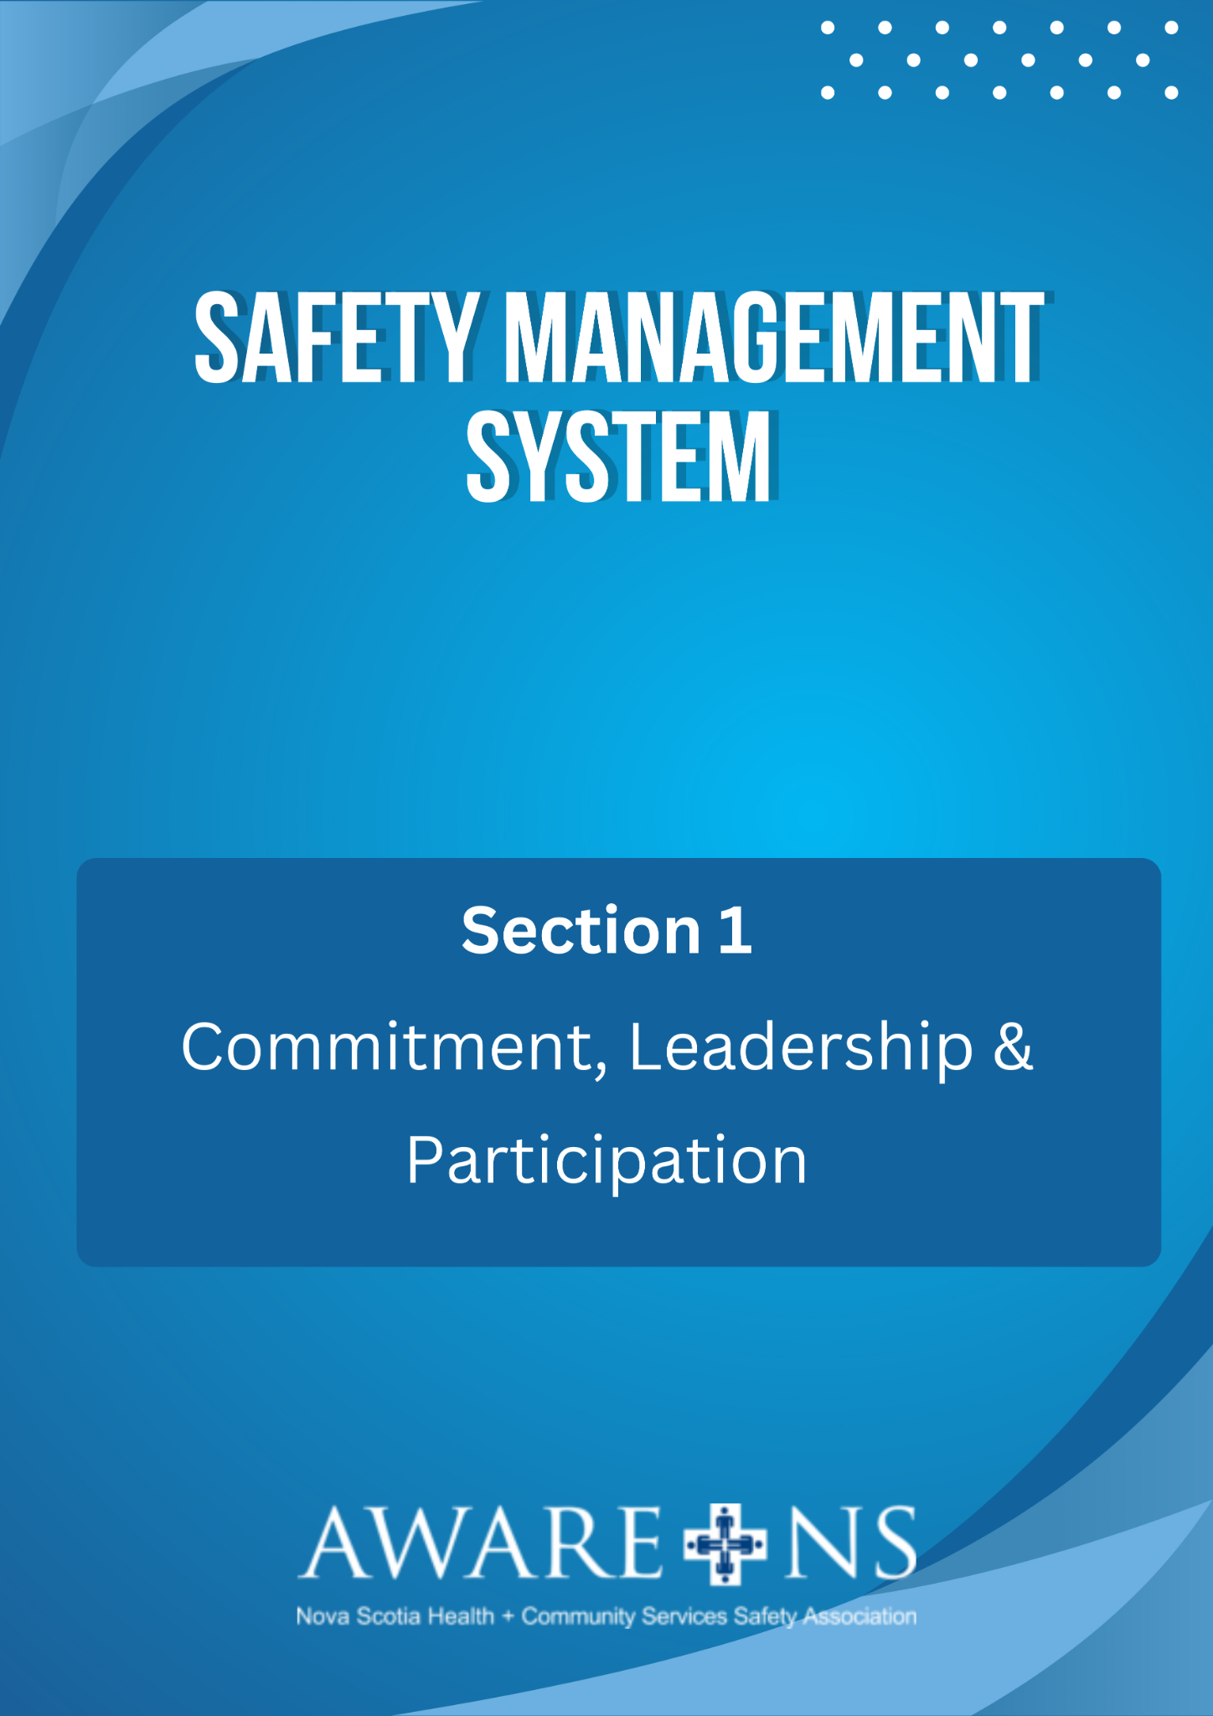

TABLE OF CONTENTS

Section 1: Commitment, Leadership and Participation

Introduction……………………………………………………………………………….……………..……………..2
Safety Management Cycle…………………………………….…………………………..………….…………..2
Safety Policy (Sample).………………………………….…………………………………..….…………..………3
Assignment of Responsibility and Accountability for Safety…………………….………….……..4
Senior Leadership……………………………………………………………………………………………………4
Managers…………………………………………………………………………….………………………………….4
Supervisors…………………………………………………………………………………………………….……….4
Employees.…………………………………………………………………………………….……………………….5
Joint Occupational Health and Safety Committee…………………………………….….………….5
Nova Scotia OHS Act and Regulations……………………………..……………………….…………….….6
Nova Scotia Occupational Health and Safety Act…………………………………………..…….….6
Internal Responsibility System (IRS)…………………………………………………………………..…...6
Due Diligence ……………………………………………………………………………………………………......6
Workplace Safety Rights……………………………………………………………………………………......7
Work Refusals Under the OHS Act .………………………………………………….……………….…….7
Report to a Supervisor or Manager …………………………………………………….……………….…8
Referral to the JOHS Committee………………………………………………..…………….….………….8
Formal Referral to the OHS Division, DSLI …………………………………………..……….…….…..9

Appendix 1.1: Safety Policy
Appendix 1.2: Right to Refuse Unsafe Work Form

Introduction

Each day our employees provide care and assistance to our clients, visitors and each other. This means our employees are exposed to a variety of ever-changing workplace hazards that can have both short-term and long-lasting physical and mental effects.

This Safety Management System was developed by [Organization Name] to provide guidance in establishing our occupational health and safety programs, systems and processes. It is a proactive process that helps effectively manage all safety aspects within our organization.

Our Safety Management System consists of thirteen elements. Each element outlines a specific component of our Safety Management System.

Elements of the Safety Management System consist of:

- Commitment, Leadership and Participation
- Hazard Management
- Workplace and Equipment Inspection
- Incident Management
- Emergency Preparedness
- Training
- Safe Work Practices
- Joint Occupational Health and Safety Committee
- Contractor Safety
- Stay at Work/Return to Work
- Communication
- Documentation
- Monitoring

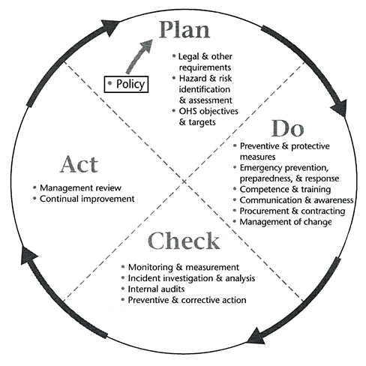
Safety Management Cycle

Our Safety Management System is built on the well-recognized Plan, Do, Check and Act continuous improvement cycle.

This framework allows for the continual identification, elimination and control of hazards to protect our clients/residents, employees, visitors and assets from injury and illness. It accomplishes this by initiating organizational structures that include policies, procedures, accountabilities, monitoring/evaluating systems, employee participation and emergency preparedness.

Safety Policy

[Organization Name] is committed to providing a healthy and safe work environment for its employees and to prevent occupational illness and injury.

The health and safety of each employee of [Organization Name] is of primary importance. The prevention of occupationally induced injuries and illnesses is of such consequence that it will be given priority. To the greatest degree possible, management will provide all required for health and safety in keeping with the highest standards.

[Organization Name] will maintain a health and safety program conforming to the sector’s best practices. The program must start with proper attitudes toward injury and illness prevention, which relies on cooperation at all levels of the organization – senior management, managers/supervisors, employees and JOHSC/JOHS representative. Only through such a cooperative effort can a safety program be established and fostered.

[Organization Name]’s objective is to minimize the number of injuries and illnesses and become safety leaders in the sector.

Our health and safety program will:
- Recognize that the responsibilities for health and safety are shared;
- Provide safeguards to meet or exceed sector standards;
- Conduct workplace inspections to identify and control hazards and unsafe practices;
- Provide necessary personal protective equipment (PPE) and instruction for its use and care;
- Develop and ensure compliance with health and safety rules;
- Promptly investigate every incident to establish root cause and to take corrective action to prevent reoccurrence;
- Establish leadership responsibility and evaluation of the health and safety program and provide the safeguards required to ensure safe conditions;
- Ensure Supervisors model proper attitudes toward health and safety in themselves and in those they supervise. Supervisors are accountable for ensuring that employees under their supervision follow policies, utilize safe work practices and receive proper training to protect their health and safety;
- Ensure Employees comply with all aspects of the health and safety program, including reporting any hazardous condition(s), injury, incident or illness related to the workplace to a Supervisor, as soon as possible; and
- Recognize, support and encourage employees to play an active role in identifying hazards and to offer suggestions or ideas to improve the health and safety program.

The senior leadership of [Organization Name], in conjunction with the Joint Occupational Health and Safety Committee, will review this policy and its effectiveness on an annual basis.

Assignment of Responsibility and Accountability for Health and Safety

[Organization Name] recognizes that all employees share the responsibilities for health and safety.

Senior Leadership

- Accept the responsibility for providing the leadership of the health and safety program, for its effectiveness and improvement.
- Create a culture of responsibility and accountability for leadership of the health and safety program.
- Ensure all required health and safety processes and practices are implemented and adequate.
- Ensure all required health and safety tools, equipment and personal protective equipment (PPE) are provided.
- Ensure Supervisors develop the proper attitudes toward health and safety in themselves and to those for whom they are directly responsible.
- Foster a culture of co-operation in all aspects of the health and safety program by continually practicing safety while performing duties.
- Continually monitors and reviews the program elements to ensure effectiveness.

Managers

- Provide information, instruction, and assistance to all supervisory staff in order to protect the health and safety of all Employees.
- Understand and enforce our incident prevention policies, as well as the Occupational Health and Safety Act and its regulations.
- Provide all supervisory staff with proper education to maintain and use tools/equipment as well as any other required personal protective equipment (PPE).
- Provide ongoing safety education programs specific to the task(s) being performed.
- Monitor departments/homes/workplaces and contractors and hold them accountable for their safety performance.
- Support and encourage employees to play an active role in identifying hazards and offers suggestions or ideas to improve the health and safety program.
- Ensure every incident is investigated thoroughly to determine root cause and take corrective action.

Supervisors

- Know and apply all aspects of the program and relevant sections of the Occupational Health and Safety Act and Regulations.
- Ensure that all Employees are educated on required health and safety processes and practices.
- Ensure that all Employees are educated on required health and safety tools, equipment and personal protective equipment (PPE).
- Advise all Employees of any potential or actual hazards and how to isolate, prevent or remove them.
- Arrange for medical treatment, as required, including transportation to a doctor or hospital, as necessary.
- Investigate every incident promptly and thoroughly to determine the root cause in order to advise management on corrective action.
- Conduct workplace inspections to recognize, assess and control unsafe working conditions and practices.
- Continually monitor all aspects of the workplace in order to identify, assess and control workplace hazards.
- Cultivate proper attitudes toward health and safety in themselves and in those they supervise.

Employees

- Read, understand and comply with the health and safety program, safe work practices, procedures and processes.
- Use all required health and safety tools, equipment and personal protective equipment (PPE).
- Report any hazardous conditions or acts.
- Report all incidents and injuries to their Supervisor as soon as possible.
- Cooperate with all aspects of the health and safety program.

Joint Occupational Health and Safety Committee

  - Performs the functions of a joint occupational health and safety committee as defined in sections 29, 30 and 31 of the OHS Act.
  - Makes recommendation(s) on health and safety concerns to Senior Leadership.
  - Holds regular meetings in accordance with written Terms of Reference/Rules of Procedure and operating procedures.
  - Maintains minutes and records of committee activities.
  - Works co-operatively with management and employees to identify hazards to health and safety and make recommendations on corrective actions.

Nova Scotia OHS Act and Regulations

Nova Scotia Occupational Health and Safety Act

The Nova Scotia Occupational Health and Safety Act and regulations are the laws governing occupational health and safety (OHS) in the province. Everyone working needs to know and understand their rights and responsibilities under this law.

The organization shall ensure that applicable legal requirements and other requirements are incorporated in its SMS.

A copy of the OHS Act may be found on the Nova Scotia Government website https://nslegislature.ca/sites/default/files/legc/statutes/occupational%20health%20and%20safety.pdf

The Internal Responsibility System (IRS)

The foundation of the OHS Act is the Internal Responsibility System. It is the philosophy that all parties who can affect the health and safety of persons at the workplace share the responsibility for health and safety. Each has primary responsibility for creating and maintaining a safe and healthy workplace to the extent of that party's authority and ability to do so.

The remainder of the OHS Act defines the rights, roles and responsibilities of the various parties in detail, as do the several regulations developed under the Act

Nova Scotia OHS Regulations

Below, are the Regulations in Nova Scotia that are considered in the development of this program:

- Administrative Penalties Regulations
- Controlled Products Regulations
- Occupational Health and Safety First Aid Regulations
- Occupational Safety General Regulations
- Smoke-free Places Regulations
- Violence in the Workplace Regulations
- Workplace Hazardous Materials Information System (WHMIS)
- Workplace Health and Safety Regulations

Due Diligence

Due diligence refers to the level of judgement, care, prudence, determination and activity that a person would reasonably be expected to undertake in particular circumstances. This is sometimes referred to as the ‘reasonable person’ standard for preventive activity associated with hazardous operations.

The OHS Act requires parties to take every precaution that is reasonable in the circumstances. It also requires all parties to comply with the Act and regulations. If a violation of the Act or regulations occurs, due diligence will be a key defense.

Workplace Safety Rights
The Right to Know - Employees have a right to information on issues that affect their health and safety or that of other persons in the workplace.
The Right to Participate – Employees have the right to report unsafe conditions and voice their concerns or opinions on any issue that affects their health and safety or the health and safety of anyone at the workplace. This includes participating in and the selection of members of a Joint Occupational Health and Safety Committee (JOHSC).
The Right to Refuse Unsafe Work – Employees have the right to refuse any act where the employee has reasonable grounds for believing that the act is likely to endanger their health and safety or that of any persons in the workplace until:
- Remedial action is taken to the satisfaction of the employee; or
- The JOHSC has investigated the matter and, with a unanimous decision, advised the employee to return to work; or
- An OHS Officer from the Department of Labour, Skills and Immigration (DLSI) has investigated.

Work Refusals Under the OHS Act

Every employee has the right to refuse to do any act which he/she believes is likely to endanger his or her health or safety or the health or safety of another person, but must follow the procedure for doing so which is set out in Section 43 of the OHS Act.

Section 43(1) of the OHS Act states:

“Any employee may refuse to do any act at the employee's place of employment where the employee has reasonable grounds for believing that the act is likely to endanger the employee's health or safety or the health or safety of any other person until:

(a) the employer has taken remedial action to the satisfaction of the employee;
(b) the (JOHS) committee, if any, has investigated the matter and unanimously advised the employee to return to work; or
(c) an (OHS) officer (of the Department of Labour, Skills and Immigration) has investigated the matter and has advised the employee to return to work.”

Additional details on dealing with unsafe work refusals are outlined in the remainder of Section 43 and in Section 44 of the OHS Act.

Report to a Supervisor or Manager

The first level in exercising the right to refuse unsafe work is for the employee to:

- Report the problem to his or her immediate Manager/Supervisor.
- The employee should remain in a safe place until the problem is eliminated or controlled to their satisfaction or until they are assigned another task.
- While the investigation of the refusal and any remedial action(s) is being carried out, the employee may be assigned to other duties.
- The Manager/Supervisor will investigate the refusal and correct the situation or control the hazard, as applicable.
- The Manager/Supervisor’s conclusions will be communicated to the employee who exercised the unsafe work refusal.
- If the Manager/Supervisor concludes that there is no hazard, or that the hazard is adequately controlled, an explanation must be given and the employee advised to return to work.
- If the employee is satisfied that the refusal has been resolved or accepts the explanation given by the Manager/Supervisor, then he/she should return to work and the matter is concluded.
- The Manager/Supervisor will document the work refusal, discussions and outcomes.

Where an employee has exercised their right to refuse under section 43 of the OHS Act, no other employee will be assigned to do that work unless the replacement employee has been advised of the refusal by the first employee, the reason for the refusal, and the replacement employee’s right to refuse under Section 43.

Referral to the JOHS Committee

If the hazard or concern has not been remedied to the employee’s satisfaction, the employee will exercise the next level in the unsafe work refusal process:

- The Supervisor will forward the work refusal to the JOHS Committee Co-Chair.
- The JOHS Committee Co-Chair will initiate an immediate investigation by the Committee.
- The employee who has exercised the right to refuse must be given the opportunity to accompany the JOHS Committee on a physical inspection of the workplace for the purpose of ensuring that the investigators understand the reasons for the refusal.
- The JOHS Committee may agree with the employee who has exercised the unsafe work refusal and, in such case, will recommend to management how to correct the problem.
- If the JOHS Committee does not find reason to support the work refusal, it may advise the employee to return to work, but such direction must be the unanimous decision of the JOHS Committee.

Formal Referral to the OHS Division, Department of Labour, Skills and Immigration

If the JOHS Committee cannot agree unanimously that the employee should return to work, or if the problem is still not resolved to the employee’s satisfaction:

- The JOHS Committee or the employee who is not satisfied with the outcome of his/her work refusal will contact the Occupational Health and Safety Division of the Department of Labour, Skills and Immigration (1-800-952-2687).
- An OHS Officer will take the case on a priority basis and will investigate as soon as possible.
- If the Officer finds that the task refused is unsafe, he/she will ensure that no one performs the task until appropriate action is taken to remedy the situation.
- If the Officer cannot find indications that the task is unsafe, or finds that the hazard has been adequately controlled, he/she will advise the employee to return to work.
- These findings will be confirmed in writing to the employee and the organization.

