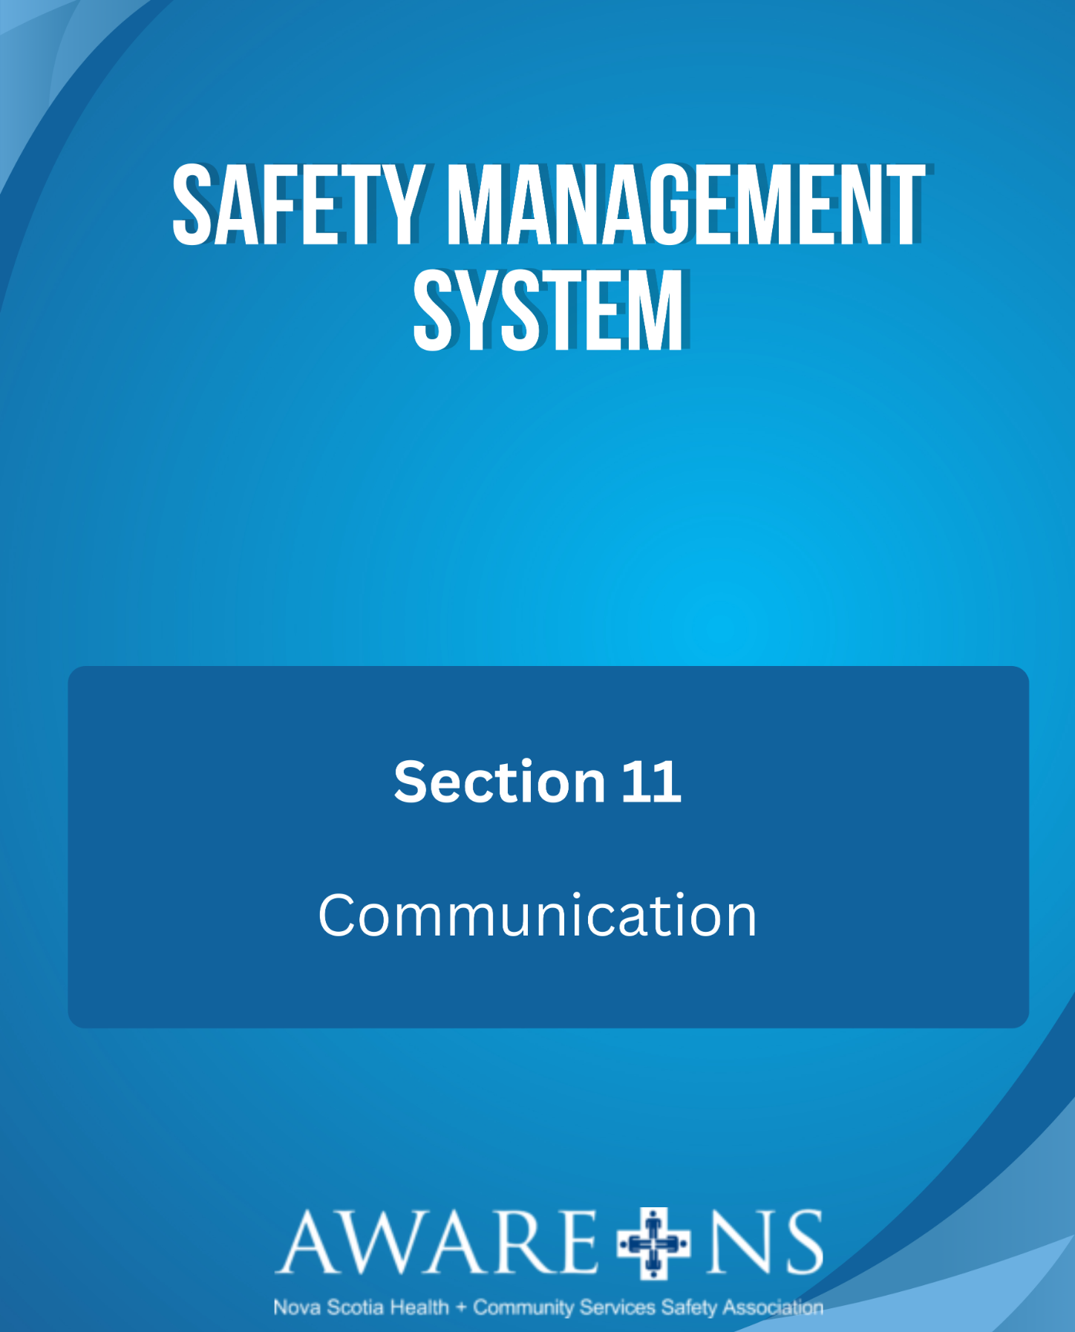

Table of Contents

Section 11: Communication

Introduction………………………………………………………………………………………………………………….....3

Awareness of the Safety Management System…………………………………………………………………3
Communicating Workplace Hazards…………………………………………………………………….…………..3
Employee Making OHS Suggestions to the Supervisor ………………………………………………………7
OHS Bulletin Board(s) and Other Information …………………………………………………………………7
Safety Huddles ………………………………………………………………………………………………………….…….8

Appendix 11.1, Safety Huddle Template
Appendix 11.2, Safety Huddle Booklet

Introduction

Communication with employees regarding all aspects of the Safety Management System (SMS) is fundamental to the Internal Responsibility System (IRS).

[Organization Name] has a system that allows collaboration between management and employees to:
- Share information regarding hazards, concerns, suggestions and updates;
- Report incidents;
- Submit work refusals; and
- Participate in inspections.

[Organization Name] is committed to providing feedback to employees regarding all safety matters.

Awareness of Safety Management System

The Manager or Supervisor of each new employee is responsible to ensure that the employee’s orientation session includes information on the SMS.

Communicating Workplace Hazards

[Organization Name] will ensure employees understand their role and responsibility to report hazards and that management will communicate known hazards in the workplace.

Management will communicate this information through:
- Orientation and training;
- Safe work procedures;
- Incident investigation and root cause analysis;
- Hazard report forms (see Appendix 2.1);
- Work refusals; and
- Safety Huddles/email/memo/OHS board.

Employees will communicate this information through:
- Reporting to their Supervisor;
- Incident report forms;
- Hazard report forms (see Appendix 2.1); and
- JOHS committee members.

Employee Making OHS Suggestions to the Supervisor

At [Organization Name], employees are encouraged to make suggestions regarding health and safety. These suggestions should be directed to their Supervisor or Manager. Employees are encouraged to write their suggestions down so that they can be easily considered and forwarded.

A JOHS Committee member who receives a suggestion should clarify with the employee that it has already been brought to their Supervisor. Once confirmed, the JOHS Committee member will bring the suggestion to the next meeting. The result of that discussion will be recorded in the minutes of the meeting. The JOHS committee member will report the outcomes of the discussion back to the employee. Sharing a suggestion is not the same as reporting a hazard.

OHS Bulletin Board(s) and Other Information

The OHS Act requires that certain information be posted for ready access by employees. [Organization Name] will maintain either a physical OHS Bulletin Board(s) or electronically on intranet sites.

The following information must be posted on each OHS Bulletin Board:

- The OHS Act;
- OHS Policy, signed and dated (annually);
- The 24-hour phone number for the Occupational Health and Safety Division of the Department of Labour, Skills and Immigration: 1-800-952-2687;
- JOHS Committee information, including the names of the committee members, work locations and contact information;
- The most recent JOHS Committee minutes;
- Any order, compliance notice, notice of appeal or decision from the Occupational Health and Safety Division of the Department of Labour, Skills and Immigration;
- Requests for a deviation, as applicable;
- Names of qualified first aid attendants; and
- Workplace violence prevention statement, signed and dated (annually).

The following information must be readily available (but does not need to be posted on the OHS Bulletin Boards):

- The fire / emergency evacuation plan for this location;
- SMS Program;
- SDSs for hazardous materials used or stored at this location;
- Records of workplace OHS inspections; and
- Records of workplace OHS monitoring or tests.

Safety Huddles
Safety huddles are typically short meetings of, ideally, the entire inter-professional team, held at the same time each shift. See Safety Huddle Template (Appendix 11.1) for help documenting the agenda and results.
Safety issues raised may include:
- Client/resident/participant change in mobility status;
- Changes to a client/resident/participant’s cognitive functions or behaviours;
- Equipment/device issues (maintenance, availability, etc.);
- Environmental concerns (clutter in rooms, etc.); or
- Staffing complement (numbers, experience levels, etc.).
Safety Huddles should be facilitated by the supervisor or delegate.

