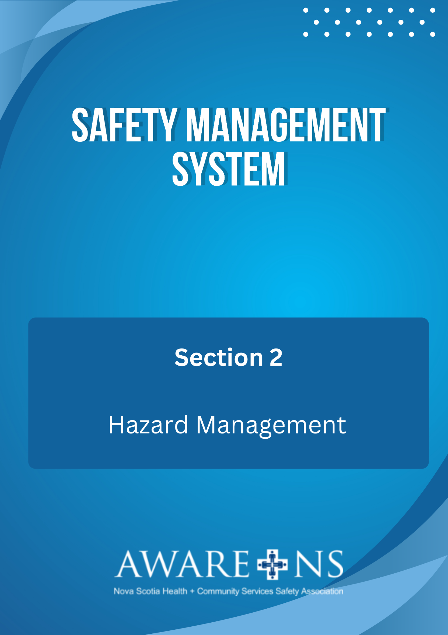

TABLE OF CONTENTS
Section 2: Hazard Management
Introduction 3
Definitions 3
Roles and Responsibilities 4
Senior Leadership 4
Managers 4
Supervisors 4
Employees 5
Employee Reporting OHS Hazards 5
Report to the Supervisor or Manager 5
Referral to the JOHS Committee 6
Formal Referral to the OHS Division, Department of Labour, Skills and Immigration 6
Hazard Assessment Flow Chart 6
Hazard Identification 6
Hazard Categories 6
Contributing Factors 7
Risk Assessment 7
Risk Factor Determination 8
Hazard Control 9
Selecting Controls 9
Implementation 10
Evaluate 10
Monitoring Controls 10

Appendix 2.1, Hazard Report Form
Appendix 2.2, Hazard Assessment Process Flow Chart
Appendix 2.3, Risk Control Assessment Tool
Appendix 2.4, Hazard Control Process Flow Chart
Appendix 2.5, Hazard Control Action Plan Tool

Introduction
[Organization Name] recognizes that hazard identification, risk assessment and hazard control are critical to the success and effectiveness of any Safety Management System.

[Organization Name] has created a proactive process to recognize hazards and eliminate or reduce the risk of injury and illness to everyone at the workplace, damage to property, equipment and the environment. By managing all hazards, [Organization Name] demonstrates their commitment and due diligence to a safe and healthy workplace.

Definitions
Hazard: A hazard is any condition or behaviour that has the potential to cause injury, illness or property damage, including acts of workplace violence or adverse health effects on someone under certain conditions at work.

Job Hazard Analysis (JHA): JHA is a safety tool that can be used to define and control hazards associated with a certain process, job, or procedure. It is a systematic examination and documentation of every task within each job to identify health and safety hazards, and the steps to control each task.

Risk: The chance or probability that a person will be harmed, or experience adverse health effects if exposed to a hazard, or the chance or probability that damage will result to equipment, materials, property or the environment if exposed to a hazard.

Risk Assessment: The overall process of hazard identification, risk analysis and risk evaluation. The level of risk associated with the job, task, equipment and environment.

Inherent Risk: The level of risk associated with the job, task, equipment, or environment before controls are implemented.

Residual Risk: The remaining risk associated with the job, task, equipment, or environment after controls are implemented.

Safe Work Procedures (SWP): Safe work procedures are a series of specific steps that guide a worker through a task from start to finish in chronological order. Safe work procedures are designed to reduce risk by minimizing potential exposure.

Safe Work Practices: Written methods outlining how to perform a task with minimum risk to people, equipment, materials, environment and processes.

Roles and Responsibilities

Senior Leadership
- Ensure that the hazard management program is implemented at the workplace.
- Provide the resources to ensure that employees are involved in the hazard identification assessment and control process.
- Ensure that managers and supervisors are fulfilling their responsibilities for conducting hazard identification and implementation of hazard control recommendations.
- Ensure that written preventative maintenance procedures are established, reviewed and implemented for applicable equipment.
- Work with Joint Occupational Health & Safety Committee (JOHSC) members to evaluate hazards in the workplace, along with supporting them to find suitable corrective actions for the control of the hazards.

Managers
- Verify a hazard inventory of the job/task is completed. This includes identifying and documenting the hazard, assessing the risk associated with the hazard and implementing corrective actions to control the hazard.
- Consult and collaborate with supervisors, employees and the JOHS Committee while conducting the hazard identification, completing the risk assessment and deciding how to control the hazard.
- Review the identified hazards and prioritize corrective actions based on the potential risk to the employee and the work environment.
- Develop written safe work procedures and practices in consultation with employees and the JOHS Committee.
- Review incident frequency and type within the department. This information will assist in choosing the appropriate preventative measures used for the Job Hazard Analysis (JHA).
- Annually review the JHA and SWP for all employee positions. Ensure that newly created positions have an accompanying JHA and SWP.
- Inform supervisors of the hazards at their workplace by providing information, education, training and supervision. This should include SWP and hazard controls, which can be shared during routine safety talks, staff meetings and other times suitable to [Organization Name].
- Document and maintain records pertaining to the information, education and training provided to employees. Ensure that records are available upon request by employees, employer, contractors, safety team or committees or the Department of Labour, Skills and Immigration.
- Appropriately address supervisor and employee health and safety concerns and complaints.

Supervisors
- Complete a hazard inventory of the job/task. This includes identifying and documenting the hazard, assessing the risk associated with the hazard and implementing corrective actions to control the hazard.
- Consult and collaborate with managers, employees and the JOHS Committee while conducting the hazard identification, completing the risk assessment and deciding how to control the hazard.
- Review the identified hazards and prioritize corrective actions based on the potential risk to the employee and the work environment.
- Inform employees of the hazards at their workplace by providing information, education, training and supervision. This should include SWP and hazard controls, which can be shared during routine safety talks, staff meetings and other times suitable to [Organization Name].
- Investigate and respond to all employee health and safety concerns and complaints.

Employees

- Report all hazards to their immediate manager or supervisor and co-operate with management in the identification, reporting and control of hazards at or near the workplace.
- Attempt to eliminate or control the hazard if it is within the scope of their ability and authority to do so.
- Participate in the hazard identification and control process, as required. Work with your manager/supervisor to recommend improvements to the control of any hazard.
- Take appropriate measures for protection of self and others from occupational injury and illness. Utilize all identified control measures including Personal Protective Equipment (PPE).
- In cases where a hazard has been identified and reported, but not corrected by the manager/supervisor, report the hazard to your JOHS Committee.

Employee Reporting OHS Hazards
[Organization Name] has developed a procedure for reporting and responding to employee health and safety hazards. Employees will actively participate in identifying hazards, without fear of reprisal or discriminatory action. Employees can use the Hazard Report Form (Appendix 2.1) to report hazardous conditions or concerns.

Report to the Supervisor or Manager
- Employee gives completed Hazard Report Form to Supervisor.
- Supervisor investigates the hazard and completes their section of the form.
- Supervisor provides feedback to employee within _________days.
- If it has been resolved to the employee’s satisfaction, the form is closed and filed.
- If it has not been resolved to the employee’s satisfaction, then it will be referred to the JOHS Committee for review and recommendation(s).
- JOHS Committee recommendations are shared with the Supervisor.
- If it remains unresolved to the employee’s satisfaction, they may contact the Department of Labour, Skills and Immigration.

If the report is made verbally, both the employee and the Supervisor must maintain notes which include date and details of conversation.

Referral to the JOHS Committee
When the hazard has not been remedied to the employee’s satisfaction, the Hazard Report Form will be forwarded to the JOHS Committee. The JOHS Committee Co-Chair will determine whether the matter is urgent or can be taken to the next meeting of the Committee.
The JOHS Committee will make recommendation(s) and complete Section 3 of the Hazard Report Form. A copy will be provided to both the employee and Supervisor.

Formal Referral to the OHS Division, Department of Labour, Skills and Immigration
If the issue is still not resolved or remedied to the employee's satisfaction, or if the JOHS committee is unable to reach a decision, they will contact Occupational Health and Safety Division of the Department of Labour, Skills and Immigration.

Hazard Assessment Flow Chart
[Organization Name] recognizes that identification, assessment, control and evaluation of hazards is systematic process. Therefore, [Organization Name] has adopted the use of the Hazard Assessment Process Flow Chart (Appendix 2.2). This flow chart will aid person(s) when applying the hazard assessment process.

Hazard Identification
The hazard identification process will outline identification techniques for hazards that cause or are likely to cause death, illness, serious physical and psychological harm to employees. As part of the process, the following shall be used to identify and evaluate workplace hazards:

- Formal workplace inspections as outlined in Section 3 of the Safety Management System
- Review of past workplace incidents
- Review of workplace practices and procedures
- Inspection of new or altered equipment
- Reported concerns and complaints
- Completed Job Hazard Analysis (JHA)
- [Organization should include any other ways they will identify hazards]

Hazard Categories
[Organization Name] recognizes that not all hazards are of the same type. Therefore, [Organization name] will consider the following hazard categories when identifying, assessing and controlling workplace hazards:

Physical hazards - include mechanical hazards, falls from heights, slips, trips, forms of energy, including electricity, visible, ultra-violet and infrared light, noise, extremes of temperature, fire, explosion and workplace violence.

Chemical hazards - include airborne gases, vapours, mists, dusts and fumes, as well as solids and liquids. Routes of exposure to chemical hazards include the skin (and eyes), ingestion (eating) and inhalation (breathing).

Biological hazards - include dangerous animals (bites, stings, etc.), allergic or toxic reactions to plants and animals (waste, dander, etc.), micro-organisms (mould, mildew, etc.) and infectious diseases (including insect and tick bites, airborne and needle stick).

Ergonomic hazards - include the interaction between people and machines (computers, lifts, slider sheets, etc.) or equipment (seating, workstation design, etc.) and environmental conditions relative to human performance and comfort, such as lighting, thermal environment, body position and repetitive motion.

Psychosocial hazards - include aspects of work which have the potential to cause psychological or physical harm. Workplace bullying is repeated, unreasonable behaviour directed towards a worker or group of workers that creates a risk to health and safety.

Contributing Factors
When hazards have been identified, [Organization Name] recognizes that hazards may have more than one factor. Therefore, [Organization Name] will consider the following contributing factors when evaluating hazards:

- Product or service produced;
- Process or tasks undertaken to produce the product or service, including any equipment, which is used;
- Place or work environment, including the physical environment (building, vehicle, outdoors, etc.) and ventilation, lighting, weather, etc. where the work is done; and
- People or employees who do the work, including their occupations and duties. [Organization Name] will also consider resident/clients and members of the public and the potential for acts of violence.

Risk Assessment
Once hazards have been identified or anticipated, a risk analysis using the Risk Control Assessment Tool (Appendix 2.3) will be performed. This will assign a risk factor rating as to set corrective action priorities based on the case with the highest risk.

Risk Factor Determination
The level of risk associated with a hazard will be estimated by considering a combination of two factors:

- Probability - the likelihood of the hazard causing an incident; and
- Severity - the consequences, if it did happen, in terms of harm to people and/or damage to property.
The following hazard probability categories will be used:
- Certain - will likely happen often in the next year (100%)
- Likely - will likely happen in next year (75%)
- Occasional - will likely happen sometime in next several years (50%)
- Remote – unlikely, but could be experienced in next several years (25%)
- Highly unlikely - event will not be experienced (5%)

The following hazard severity categories will be used:
- Catastrophic - Fatality / Coma
- Serious - Severe injury – loss of, or use of limbs, hospitalization
- Moderate - Injury Requires Medical attention
- Marginal - Minor injury – bruises, cuts
- Negligible - No injury

The following Risk Matrix chart will be used to assign a risk factor rating:

 |  | Severity (consequence of exposure)
 |  | Insignificant (1) | Minor (2) | Moderate (3) | Major (4) | Catastrophic (5)
Probability (likelihood of occurrence) | Certain (5) | 5 | 10 | 15 | 20 | 25
 | Likely (4) | 4 | 8 | 12 | 16 | 20
 | Occasional (3) | 3 | 6 | 9 | 12 | 15
 | Unlikely (2) | 2 | 4 | 6 | 8 | 10
 | Rare (1) | 1 | 2 | 3 | 4 | 5

- High Risk (16- 25) – Significant and unacceptable risks. Immediate action required.
- Medium Risk (9-15) – Significant risks.
- Low Risk (1-8) – Not significant. Should be addressed through regular health and safety measures and procedures.

Hazard Control
[Organization Name] recognizes that the effective selection, implementation and monitoring of hazard controls are a critical component of the Hazard Management Program. [Organization Name] has created the following procedures for determining its hazard control. Follow the Hazard Control Process Flow Chart (Appendix 2.4).

Selecting Controls
[Organization Name] will use the following hierarchy of controls when selecting controls for identified hazards:

Elimination: Whenever possible, remove the hazard completely through elimination. Examples include automating a function to eliminate manual handling, eliminating the use of a toxic chemical, eliminating the use of a piece of dangerous equipment or eliminating the performance of a dangerous task.
Substitution: Where the hazard cannot be eliminated, consider alternatives to the processes, substances, machines or equipment being used. Substitution may reduce the risk of injury or illness to an acceptable residual level.
Engineering: Engineering controls involve the design of the workplace and its related processes. Engineering controls include ventilation systems, guards on equipment, fire suppression systems and enclosing of noisy machinery.
Administrative: Where the hazard cannot be eliminated, and where substitution and engineering controls do not adequately manage the hazard, administrative controls are frequently introduced to reduce the risk. Administrative controls include developing safe work programs, practices and procedures or creating new policies, training and supervision. Approaches such as scheduling work, job rotation, procurement policies for equipment and materials, relocating employees from construction zones, etc. should also be considered.
Personal Protective Equipment (PPE): Requirement to rely on PPE is an admission that it has not been possible to eliminate the hazard or reduce it to an acceptable level of residual risk by the use of other controls. It is dependent on the correct choice of PPE, correct fitting, the service life of the PPE, worker compliance with use and proper choice/decision about when to wear. This is the most unreliable control as it creates opportunities for system failures. Therefore, the use of PPE requires other administrative controls, such as development of a safe work procedure or practices, employee training, supervision to supplement this control option.

Implementation
When the correct hazard control has been selected, the person(s) responsible for implmentation will proceed to implement and document the new control. All employees who will be affected by the new control will receive new training and training material will be updated. Use the Hazard Control Action Plan Tool to prioritize and track progress (see Appendix 2.5).

Evaluate
The Hazard Management Program will use the following evaluation technique to determine how well hazard controls are working. This will be completed by manager, supervisor or designated subject matter expert who will:
  - talk to the employees who report to you about the work being done and the controls that have been put in place;
  - observe work being done; and
  - ask employees performing the work for ways to improve their health and safety.

Monitoring Controls
In the event it is determined that a control is not adequate to control the hazard, the manager, supervisor or designated subject matter expert will re-evaluate both the identified hazard and control, and will determine and implement another adequate control techinique. All new or modified controls will be documented and all employees will be given new or additional training based on the new control method.

