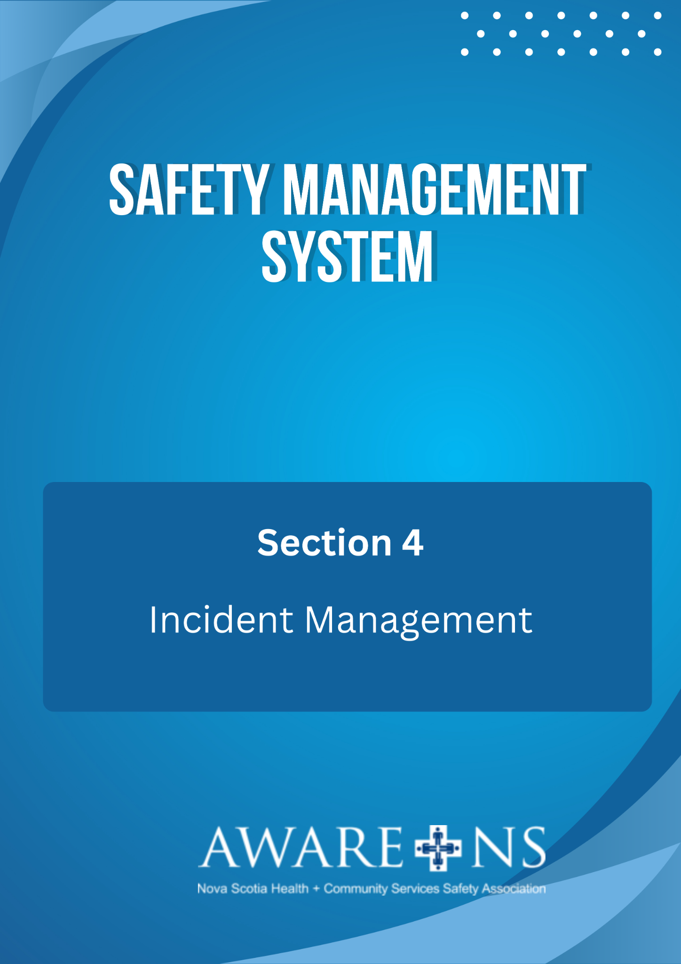

Table of Contents

Section 4: Incident Management

Introduction 3
Requesting Medical Assistance………………..………………………………………………………………………………………….....3
Purpose of Incident Investigation 3
Responsibilities for incident reporting and investigation 4
Senior Leadership 4
Managers and supervisors 4
Employees 4
JOHS Committee 4
Human Resources 4
Incident reporting 5
Notice to the Department of Labour, Skills and Immigration 5
Disturbance of serious incident scene 6
Training of incident investigators 6
Incident Investigation Procedure 6
Documenting Incidents……………………………………………………………………………………………………………….6
Investigation of Incidents……………………………………………………………………………………………………………6
Preparing for the Investigation……………………………………………………………………………………………………7
Information Gathering………………………………………………………………………………………………….…………….7
Conducting Interviews…………………………………………………………………………………………………………….….8
Review and Analyze Evidence…………………………………………………………………………………………..……..…8
Implement Corrective Action and Evaluate Effectiveness……………………………………………………….….9

Appendix 4.1, Quick Reference Investigation Process
Appendix 4.2, Quick Reference Interview Tips
Appendix 4.3, Quick Reference Post Investigation Debriefing
Appendix 4.4, Quick Reference Root Cause Analysis
Appendix 4.5, Incident Report Form

Introduction

In establishing the requirement for an Occupational Health and Safety Program, Section 28(2) of the Occupational Health and Safety Act requires that the Program include:

“(g) a system for the prompt investigation of hazardous occurrences to determine their causes and the actions needed to prevent recurrences.”

In the event of workplace violence, Nova Scotia’s “Violence in the Workplace Regulations”, in particular Sections 12-14, specify the duty to report, document and investigate incidents of violence. In addition, there are requirements to prevent recurrence and appropriate debriefing with employees exposed to or affected by workplace violence.

Requesting Medical Assistance

In the event that an incident requiring medical assistance occurs, employees should remain calm and contact either the first aid attendant or nurse on duty to provide first aid treatment or arrange for additional medical assistance. If necessary, it is [Organization Name]’s duty to arrange for appropriate transportation to the hospital.

In the event that it is an incident of violence go to a safe location and assess if further assistance is required.

Purpose of Incident Investigation

It is the policy of [Organization Name] that all incidents shall be reported and that all incidents that result in injury to people or significant damage to property shall be investigated.

The purpose of the investigation is to determine the root cause(s) of the incident so that corrective actions can be taken to prevent recurrence. An assessment of the effectiveness of any corrective actions will be monitored.

Through this process, it is intended that the investigation results and recommendations will contribute to the continual improvement of the SMS and to a safer workplace.

It is also important to investigate "near miss” incidents and property damage incidents. “Near miss” incidents are those where the incident did not cause an injury, or damage, but could have resulted in personal injury or damage. These incidents are reported and recorded in order to identify the need for corrective actions before a more serious incident happens.

Responsibilities for Incident Reporting and Investigation

Senior Leadership is responsible to:
- ensure that appropriate investigative systems and tools have been developed;
- ensure that incidents are investigated to determine root cause(s);
- ensure that corrective action(s) are implemented to prevent recurrence of the incidents;
- ensure that managers, supervisors and JOHS Committee Members are trained in conducting investigations
- ensure that the Department of Labour, Skills and Immigration is notified of all serious incidents as required by the Occupational Health and Safety Act;

Managers and Supervisors are responsible to:
- participate in OHS Incident Investigation training;
- report and document incidents;
- conduct investigations and determine the root cause(s) of incidents;
- recommend corrective action(s) and monitor implementation to prevent recurrence of the incident

If the supervisor or manager is directly involved in an incident, they will contact their senior leader, who will jointly assign an alternate investigator to undertake the investigation of that incident.

Employees are responsible to:
- report all incidents to their supervisors or managers;
- complete Incident Report Form
- co-operate fully with any investigation of the incident, providing all information relevant to the investigation

Joint Occupational Health and Safety Committee:
- participate in OHS Incident Investigation training;
- when requested to do so, a JOHS Committee member will participate in the investigation;
  - following the completion of the investigation, the JOHS Committee will review the report of the incident investigation, including completeness, any recommendations that are made, and whether further investigation may be desirable;
- at every meeting a summary of Incident Reports and corrective actions is presented;
- the JOHS committee may recommend that further investigation of any incident

Human Resources or designate is responsible to:
- keep official records (respecting employee and resident/client/participant confidentiality), provide secure filing of Incident Reports;
- provide a Monthly Summary of Incident Reports to all JOHS Committee Meetings
- ensure completion of Workers’ Compensation Claims;
- Ensure employee benefits that may be needed are made available following an OHS incident; and

Incident Reporting

Reporting incidents (or near misses) is important to understand and control hazardous conditions. Workplace incidents, including violence, will be reported by completing an Incident Report Form (see Appendix 4.5).

As time is of the essence in undertaking an investigation, this Incident Report Form should be completed as soon as possible; ideally within 24 hours of the incident.

Notice to the Department of Labour, Skills and Immigration

Section 63 of the Occupational Health and Safety Act requires that the employer send written notice of certain more serious incidents (the Act uses the word accident) at the workplace:
Notice of accident at the workplace
63 (1) The employer shall notify the Director
(a) as soon as possible, but in no case later than twenty-four hours, after a fire, flood or accident at the workplace that causes
(i) unconsciousness,
(ii) a fracture of the skull, spine, pelvis, arm, leg,
ankle, wrist or a major part of the hand or foot,
(iii) loss or amputation of a leg, arm, hand, foot, finger or toe,
(iv) a third degree burn to any part of the body,
(v) loss of sight in one or both eyes,
(vi) asphyxiation or poisoning,
(vii) any injury that requires the admission to hospital, or
(viii) any injury that endangers the life,
of an employee, unless the injury can be treated by immediate first
aid or medical treatment and the person can return to work the following day;
(b) as soon as possible, but in no case later than twenty-four hours, after
(i) an accidental explosion,
(ii) a major structural failure or collapse of a building or other structure,
(iii) a major release of a hazardous substance, or
(iv) a fall from a work area in circumstances where
fall protection is required by the regulations,
at the workplace, whether any person is injured or not; and
(c) immediately when a person is killed from any cause, or
is injured from any cause in a manner likely to prove fatal, at the
workplace.
(2) A true copy of the notice of accident required to be given by
an employer to the Workers’ Compensation Board, pursuant to the Workers’ Compensation Act, may be delivered to the Director as sufficient notice pursuant to this
Section if it is delivered within the time required in subsection (1).
(3) Where notice is required to be sent to the Director pursuant to
this Section, the employer shall notify the committee or representative at the workplace, if any. 1996, c. 7, s. 63; 2010, c. 66, s. 12; 2016, c. 14, s. 4.
1996, c. 7 occupational health and safety 4

Disturbance of Serious Incident Scene

Section 64 of the OHS Act requires that the scene of an incident (the Act uses the word “accident”) that results in a serious injury or death not be disturbed:

64 Except as otherwise directed by an officer, no person shall disturb the scene of an accident that results in serious injury or death except as is necessary to…

(a) attend to persons injured or killed;
(b) prevent further injuries; or
(c) protect property that is endangered as a result of the accident

Training of Incident Investigators

Incident investigations shall be carried out by competent persons, i.e. supervisors/managers and JOHSC members, trained in incident investigation; consequently, specific training in conducting OHS incident investigations is required.

Incident Investigation Procedure

Documenting Incidents

Once the situation is under control, i.e. First aid treatment, the incident must be documented using the Incident Report Form. The employee will complete sections 1-7 and will submit the form to their supervisor. The supervisor will use the Incident Report Form as a guide to complete the investigation of the incident.
Appendix A

In the event that the incident is a result of an interaction between a worker and resident/client there may be a need to complete a Resident/Client/Participant Incident Form, in addition to the Incident Report Form.

Investigation of Incidents

The extent to which an investigation is completed will vary depending on the severity of the incident and associated risk. The objective of every investigation is to determine root cause(s) to be able to establish the necessary actions required to prevent a similar occurrence.

The Employer is responsible for ensuring an investigation is conducted. In many cases this responsibility is designated to the supervisor of the employees involved in the incident. Based on the incident severity, the JOHS Committee may be asked to participate in the investigation. All investigations will occur as soon as possible.

Preparing for the Investigation

- Determine if the incident needs to be referred to the police or any other regulatory or legislative body (i.e. the Department of Labour, Skills and Immigration). An external investigation does not preclude one conducted by the workplace, but the workplace investigation must not impede or compromise the external investigation.
- The supervisor will determine who should be involved in the investigation. Person(s) who may be involved include: person(s) involved, department manager and/or manager on call, Human Resources, JOHS committee member(s)/representative, Occupational Health Nurse.
- Review the Incident Report Form
- If required, complete WCB injury/illness report forms.
- Develop a plan to conduct the investigation that outlines all steps to be followed:
  - Prepare a summary of the information that needs to be collected
  - Determine which documents need to be gathered
  - Decide who to speak to and in what order
  - Decide when and where (and by what method) interviews will be conducted
Information Gathering

When gathering information, the supervisor (investigator) needs to be thorough and consider what was occurring before, during, and after the incident. Potential cause factors to be assessed include: Human Behaviour (employees, residents/clients/participants, volunteers, and contractors), Tasks, Materials/Equipment, Environment and Organizational Factors (policies, procedures). Each of these factors needs to be considered in order to identify the root cause(s) and to develop corrective action(s).

A comprehensive incident investigation seeks to identify all possible causes, not single issues in isolation. As many factors may be identified, it is recommended that the supervisor ask “why” 5 times to look to identify the most important contributing factors.

The Incident Report Form can be used to document the information gathered, conduct a root cause analysis, and answer the question of why an incident occurred.

Conducting Interviews

- Record information related to the interviews, such as:
  - Date, time and location of the interview;
  - Names of people interviewed and names of anyone present at the interview (i.e. Union representation).
  - Assign another manager to be present in the interviews and also be the scribe
- When interviewing any person involved:
  - Interview anyone who may have firsthand knowledge of the incident
  - Assure that there is no penalty for participation and that they are expected to cooperate; and
  - Encourage persons involved to recount only first-hand information. Rumour, innuendo or speculation should be given little weight unless independently confirmed.

- When interviewing the people who suffered as a result of an incident at the workplace, be aware that discussing the incident may be difficult and traumatic for them. It may be necessary to involve treatment providers or individuals with specific training.
Review and Analyze Evidence

- An investigation is complete when root cause(s) have been identified and when the supervisor (investigator) can report on what happened.
- The investigation must result in the identification of corrective actions to prevent recurrence of any incident. The notice of actions must be provided to: any employee affected by the incident.
- The incident of workplace violence must be de-briefed with employees, so that they can understand what went wrong and what actions are being taken to prevent a recurrence. The following should be included in the debriefing process:
  - Involve the employee(s) involved in the incident, if appropriate, and if agreeable to being part of the debrief
  - Review the particulars regarding the incident (what went wrong)
  - Review what went right in response to the incident (i.e. training, communication etc.)
  - Discuss what the corrective actions will be to prevent a recurrence. Get input regarding the effectiveness of the corrective actions and other possible improvement opportunities.

Implement Corrective Action and Evaluate Effectiveness

The recommended corrective action(s) to prevent a recurrence of similar incidents may include addressing one or more of the following program elements:
- Policy/Procedures (i.e. amendments, updates or enhancements)
- Training (i.e. deliver new training, refresher)
- Equipment repair, maintenance or replacement
- Facility design and layout including alarm systems, communications equipment and protocols, etc.
- Staffing
- Supervisor availability and accountability
- Change to human behaviours
- Change to equipment, etc.
Recommendations should be:
- Specific for the safety problem/hazard
- Practical and feasible
- Credible (can be trusted to work)
- Based on consultation with employee
After recommendations are in place, follow up to validate solutions. Reassess where necessary and monitor the situation for continuous improvement.

http://www.gov.ns.ca/just/regulations/regs/ohsviolence.htm

