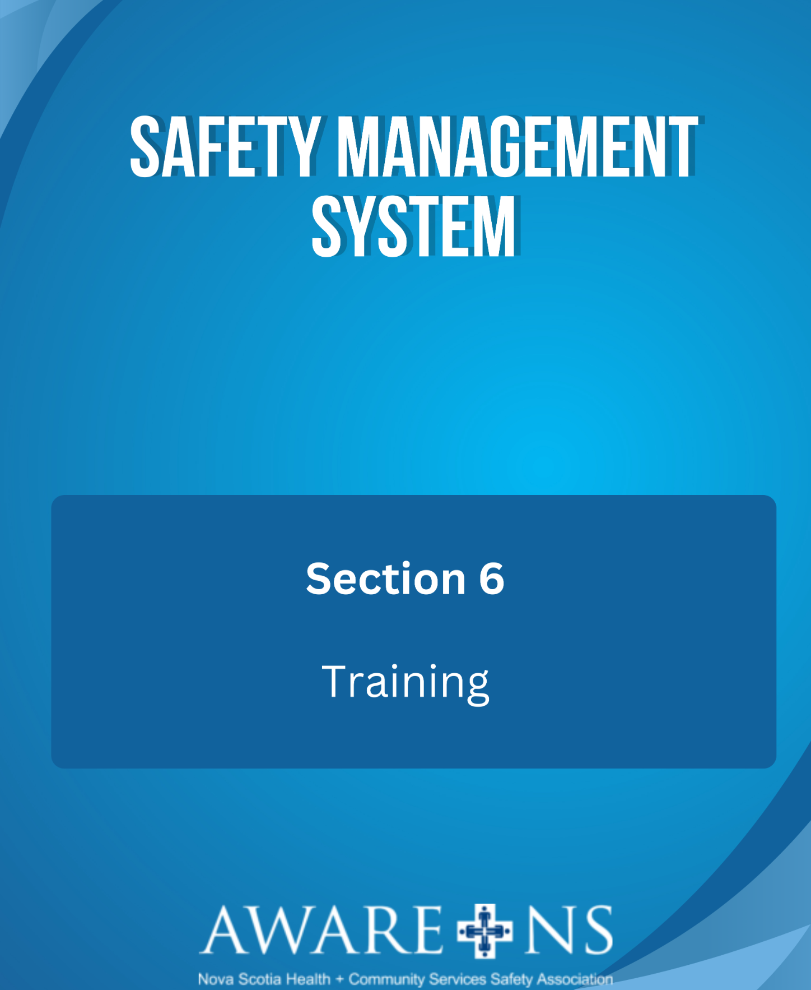

Table of Contents

Section 6: Training

Training Introduction…………………………………………………………………….…………………………………………………...................…3
Responsibility for Training 3
Training Records 3
OHS Training Requirements 4
Safety Rules 5

Appendix 6.1, Training Matrix
Appendix 6.2, General Health and Safety Rules

Introduction
Safety training helps establish a safety culture in which employees themselves help promote proper safety procedures while on the job. It is important that new employees be properly trained and embrace the importance of workplace safety.

An effective training program can reduce the number of injuries, property damage, legal liability, illnesses, worker’s compensation claims, missed time from work and can also help to meet the requirements under the Nova Scotia OHS Act and Regulations.

Responsibility for Training

Senior Leadership team will ensure that:
- training needs are identified;
- appropriate training is provided to all employees, including refresher training, as required;
- systems are in place to ensure the competency of trainers, to periodically evaluate the relevance and effectiveness of training and that training records are maintained

Managers or Supervisors will ensure that:
- employees receive proper safety training as part of their workplace orientation;
- employees are properly trained for their assigned tasks, including both generic and on-the job specific training;
- refresher training is provided, as required; and
- training records are maintained

Employees will:
- participate in all the training provided or authorized by [Organization Name]; and
- apply that training to their jobs to enable them to work in a safe, healthy and responsible manner

Training Records

________________is responsible to maintain working records of all employees training, including hard copies of any certificates. These records are maintained at ____________.

OHS Training Requirements

[Organization Name] uses the following to outline the minimum training guidelines for employees based on their position.

All Employees
- [Organization Name]’s orientation:
  - Introduction to Safety Management System (SMS), the Safety Policy
  - OHS Act and Regulations, including Internal Responsibility System (IRS) - review employees’ right to know, right to participate and right to refuse work
  - Workplace Violence Prevention Policy and Plan
  - How to report incidents, near misses and hazards
  - OHS Bulletin Board location or local Intranet sites where OHS information may be available
  - Review organizational Safe Work Practices, safety rules, and emergency response procedures
  - General WHMIS training (i.e. AWARE-NS)
  - JOHSC Introduction
- Work area orientation including:
  - Review work area Safe Work Practices
  - Review safety equipment locations (i.e. first aid kits, fire extinguishers, eye wash stations)
  - Work area specific training
  - Specific WHMIS training

Managers and Supervisors
- OHS Leadership courses through AWARE-NS:
  - SAFER Leadership
  - Due Diligence, IRS
  - Roles and Responsibilities
  - Incident Investigation and Root Cause Analysis
  - Workplace Inspections
  - Hazard Identification
  - Contractor Safety
  - Stay at Work/Return to Work
- Dealing with concerns and complaints
- Dealing with work refusals
- Safety Management System

JOHS Committee Members
- Committee members are certified through AWARE-NS training in the following topics:
  - Internal Responsibility System (IRS)
  - Safety Accountability and Communication
  - JOHS Committee Awareness
  - Incident Investigation and Root Cause Analysis
  - Workplace Inspections
  - Hazard Identification
- Dealing with work refusals

First Aid Attendants (select best fit for your organization)
- Emergency First Aid and CPR (one day)
- Standard First Aid and CPR (two days) required if working alone
- [Organization Name] has a first aid deviation, therefore, first aid training is not required

Fire Wardens
Orientation to the roles and responsibilities under Fire Safety and Emergency Evacuation Plan, including drills.

Appendix 6.1, Training Matrix is used to track all OHS training at [Organization Name].

Safety Rules
In addition to specific standards or procedures respecting hazardous tasks, a number of more general rules respecting behaviour and job performance have been established. Compliance with these rules is mandatory. These are found:

- Appendix 6.2, General Health and Safety Rules

