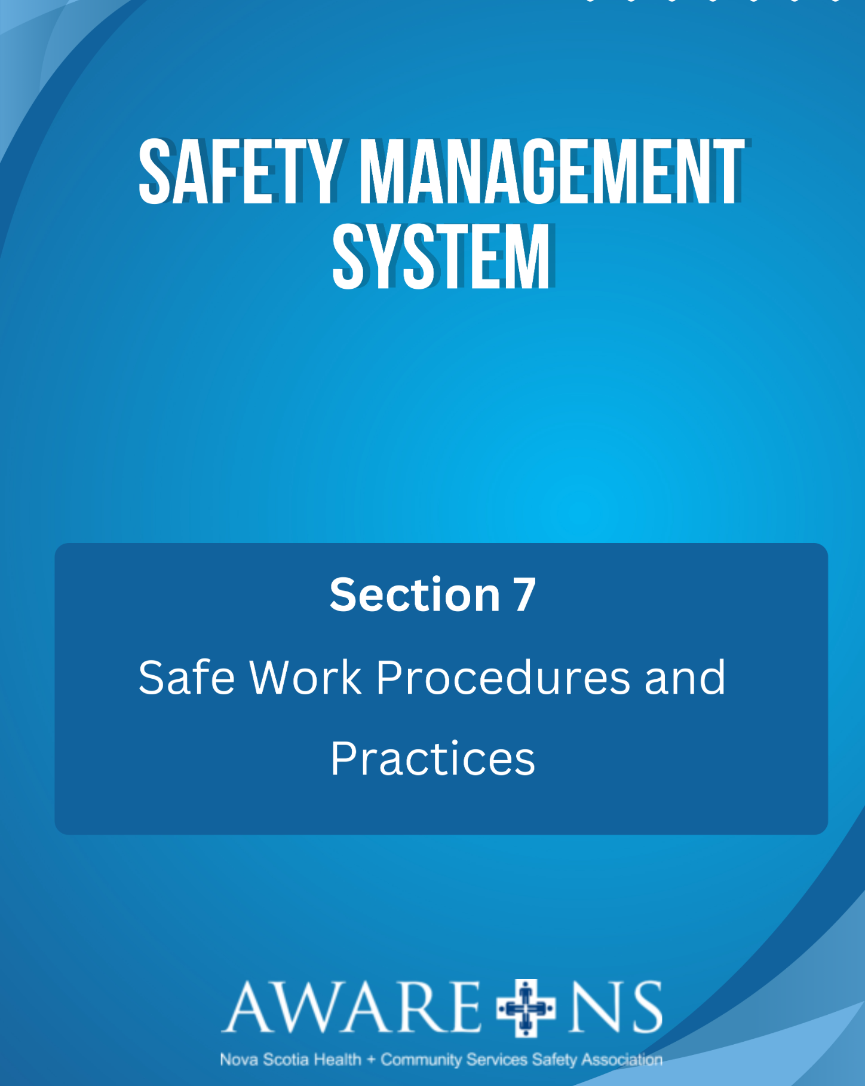

Table Of Contents

Section 7: Safe Work Procedures and Practices
Introduction ................................................................................................................................................ 3
Definitions:
Safe Work Procedures................................................................................................................................. 3
Safe Work Practices......................................................................................................................................3
Job Hazard Analysis………………………………………………………………………………………………………………………………..3
Responsibilities............................................................................................................................................ 3
Developing Safe Work Procedures........................................................................................................……..4
Test the Procedure .....................................................................................................................……………….5
Obtain Approval ...........................................................................................................................................5
Implementation ...........................................................................................................................................5
Monitor and Review.....................................................................................................................................5
Accessibility and Display ..............................................................................................................................5
Records Management ..................................................................................................................................5

Appendix 7.1, Safe Work Procedure Template

Additional Resources:
Safe Work Procedures and Practices

Introduction

Safe Work Practices and Procedures provide information to assist employees to perform tasks safely.
Safe Work Practices and Procedures outline the hazards, risks and control measures to be applied to ensure the task/activity is being performed in a manner to reduce the risk of injury.

Definitions

Safe Work Procedures
Safe work procedures (SWP) describe how work is to be carried out in a safe and standardized process. They are an integral part of the risk management process. A safe work procedure (SWP) is a step-by-step sequence of instructions on how to complete a task safely.

Safe Work Practices
Safe Work Practices means working in a way that minimizes risk to yourself, other people, equipment, materials and the environment. Safe work practices help control hazards and manage risks associated with non-routine work. Safe Work Practices are a guideline of do’s and don’ts.

Job Hazard Analysis (JHA)
JHA is a safety tool that can be used to define and control hazards associated with a certain process, job, or procedure. It is a systematic examination and documentation of every task within each job to identify health and safety hazards, and the steps to control each task.

Responsibilities

Senior Leadership:
- ensure managers/supervisors are developing Safe Work Practices and Procedures
- responsible for ensuring that Safe Work Practices and Procedures are implemented
Managers and Supervisors:
- responsible for the creation and maintenance of the Safe Work Practices and Procedures, associated tools/forms and providing training in the Safe Work Practices and Procedures
Employees:
- responsible to familiarize themselves and comply with the Safe Work Practices and Procedures that exist in their work area
- participate in the creation of Safe Work Practices and Procedures, as needed

Developing Safe Work Procedures

Safe work procedures will:
- describe how the work is carried out;
- identify the work activities assessed as having safety or environmental risks;
- state what the safety and environmental risks are;
- describe the control measures that will be applied to the work activities;
- describe how measures will be implemented to undertake the work in a safe and manner;
- outline the legislation, standards and codes to be complied with
- describe the equipment used in the work, the qualifications of the personnel undertaking the work and the training required to undertake the work in a safe manner
- assign a level of risk

A safe work procedure is often developed proactively. They may also be developed as needed, such as for a:
- corrective action in an incident/hazard report, or
- risk control measure in a risk assessment. Some specific examples where this may be the case include:
  - if there was an incident in the past involving that job
  - new jobs where a risk assessment determines the need

Person(s) creating the safe work procedure must be familiar with the process and understand hazard identification and methods of control. The supervisor is responsible for choosing who is involved in the safe work procedure development process, including employees who perform the actual job task, and may also include subject matter experts, supervisors, managers, safety specialists, trainers, engineers, etc.

The following steps should be taken to ensure a safe work procedure is developed:

- Consult legislative requirements and best practices:
- review legislative requirements including those from guidelines, legislation and best practices; and
- if the task/activity uses any hazardous chemicals, the safe work procedure and safe work practice must reference the safety data sheet for each hazardous chemical.

- Observe and record the sequence of basic job steps:
- note what the employee is actually doing to complete the job; and
- focus on the actions being performed, as well as the equipment being used.

- Complete a Job Hazard Analysis (JHA):
A JHA consists of the following steps:
- select the job to be analyzed;
- separate the job into basic steps;
- identify the hazards within each step;
- control each hazard
- assign risk level
- revise the JHA

Test the Procedure
Ensure that the documented safe work procedure is tested to ensure it is accurate and reflects the actual job steps. Observe employees following the safe work procedure and adjust the procedure as necessary. This should include discussion with the employees.

Obtain Approval
Before it can be finalized, ensure that the safe work procedure goes through an approval process. [Organizational Name]’s approval process is as follows__________________________.

Implementation
Once the safe work procedure is approved, it is the procedure moving forward.

Monitor and Review
The safe work procedure should be reviewed whenever:
- the task/activity changes;
- when a new hazard is identified;
- after a near miss, injury or illness occurs with the task/activity;
- there is a change to legislation, standards or codes of practice; or
- at a minimum of __ years

Accessibility and Display
Safe work procedures should be readily available in the areas in which they are to be used.

Records Management
Safe work procedures can be uniquely identified as each document contains the following:
- Date of Creation: the date the document was first approved; and
- Date of Last Update: the date the document was last approved.

