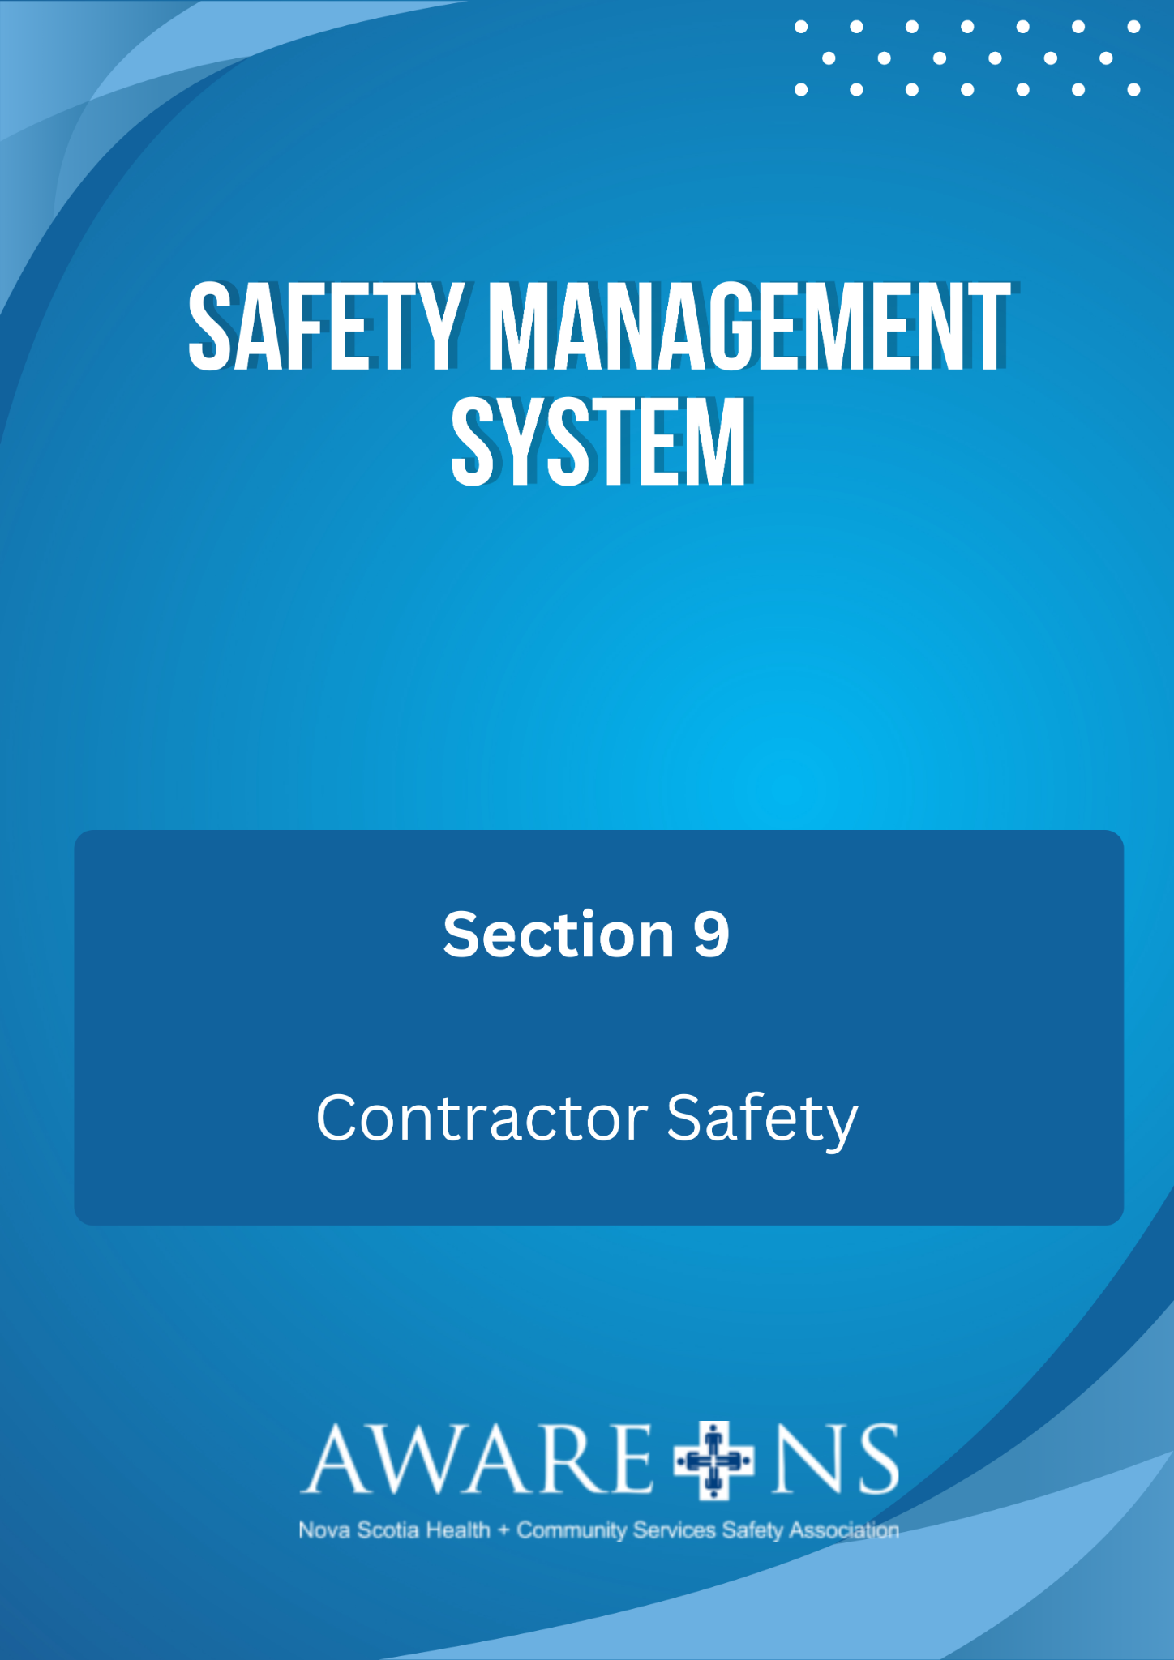

TABLE OF CONTENTS

Section 11: Contractor Safety
Page
Introduction 3
Policy. 3
Procedure 3
Before Work Begins………………………………………..……………………………………………………………..3
During Work………………………………………………………..…………………………………………………………4
Completion of Work……………………………………………………………………………………………………….4

Additional Resources:
Contractor Safety – Orientation Handbook

Introduction

The purpose of this policy is to ensure that construction and maintenance work undertaken by Contractors at [Organization Name] will be completed in a healthy and safe manner in consideration of all hazards present at the site or associated with the work to be performed and in compliance with the Nova Scotia OHS Act and regulations and the requirements of [Organization Name]’s Safety Management System.

This policy does not apply to:
- “supply and deliver” contracts where work is not undertaken at [Organization Name]; or
- Lower risk work by contract consultants, such as lawyers, accountants, human resource consultants, unless they enter the area where the construction or maintenance work is being performed.

Policy
[Organization Name] is committed to providing a safe workplace for all users of its facilities. [Organization Name] recognizes and respects the rights of employees to work and provide service in a safe workplace as defined by the Occupational Health and Safety Act of Nova Scotia, various collective agreements and this policy. [Organization Name] has an obligation to provide a safe environment for residents, clients, participants, their families, visitors, employees and other users of the facilities.

Procedure

Before work begins at [Organization Name]:

The contractor will submit the following documents:
- Safety Policy;
- Workers’ Compensation Board of Nova Scotia Letter of Good Standing;
- Liability Insurance; and
- Certificate of Recognition or be in receipt of a Letter of Good Standing from the Nova Scotia Construction Safety Association, if applicable.

The Project Representative of [Organization Name] shall:

- Complete and record the Contractor Orientation for all workers that will be working on the job, supplemental information may be provided based on the scope of work;
- Ensure that the contractor has completed a hazard assessment, including controls;
- Ensure that the Contractor has provided documentation of all appropriate training completed by employees who will be working on the project (i.e. WHMIS, confined space, fall arrest, Journeymen’s certification, etc.);
- Exchange and review the emergency response plans for both the Contractor and [Organization Name]; and
- Develop a communication plan based on the scope of the project.

During work:

The Contractor shall:

- Provide a copy of all safety-related documents to [Organization Name], i.e. safety talks, Hazard Assessment, Incident/Near Miss reports;
- Ensure that supervision is provided to the project during the time that the work is being performed; and
- While working on projects, the contractor shall participate in all required safety meetings.

The Project Representative of [Organization Name] shall:

- Ensure that supervision is provided to the project during the time that the work is being performed;
- Ensure the contractor complies with all aspects of the Safety Management System (SMS) and OHS Act and Regulations during the time that the work is being done;
- Ensure that the contractor is compliant with all aspects of the “Contractor Safety Orientation Handbook for Healthcare and Community Services”.

Upon completion of work:
- Ensure the contractor has completed expected work to satisfaction;
- All waste has been removed; and
- Work area is to be inspected to ensure that it is left in an acceptable manner.

